[AWS Developer Associate (DVA-C02)](https://arkalim.notion.site/AWS-Developer-Associate-DVA-C02-aa44174fd7634a788368a85ec533e5fc)

**EC2**

**Intro**

* Regional Service
* **Infrastructure as a Service (IaaS)**
* Stopping & starting an instance may change its public IP but not its private IP
* **AWS Compute Optimizer** recommends optimal AWS Compute resources for your workloads
* There is a vCPU-based On-Demand Instance soft limit per region

This refers to a **soft service quota (limit)** on the **total number of virtual CPUs (vCPUs)** you can use **at once for On-Demand EC2 instances in a specific AWS region**. (*A* ***soft limit*** *is the default quota AWS sets. It can be* ***increased upon request*** *(unlike hard limits))*

**🔍 Example:**

Suppose:

Your region’s vCPU soft limit is **64 vCPUs** for On-Demand instances.

You try to launch 8 t3.large instances (each has **2 vCPUs**).

That’s **16 vCPUs** total — ✅ allowed.

But if you try to launch:

10 m5.4xlarge (each has **16 vCPUs**)

Total = 160 vCPUs ❌ — you’ll **hit the limit** and get an error.

* + **Remember the vCPU Scaling with Size**

**large = 2 vCPUs**

**xlarge = 4 vCPUs**. Then it doubles as you go up:

2xlarge = 8 vCPUs

4xlarge = 16 vCPUs

8xlarge = 32 vCPUs

12xlarge = 48 vCPUs

16xlarge = 64 vCPUs

24xlarge = 96 vCPUs

AWS doesn't limit how many **instances**, but how many **vCPUs** you use per **purchase option (like On-Demand, Spot)** and **per instance family** (e.g., m5, c6g, etc.).

*“A developer tries to launch 10 m5.4xlarge EC2 instances and gets an insufficient capacity error. How should they resolve this?”*   
➡️ **Request a vCPU limit increase in the appropriate region.**

**User Data**

* Bootstrap script (runs on the first launch)
* Used to automate **dynamic** boot tasks (that cannot be done using AMIs)
  + Installing updates
  + Installing software
  + Downloading common files from the internet
* Runs with the **root user privilege**

**Instance Classes**

* **General Purpose**
  + Great for a diversity of workloads such as **web servers** or **code repositories**
  + Balance between compute, memory & networking
* **Compute Optimized**
  + Great for compute intensive tasks that require high performance processors.
    - Batch Processing
    - Media Transcoding
    - HPC (High Performance Computing)
    - High Performance Web Servers
    - Scientific modelling and machine learning
    - Gaming Servers
* **Memory Optimized**
  + Great for **in-memory databases** or **distributed web caches**
* **Storage Optimized**
  + Great for storage intensive tasks (accessing local databases)
    - OLTP systems
    - Distributed File System (DFS)

**📊 EC2 Instance Family Comparison Table**

| **Feature** | **🟦 General Purpose** | **🟥 Compute-Optimized** | **🟩 Memory-Optimized** | **🟨 Storage-Optimized** |
| --- | --- | --- | --- | --- |
| **Best For** | Balanced workloads | CPU-heavy tasks | RAM-heavy tasks | High-speed, low-latency storage |
| **Families** | t, m (e.g., t3, m6i) | c (e.g., c5, c7g) | r, x, z (e.g., r5, x2g) | i, d, h (e.g., i3, d2) |
| **CPU-to-Memory Ratio** | Balanced | High CPU, less memory | High memory, moderate CPU | Moderate CPU, fast local storage |
| **RAM Size** | Moderate | Low to moderate | Very high | Moderate |
| **Disk Type** | EBS only | EBS only | EBS only | **Local NVMe/SATA SSDs** |
| **Performance Type** | Balanced, cost-effective | High performance CPU | Massive memory capacity | Super fast IOPS, throughput |
| **Common Use Cases** | Web servers, small DBs, dev/test | Gaming, media processing, ML CPU | Redis, in-memory DBs, SAP, analytics | NoSQL DBs, OLTP systems, file servers |
| **Burstable Options?** | Yes (t family) | No | No | No |
| **Cost** | $$ (Cost-effective) | $$–$$$ | $$$ | $$$ |

**🧠 Quick Mnemonics:**

* **General Purpose = "Good at most things"**  
  Use when you're not sure — balanced.
* **Compute = "Brains"** 🧠  
  Use when the app needs to think fast.
* **Memory = "Big notebook"** 📒  
  Use when the app needs to remember a lot.
* **Storage = "Local SSD rocket"** 🚀  
  Use when the app needs super-fast disk reads/writes.

**1. Disk Type (Storage Type)**

The kind of **storage** that comes with your EC2 instance.

**🔹 Two main types:**

|  |  |
| --- | --- |
| **EBS (Elastic Block Store)** | External block storage volumes you attach to instances. Default for most EC2s. |
| **Instance Store (Local NVMe/SATA SSD)** | Physically attached storage with very high IOPS and throughput. **Faster** but **ephemeral** (lost on stop/terminate). |

**2. Performance Type**

How powerful the instance is in terms of **CPU, RAM, networking, and disk I/O**. It's about the **intensity and consistency** of performance.

**3. Burstable Options**

**Burstable instances** use a **CPU credit system**. You get steady baseline CPU and can “burst” to higher performance temporarily **if you have credits**.

| **Feature** | **Description** |
| --- | --- |
| **CPU Credits** | Earned when idle, spent when bursting |
| **Baseline Performance** | Low to moderate — suitable for apps that are idle often |
| **Key Family** | t (e.g., t3.micro, t4g.small) |

**4.What is Low-Latency Storage?**

**Latency** is the **time delay** between requesting data and actually receiving it.  
So, **low-latency storage** means storage that delivers data **very quickly** after it's requested.

Think: **"fast response"** time for read/write operations.

**##Security Groups**

* **Only contain Allow rules**
* External firewall for EC2 instances (applied on Elastic Network Interface (ENI), if a request is blocked by SG, instance will never know)
* Security groups rules can reference a resource by IP or Security Group
* Default SG
  + inbound traffic from the same SG is allowed
  + all outbound traffic is allowed

When you create a **new VPC**, AWS automatically creates **one default Security Group** for that VPC.

**📦 Key Properties of a Default Security Group:**

| **Feature** | **Behavior** |
| --- | --- |
| **Inbound Rules** | Allows all traffic **from instances associated with the same SG** |
| **Outbound Rules** | Allows **all outbound traffic** to anywhere (0.0.0.0/0) |
| **Stateful** | Yes — return traffic is automatically allowed |
| **Assigned Automatically** | Yes — if you don’t specify an SG when launching an instance |
| **Modifiable?** | ✅ Yes, you can modify the default SG or delete the rules |
| **Deletable?** | ❌ No, you **cannot delete** the default SG (but can remove its rules) |

**🧠 Breakdown of Default Behavior:**

**✅ Inbound:**

Only accepts traffic **from other EC2 instances** associated with **the same Security Group**.

* + Allows internal EC2-to-EC2 communication **if they're in the same SG**.

**✅ Outbound:**

**All traffic is allowed** (HTTP, SSH, DNS, etc.)

**🔒 Example:**

Let’s say:

You launch two EC2 instances without specifying a Security Group.

Both will get the **default SG**.

They can **communicate with each other**, but no external client can reach them **unless you add inbound rules** (e.g., allow HTTP or SSH).

*“A developer launches an EC2 instance without specifying a Security Group. The instance cannot be accessed via SSH. What is the likely reason?”*

**Answer:** The **default Security Group does not allow inbound SSH (port 22)** — you must **add an inbound rule manually**.

* New SG
  + all inbound traffic is blocked
  + all outbound traffic is allowed
* A security group can be attached to multiple instances and vice versa
* Bound to a VPC (and hence to a region)
* Recommended to maintain a separate security group for SSH access
* Blocked requests will give a **504 Timeout** error

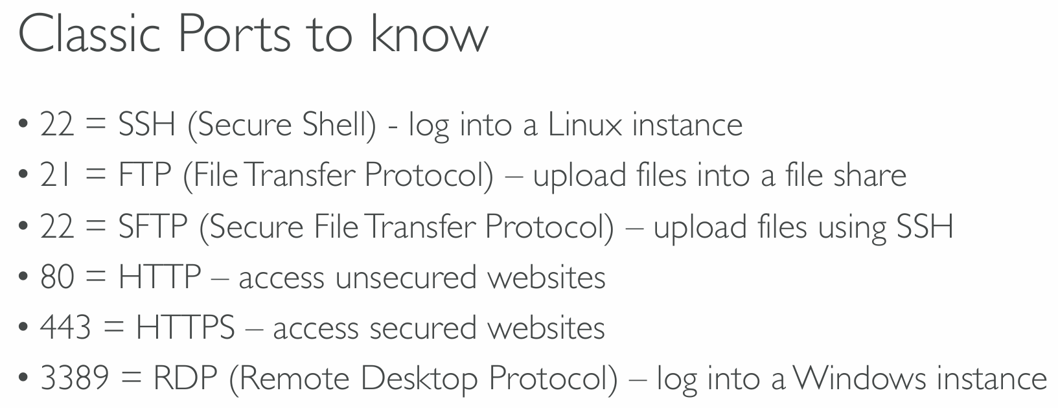

**Elastic Network Interface (ENI)**

* ENI is a virtual network card that **gives a private IP to an EC2 instance**
* A primary ENI is created and attached to the instance upon creation and will be deleted automatically upon instance termination.
* We can create additional ENIs and attach them to an EC2 instance to access it via multiple private IPs.
* We can detach & attach ENIs across instances
* **ENIs are tied to the subnet** (and hence to the AZ)

**Instance Profile**

* Never enter AWS credentials into the EC2 instance, instead attach IAM Roles to the instances (instance profile)
* Steps to create an instance profile for an EC2 instance and add a role to it
  + aws iam create-instance-profile
  + aws iam add-role-to-instance-profile
  + aws ec2 associate-iam-instance-profile

**##Purchasing Options**

**On-demand Instances**

* Pay per use (no upfront payment)
* Highest cost
* No long-term commitment
* Recommended for short-term, uninterrupted and **unpredictable** workloads

**Standard Reserved Instances**

* Reservation Period: 1 year or 3 years
* Recommended for steady-state applications (like database)
* **Sell unused instances** on the Reserved Instance Marketplace

**Convertible Reserved Instances**

* Can change the instance type
* Lower discount
* **Cannot sell unused instances** on the Reserved Instance Marketplace

**Scheduled Reserved Instances**

* reserved for a time window (ex. everyday from 9AM to 5PM)

**Spot Instances**

* Work on a bidding basis where you are willing to pay a specific max hourly rate for the instance. Your instance will get interrupted if the spot price increases your bidding price.
* The behaviour for spot instance interruption can be **stop**, **hibernate** or **terminate**. It cannot be **reboot**.
* **Spot blocks** are designed not to be interrupted
* Good for workloads that are resilient to failure
  + Distributed jobs (resilient if some nodes go down)
  + Batch jobs

**What are Spot Instances?**

**1. Pricing and Bidding:**

* Spot Instances let you use **unused EC2 capacity** at a **discounted price** compared to On-Demand.
* You **bid the max hourly price** you’re willing to pay for the instance.
* If the **Spot price** (market demand) goes **above your bid price**, your instance gets **interrupted**.

**2. Interruption Behavior:**

When AWS reclaims your Spot instance, it **cannot** just reboot it; it must either:

* **Stop** the instance (you can restart it later)
* **Hibernate** the instance (save state and resume later)
* **Terminate** the instance (instance is deleted)

*Reboot is NOT an option for Spot interruptions.*

**3. Spot Blocks:**

* Spot blocks are **special Spot Instances** that run continuously for a **fixed duration** (1 to 6 hours).
* These are **designed not to be interrupted** during that time.
* Useful if you want discounted compute but can’t tolerate interruptions **for a few hours**.

**4. Best Use Cases:**

Spot Instances are ideal for workloads that are **resilient to interruptions** and can handle sudden termination, such as:

* **Distributed jobs:** Systems like Kubernetes, Hadoop, or Spark that run many nodes and tolerate some failures
* **Batch jobs:** Large-scale processing jobs where tasks can be retried or restarted

**Dedicated Hosts**

* Server hardware is allocated to a specific company (not shared with other companies)
* **3 year reservation** period
* Billed per host (expensive)
* Useful for software that have **BYOL (Bring Your Own License)** or for companies that have strong regulatory or compliance needs

**Dedicated Instances**

* Instances running on a **dedicated hardware for an AWS account**.
* Both dedicated and non-dedicated instances of an account can be running on the dedicated hardware
* Billed per instance
* No control over instance placement
* Cheaper than Dedicated Host

**Dedicated Hosts vs Dedicated Instances**

| **Feature** | **Dedicated Host** | **Dedicated Instance** |
| --- | --- | --- |
| **Physical Isolation** | You get an entire **physical server** dedicated to you | Your instance runs on hardware **not shared with others** |
| **Visible Host Hardware** | ✅ Yes — full control and visibility of sockets, cores | ❌ No — AWS abstracts the host hardware |
| **Bring Your Own License (BYOL)** | ✅ Supported — especially for Microsoft Windows/SQL Server | ❌ Not supported for most BYOL use cases |
| **Placement Control** | ✅ You can place specific instances on specific hosts | ❌ No control over instance placement |
| **Pricing Model** | **Per-host** billing (charged hourly per physical host) | **Per-instance** billing (like On-Demand) |
| **Use Case** | License tracking, compliance (e.g., for Oracle, Windows) | Just need isolation, not licensing or full host control |

**Zonal Reserved Instances**

* Reserve capacity in an AZ to launch EC2 instances when needed
* Can reserve for a recurring schedule (ex. everyday from 9AM to 5PM)
* **No need for 1 or 3-year commitment** (independent of billing discounts)
* Need to specify the following to create capacity reservation:
  + AZ
  + Number of instances
  + Instance attributes
* **Regional reserved instances don’t provide capacity reservations**

**Reserved Capacity and Instance Comparison**

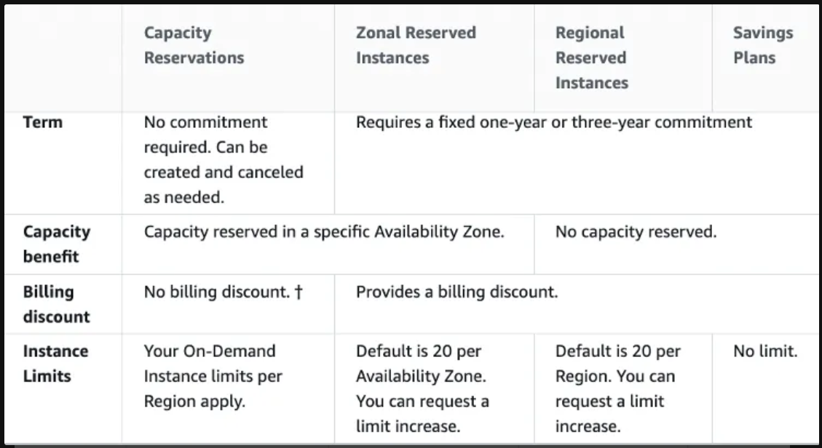

**Spot Instances**

**Spot Requests**

* **One-time**: Request once opened, spins up the spot instances and the request closes.
* **Persistent**:
  + Request will stay disabled while the spot instances are up and running.
  + It becomes active after the spot instance is interrupted.
  + If you stop the spot instance, the request will become active only after you start the spot instance.
* You can only cancel spot requests that are open, active, or disabled.
* Cancelling a Spot Request does not terminate instances. You must first cancel a Spot Request, and then terminate the associated Spot Instances.

**Spot Fleets**

* Combination of spot and on-demand instances (optional) that tries to **optimize for cost or capacity**
* **Launch Templates must be used to have on-demand instances in the fleet**
* Can consist of instances of different classes
* Strategies to allocate Spot Instances:
  + **lowestPrice** - from the pool with the lowest price (cost optimization, short workload)
  + **diversified** - distributed across all pools (great for availability, long workloads)
  + **capacityOptimized** - pool with the optimal capacity for the number of instances

**Elastic IP**

* **Static Public IP** that you own as long as you don't delete it
* Can be attached to an EC2 instance (even when it is stopped)
* Soft limit of 5 elastic IPs per account
* Doesn’t incur charges as long as the following conditions are met (EIP behaving like any other public IP randomly assigned to an EC2 instance):
  + The Elastic IP is associated with an Amazon EC2 instance
  + The instance associated with the Elastic IP is running
  + The instance has only one Elastic IP attached to it

**Placement Groups (Placement Strategies)**

* **Cluster Placement Group (optimize for network)** 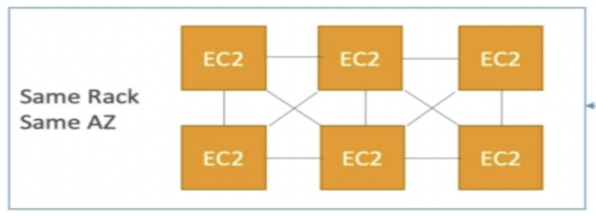
  + All the instances are placed on the same hardware (same rack)
  + Pros: Great network (10 Gbps bandwidth between instances)
  + Cons: If the rack fails, all instances will fail at the same time
  + Used in **HPC** (minimize inter-node latency & maximize throughput)
* **Spread Placement Group (maximize availability)** 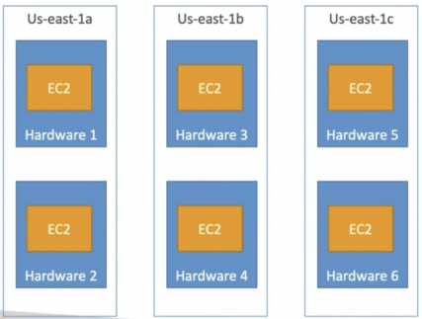
  + Each instance is in a separate rack (physical hardware)
  + Supports Multi AZ
  + Up to 7 instances per AZ per placement group (ex. for 15 instances, need 3 AZ)
  + Used for critical applications
* **Partition Placement Group (balance of performance and availability)**

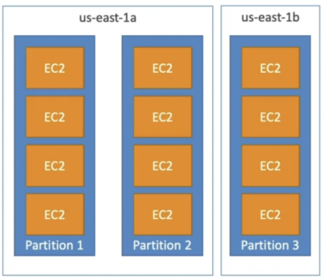

* + Instances in a partition share rack with each other
  + If the rack goes down, the entire partition goes down
  + Up to 7 partitions per AZ
  + Used in **big data** applications (Hadoop, HDFS, HBase, Cassandra, Kafka)

💡 If you receive a capacity error when launching an instance in a placement group that already has running instances, stop and start all of the instances in the placement group, and try the launch again. Restarting the instances may migrate them to hardware that has capacity for all the requested instances.

**Instance States**

* **Stop**
  + EBS root volume is preserved
* **Terminate**
  + EBS root volume gets destroyed
* **Hibernate**
  + Hibernation saves the contents from the instance memory (RAM) to the EBS root volume
  + EBS root volume is preserved
  + The instance boots much faster as the OS is not stopped and restarted
  + When you start your instance:
    - EBS root volume is restored to its previous state
    - RAM contents are reloaded
    - Processes that were previously running on the instance are resumed
    - Previously attached data volumes are reattached and the instance retains its instance ID
  + Should be used for applications that take a long time to start
  + **Not supported for Spot Instances**
  + Max hibernation duration = **60 days**
* **Standby**
  + Instance remains attached to the ASG but is temporarily put out of service (the ASG doesn't replace this instance)
  + Used to install updates or troubleshoot a running instance

**EC2 Nitro**

* Newer virtualization technology for EC2 instances
* Better networking options (enhanced networking, HPC, IPv6)
* Higher Speed EBS (64,000 EBS IOPS max on Nitro instances whereas 32,000 on non-Nitro)
* Better underlying security

**vCPU & Threads**

* vCPU is the total number of concurrent threads that can be run on an EC2 instance
* Usually 2 threads per CPU core (eg. 4 CPU cores ⇒ 8 vCPU)

**Amazon Machine Image (AMI)**

* AMIs are the image of the instance after installing all the necessary OS, software and configuring everything.
* It boots much faster because the whole thing is pre-packaged and doesn’t have to be installed separately for each instance.
* Good for static configurations
* **Bound to a region** (can be copied across regions)

💡 When the new AMI is copied from region A into region B, it automatically creates a snapshot in region B because AMIs are based on the underlying snapshots.

**EC2 Classic & ClassicLink**

* Instances run in single network shared with other customers (this is how AWS started)
* **ClassicLink** allows you to link EC2-Classic instances to a VPC in your account

**Billing**

* **Reserved instances will be billed regardless of their state** (billed for a reserved period)
* **On-demand instances in stopping state when preparing to hibernate will be billed**
* If an instance is running, it will be billed
* In all the other cases, an instance will not be billed
* **Burstable performance instances** (T3, T3a, and T2 families), are designed to provide a baseline level of CPU performance with the ability to burst to a higher level when required by your workload.
* Burstable instances use a credit system to manage CPU performance. When the instance is idle or not using its full CPU capacity, it earns CPU credits. When the instance needs more CPU performance than its baseline, it can use these credits to "burst" above its baseline and provide the needed performance. ****Example: for a T2.micro instance in a new AWS account (< 1 year old), burst performance will cost nothing as it will consume the credits from the free tier.

**Run Command**

* Systems Manager **Run Command** lets you remotely and securely **manage the configuration** of your **managed instances**. A *managed instance* is any EC2 instance that has been configured for **Systems Manager**.
* Run Command enables you to **automate common administrative tasks** and perform ad-hoc configuration changes at scale.
* You can use Run Command from the **AWS Console**, the AWS CLI, AWS Tools for Windows PowerShell, or the AWS SDKs. Run Command is offered at no additional cost.

**Instance Tenancy**

* **Default**: Instance runs on shared hardware
* **Dedicated**: Instance runs on single-tenant hardware
* **Host**: Instance runs on dedicated host

💡 Tenancy of an instance can only be changed from host to dedicated or dedicated to host after the instance has been launched. Dedicated instance tenancy takes precedence over Default instance tenancy.

**Troubleshooting**

* The following are a few reasons why an instance might immediately terminate:
  + You’ve reached your EBS volume limit.
  + An EBS snapshot is corrupt.
  + The root EBS volume is encrypted and you do not have permissions to access the KMS key for decryption.
  + The instance store-backed AMI that you used to launch the instance is missing a required part.

**EC2 Instance Metadata**

* EC2 instances can get metadata about them @ <http://169.254.169.254/latest/meta-data>. This API is internally available to the EC2 instances.
* It allows the instances to get the metadata without using an IAM role.
* **IAM role can be retrieved from the metadata but not the IAM policy.**

💡 When you have an IAM role attached to your EC2 instance and you run AWS CLI commands from inside this instance, AWS CLI uses instance metadata to get temporary credentials.

**SSH Access**

* SSH keys can be used to securely SSH into public EC2 instances
* **Can generate a public key from the private key if the public key gets misplaced but not the other way around.**
* SSH keys can be reused across regions:
  1. Generate a public SSH key (.pub) file from the private SSH key (.pem) file.
  2. Set the AWS Region you wish to import to.
  3. Import the public SSH key into the new Region.

**LAMBDA**

**Intro**

* Function as a Service (FaaS)
* Serverless
* Auto-scaling
* Pay per request (number of invocations) and compute time
* Free tier: 1,000,000 requests and 400,000 GBs of compute time
* Supported runtime
  + NodeJS
  + Python
  + Java
  + C#
  + Golang
  + Ruby
  + Any other language using Custom Runtime API (example Rust)
  + Docker containers

**Performance & Limits**

* RAM: 128MB (default) - 10 GB (1 MB increments)
* Disk capacity (/tmp): 512 MB (free) - 10 GB
* Cannot configure vCPU count directly, increase RAM to increase vCPU count
  + RAM = 1,792 MB ⇒ vCPU = 1
  + For vCPU > 1, need to use multi-threading to take advantage of multiple cores
* Timeout: default 3s, max 15 mins (900s)
* Environment variables: max 4 KB
* Deployment
  + Compressed: max 50 MB
  + Uncompressed: max 250 MB (for more use /tmp)

**Cold Start**

* To minimize partial cold start time, minimize the time taken to execute the code outside the lambda handler by:
  + Reducing the deployment package size
  + Increasing computing power (by increasing the allocated memory)

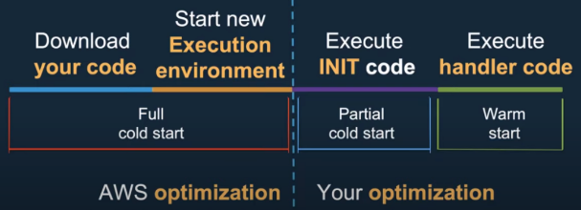

**Access Control**

* IAM permissions to control API access to Lambda
* Resource-based policies to allow other services to invoke the lambda function

**Synchronous Invocation**

* The caller invokes the lambda function and waits for it to return the result
* Error handling (retries, exponential backoff, etc) must be done by the caller

**Exponential Backoff** is a **retry strategy** used in AWS (and other distributed systems) to manage retries when requests fail — especially due to throttling or temporary errors (like HTTP 429 or 5xx errors).

Instead of retrying immediately or at fixed intervals, exponential backoff **waits progressively longer between each retry**, reducing the risk of overwhelming the service.

**🔄 How It Works**

When a request fails:

1. **Wait for a delay** before retrying.
2. If it fails again, **increase the delay exponentially**.
3. Add **jitter (randomness)** to avoid "retry storms" (when many clients retry at the same time).

**📌 Formula (Typical)**

Delay = base * 2^n + jitter

* base: initial delay (e.g., 100ms)
* n: number of retries (starting at 0)
* jitter: random value to spread retries and avoid collision

Example:

* Retry 1: wait 100ms
* Retry 2: wait 200ms
* Retry 3: wait 400ms
* Retry 4: wait 800ms (+ random jitter)

**✅ AWS Services That Use It**

Many AWS SDKs and services implement exponential backoff automatically, including:

* **Amazon S3**
* **DynamoDB**
* **SNS/SQS**
* **Lambda**
* **AWS SDKs (Java, Python, etc.)**

For example, if you get a ProvisionedThroughputExceededException from DynamoDB, the SDK retries using exponential backoff.

**⚠️ Why It's Important**

Without exponential backoff:

* Services could be **flooded** with retries.
* **Rate-limited** or throttled requests could cause cascading failures.
* It would be harder to **recover gracefully** from temporary issues.
* Invoking a lambda function using CLI or SDK results in synchronous invocations by default. To invoke explicitly, set invocation-type to RequestResponse

**✅ Synchronous vs Asynchronous Lambda Invocation**

When you **invoke an AWS Lambda function**, you can choose whether to **wait for the result (synchronous)** or **just trigger the function and move on (asynchronous)**.

**💡 By Default: Synchronous Invocation**

When using the **AWS CLI or SDK**, the **default** behavior is **synchronous**, which means:

* Your request **waits until the Lambda function finishes execution**.
* You get the **function’s response/output** in your command or code.
* This is called InvocationType: "RequestResponse"

**🛠️ CLI Example (Synchronous by Default):**

aws lambda invoke \

--function-name myFunction \

--payload '{"key":"value"}' \

response.json

* Even without specifying --invocation-type, this waits for a response.
* It writes the response to response.json.

**🔁 Explicitly Setting the Invocation Type**

To be **explicit**, you can set:

--invocation-type RequestResponse

Even though it’s the default, it's useful when you want to be clear or avoid ambiguity in scripts or automation.

**🔄 Other Invocation Types:**

| **InvocationType** | **Description** |
| --- | --- |
| RequestResponse | **Synchronous** (waits for response) — default in CLI/SDK |
| Event | **Asynchronous** — Lambda queues the event and returns immediately |
| DryRun | Checks permissions and if the function can be invoked, **but doesn’t run it** |

**🧠 Summary**

* Using CLI or SDK **invokes Lambda synchronously by default**.
* This means your code **waits for the function to finish** and gets the result.
* To be explicit, set --invocation-type RequestResponse.
* Some services that invoke the lambda function synchronously
  + Invoked by user
    - ALB
    - API Gateway
    - CloudFront (Lambda@Edge)
    - S3 Batch
  + Invoked by service
    - Cognito
    - Step Functions
    - **SQS** (through event source mapping)

**Asynchronous Invocation**

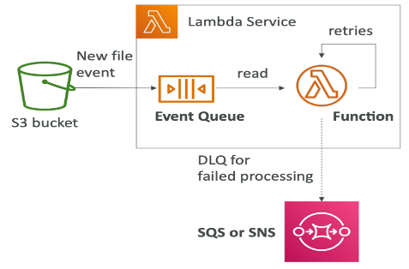

* The caller just invokes the lambda function and does not wait for the result. Can send many events and let lambda process them.
* The event is put in an event queue from which the lambda function reads
* Invoking a lambda function asynchronously returns **status code 202 (lambda function invoked)**. We don’t know if the processing was successful or not.
* For asynchronous invocation, set invocation-type to Event
* Error handling is done by the lambda function
  + Retries: 0 - 2
  + Exponential Backoff: 1 min (first retry), 2 min (second retry)
  + Can setup DLQ (SQS queue or an SNS topic) **on the lambda function** to send failed events after retries. Need to provide IAM permissions to the lambda to write to DLQ.

**1. What a DLQ is:**

* A place to capture **failed messages/events** that couldn't be processed successfully.

**2. Where DLQs are used:**

* **AWS Lambda** (asynchronous invocations only)
* **Amazon SQS**
* **Amazon SNS**
* **Amazon EventBridge**

**3. How they work:**

* AWS retries the operation.
* If it fails after a certain number of retries, the message/event goes to the DLQ.
* You can use tools like **CloudWatch** and **SQS metrics** to monitor DLQs.

**4. Configuring DLQs:**

* For Lambda: you must explicitly set a DLQ for async invocations.
* For SQS: DLQs are configured at the queue level (e.g., maxReceiveCount in redrive policy).
* Know how to attach an SQS queue or SNS topic as a DLQ.

**🧠 Example Exam Scenario:**

"Your Lambda function processes events from an SNS topic. Occasionally, it fails due to bad data. You want to ensure failed events are not lost. What should you do?"

✅ Correct answer: **Configure a Dead Letter Queue (SQS or SNS) for the Lambda function**.

* + Retries lead to duplicate logs in CW
  + Make sure the event processing is **idempotent** (not affected by retries)
* Some services that invoke the lambda function asynchronously
  + S3 (S3 notifications)
  + **SNS**
  + EventBridge (events in event buses)
  + CodeCommit (Code Commit Trigger: new branch, new tag, new push)
  + CodePipeline (invoke a Lambda function during the pipeline)

**Event Source Mapping**

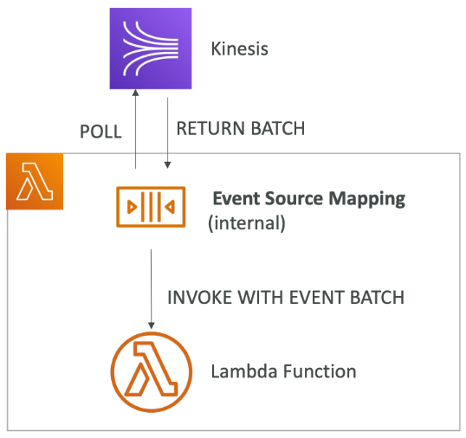

* **Lambda needs to poll the service to get records for processing** (required when the following services are configured as the trigger for lambda function)
  + Kinesis Data Streams (KDS)
  + DynamoDB Streams
  + SQS queues (Standard and FIFO)
* When we configure the lambda function to work with the above services, an event source mapping is created internally which repeatedly polls the service to get a batch of data and **invoke the lambda function synchronously with an event batch**.
* Need to attach IAM permissions to the Lambda role to read from the appropriate service.

💡 **Event Source Mapping is a process internal to Lambda.** It is managed by the Lambda service but is not directly run inside the Lambda function.

There are two kinds of event source mappers:

**Streams**

* Used for KDS and DynamoDB streams as Lambda trigger
* The event source mapping creates an iterator for each shard. Items within a shard will be processed in order but items across shards might not be processed in order.
* The iterator can be configured where to read from:
  + Trim Horizon (beginning of the shard)
  + At timestamp
  + Latest
* **Processed records aren’t removed from the stream** and can be viewed by other consumers.
* For low traffic streams, process the records in batches for each shard using batch window (time to wait for the batch to fill up)
  + 1 lambda per shard
  + In order processing for each shard
* For high traffic streams, process multiple batches (partitioned using partition key) in parallel at the shard level
  + Max 10 batches per shard (10 lambdas per shard)
  + In order processing for each partition key

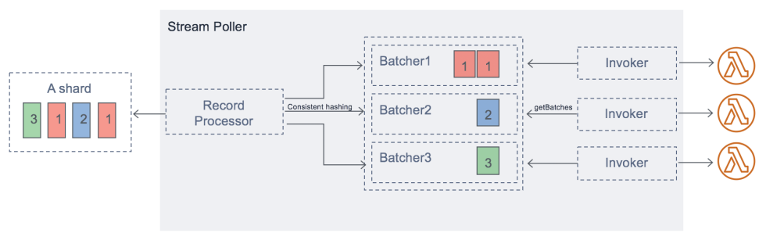

* Error Handling
  + **If an error occurs while processing a batch, the entire batch is reprocessed until the processing succeeds or items in the batch expire.**
  + Processing for the affected shard is paused until the error is resolved (to ensure that batches are processed in order).
  + Event source mapping can be configured to:
    - Discard old events (send to a **destination**)
    - Restrict the number of retries
    - Split the batch on error (process the batch partially) (work around Lambda timeout issue)

**Queues**

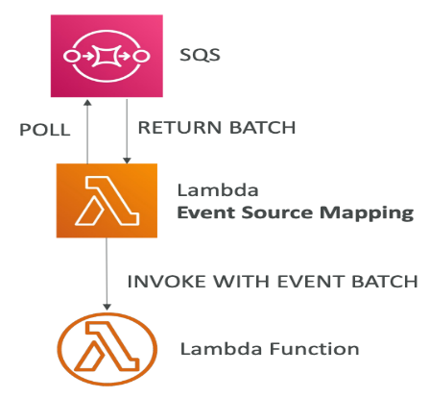

* Used for SQS as Lambda trigger
* Event source mapping uses **long polling** to poll the queue for messages.
* **Batch size**: 1 - 10 messages
* Recommended to set message visibility timeout to 6x lambda function timeout
* FIFO Queues
  + In-order processing
  + Lambda scales to the number of group IDs
* Standard Queues
  + Processing not necessarily in order
  + Lambda scales up to process items in the queue as quickly as possible (adds 60 more instances per minute)
  + Up to 1000 batches of messages processed simultaneously
* **When an error occurs, items within the batch are returned to the queue** and might be processed in a different grouping than the original batch.
* The event source mapping might receive the same item multiple times, even if no function error occurred. So the processing should be **idempotent**.
* **Lambda deletes messages from the queue after they're processed successfully.**
* **DLQ needs to be set on the queue, not the Lambda function** because DLQ for Lambda is only for asynchronous invocations.
* Lambda destination can be used for failures

**Integration with ALB**

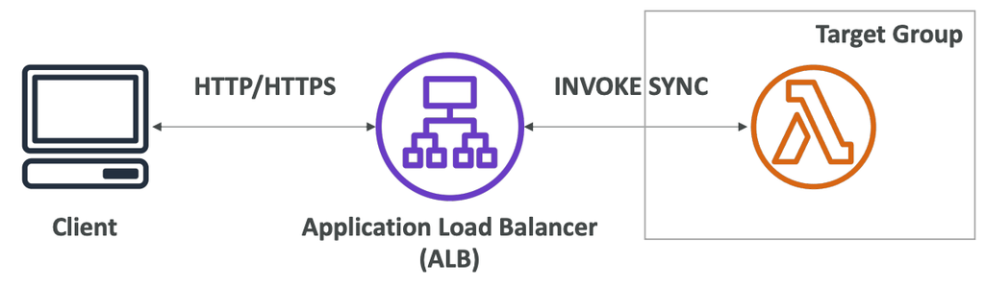

* ALB is used to expose a lambda function as an HTTP/HTTPS endpoint
* Lambda function must be registered in a target group
* ALB converts the HTTP request into a JSON event to invoke the lambda synchronously. It also converts the response from Lambda back into HTTP response to return to the client.
* Multi-value headers support in ALB

If **multi-value header setting in the target group** is enabled, **HTTP headers** and **query string parameters** with the same key but different values are converted to arrays in the JSON event.

**✅ What Problem Does It Solve?**

Sometimes a client sends multiple values for the same header or query parameter. For example:

**Request Example:**

GET /api?tag=dev&tag=qa

Host: example.com

X-User: alice

X-User: bob

Normally, AWS would pass just **one value per key** (either the first or last one).

But with **multi-value headers enabled**, it will pass **all values as arrays**.

**🧠 Example Event Payload:**

**🔁 Without multi-value setting:**

{

"queryStringParameters": {

"tag": "qa"

},

"headers": {

"x-user": "bob"

}

}

**✅ With multi-value setting enabled:**

{

"multiValueQueryStringParameters": {

"tag": ["dev", "qa"]

},

"multiValueHeaders": {

"x-user": ["alice", "bob"]

}

}

**🧠 Why This Matters**

* Lets your Lambda **see all values**, not just one.
* Important for **APIs or apps** where multiple values for the same key are expected.
* Useful for **filters**, **tags**, **multi-select parameters**, or **authorization checks**.

**🔧 How to Enable It**

When creating a Lambda target group for your ALB:

* Set "Multi value headers" to **"enabled"** in the console or via API/CLI.

**Event and Context Objects**

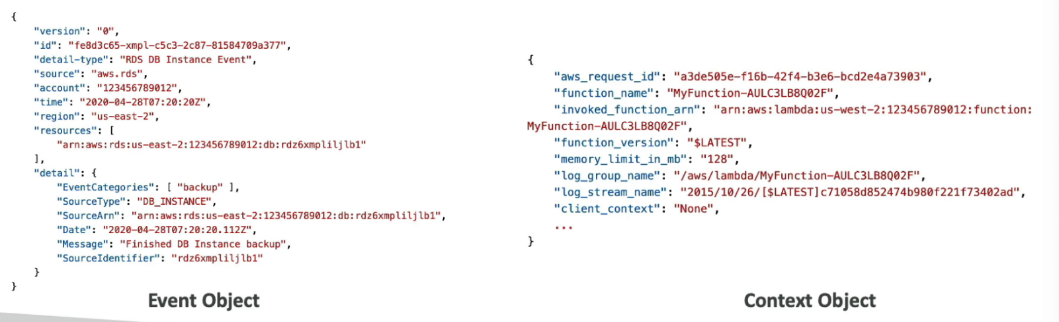

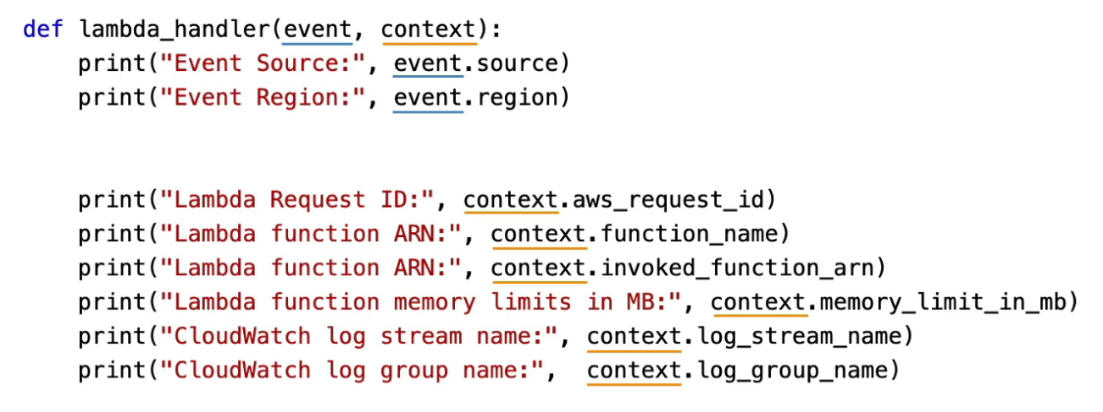

**Event Object**

* JSON formatted event (data for the function to process)
* Lambda runtime converts the event to an object based on the language (e.g. dict type in Python)

**Context Object**

* JSON document available to the function at runtime which provides metadata about the function, invocation and runtime environment
* Contains the name of log stream

**Destinations**

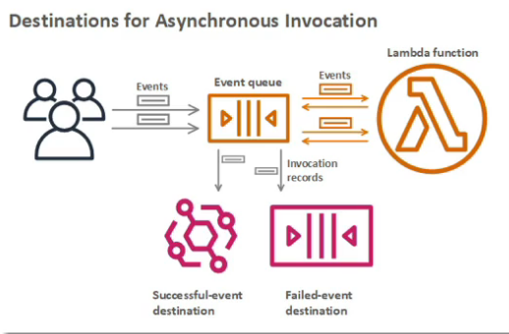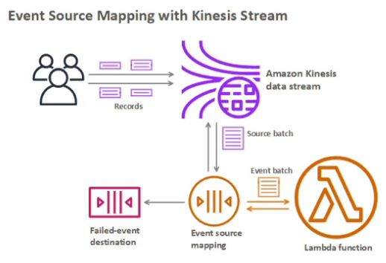

Configure the lambda function to send information regarding the invocations and results of **asynchronous invocations** or **synchronous invocations through event source mapping** (successful or failed) to a destination.

* Successful invocations are sent to destination immediately but failed invocations are retried before sending to the destination.
* Can send successful and failed invocations to different destinations.
* **Destination is recommended over DLQ** (as it supports more destinations)
* Destination for asynchronous invocations of Lambda function:
  + SQS
  + SNS
  + Lambda
  + Event bus
* Destination for discarded event batches in **Stream type Event Source Mapping**:
  + SQS
  + SNS

**Access Control**

**Lambda Execution Role**

* IAM role for Lambda functions
* Best practice: one execution role per function
* When using event source mapping, the Lambda function needs IAM permissions in the execution role to poll another service for events.
* Commonly used managed policies for Lambda:
  + AWSLambdaBasicExecutionRole - Send logs to CloudWatch.
  + AWSLambdaKinesisExecutionRole - Read from Kinesis
  + AWSLambdaDynamoDBExecutionRole - Read from DynamoDB Streams
  + AWSLambdaSQSQueueExecutionRole - Read from SQS queues
  + AWSLambdaVPCAccessExecutionRole - Deploy Lambda function in VPC
  + AWSXRayDaemonWriteAccess - Upload trace data to X-Ray

**Resource-based Policy**

* Used to allow other services to invoke the lambda function
* When a service like S3 triggers a lambda function, the resource-based policy for that lambda function gives it access.
* An IAM principal can access Lambda if the IAM policy attached to the principal authorizes it or the resource-based policy authorizes.

**Cross Account Access**

You can give a Lambda function created in one account ("account A") permissions to assume a role from another account ("account B") to access resources such as DynamoDB or S3 bucket. You need to create an execution role in Account A. Then you need to create a role in account B that the Lambda function in account A assumes to gain access to the cross-account DynamoDB table. Make sure that you modify the trust policy of the role in Account B to allow the execution role of Lambda to assume this role. Finally, update the Lambda function code to add the AssumeRole API call.

**🔑 What is Cross-Account Access in AWS Lambda?**

Cross-account access means allowing a Lambda function **in one AWS account (Account A)** to **access resources (like DynamoDB tables or S3 buckets) in another AWS account (Account B)**.

**🛠️ How Does It Work?**

Lambda runs with an **execution role** (an IAM role in Account A). But to access resources in Account B, the Lambda function needs to **temporarily assume a role** that exists in Account B with permissions to those resources.

**Step-by-step process:**

| **Step** | **What to do** | **Details** |
| --- | --- | --- |
| 1. | **Create an execution role in Account A** | This is the role your Lambda function uses by default to execute. It needs permissions to call **STS:AssumeRole** on Account B’s role. |
| 2. | **Create a role in Account B** | This role has the necessary permissions on the target resource (e.g., read/write access to DynamoDB or S3). |
| 3. | **Modify the trust policy of the Account B role** | The trust policy must allow the execution role from Account A to assume this role. Example trust policy snippet in Account B role: |

json

{

"Version": "2012-10-17",

"Statement": [{

"Effect": "Allow",

"Principal": {

"AWS": "arn:aws:iam::<AccountA_ID>:role/<AccountA_Lambda_ExecutionRole>"

},

"Action": "sts:AssumeRole"

}]

}

| 4. | **Update the Lambda function code in Account A** | Use the AWS SDK to call AssumeRole API, get temporary credentials, and use them to access Account B resources. |

**Why do this?**

* **Security best practice**: You don’t need to give permanent permissions across accounts.
* **Separation of concerns**: Each account manages its own resources securely.
* **Fine-grained access**: The cross-account role can have scoped permissions.

**Environment Variables**

* Environment variables (key-value pairs) for Lambda
* **No limit on the number of environment variables**
* **Max total size of all environment variables = 4 KB**
* Lambda adds some system environment variables by default
* Can be used to store parameters (config) and secrets (encrypt using Lambda key or CMK in KMS)
* **Lambda encrypts environment variables at rest by default.**
* **Encryption helpers:** encrypt environment variables client side, before sending them to Lambda. This enhances security further by preventing secrets from being displayed unencrypted in the Lambda console, or in function configuration.

**Observability**

**Logging & Monitoring**

* Lambda automatically sends logs to CW using AWSLambdaBasicExecutionRole policy
* Lambda automatically sends metrics to CW
  + Invocations, duration, concurrent execution
  + Error count, success rate, throttles
  + Async delivery failures
  + Iterator age (how much the lambda is lagging when reading from a stream)

**Tracing**

* Enable **Active Tracing** in Lambda configuration (runs X-Ray daemon)
* Instrument your code with X-Ray SDK
* Ensure Lambda function has AWSXRayDaemonWriteAccess policy (automatically added when Active Tracing is enabled)
* Environment variables used by the X-Ray SDK (automatically configured)
  + AWS_XRAY_DAEMON_ADDRESS: the X-Ray Daemon ip-address:port
  + _X_AMZN_TRACE_ID: contains the tracing header
  + AWS_XRAY_CONTEXT_MISSING: by default, LOG_ERROR

**Lambda@Edge**

* Run lambda function, written in **NodeJS or Python**, at edge locations by attaching them to CloudFront distributions
* Minimizes latency (globally available)
* Throughput: **thousands of requests/second**
* Can be used to modify Viewer and Origin Request and Response

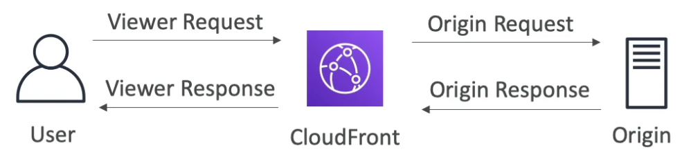

* Create functions in us-east-1 ⇒ CloudFront replicates to the edge locations

**Lambda@Edge vs CloudFront Functions**

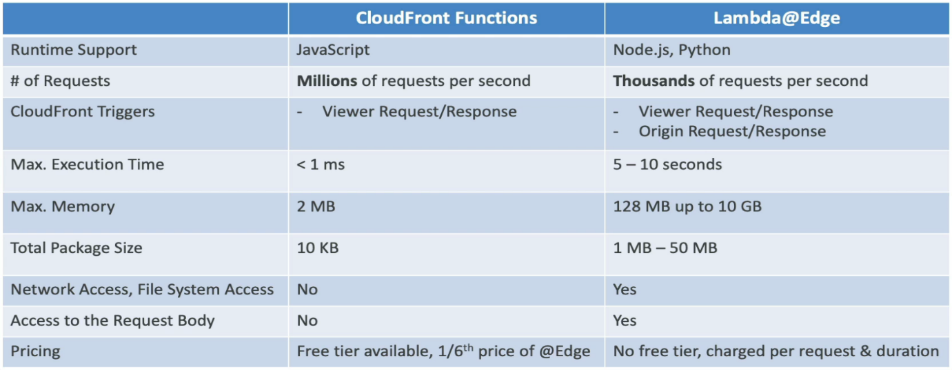

**📌 Lambda@Edge vs CloudFront Functions**

| **Feature** | **Lambda@Edge** | **CloudFront Functions** |
| --- | --- | --- |
| **Launch Year** | **2017** | **2021** |
| **Runtime Environment** | **Runs on AWS Lambda infrastructure** | **Runs on a lightweight, custom runtime at CloudFront edge locations** |
| **Use Cases** | **Complex request/response processing, headers manipulation, authentication, A/B testing, image optimization, etc.** | **Lightweight HTTP request/response manipulation, URL rewrites, redirects, header manipulation, access control** |
| **Execution Time Limit** | **Up to 5 seconds** | **Up to 1 millisecond** |
| **Supported Languages** | **Node.js or Python (Lambda runtimes)** | **JavaScript only (ECMAScript 5.1 syntax)** |
| **Invocation Points** | **Viewer Request, Viewer Response, Origin Request, Origin Response (4 event types)** | **Viewer Request, Viewer Response (2 event types)** |
| **Cost** | **More expensive (billed per invocation and duration)** | **Cheaper (billed per million requests)** |
| **Latency Impact** | **Higher latency due to full Lambda runtime startup** | **Minimal latency (faster cold start and execution)** |
| **Access to AWS Services** | **Full access via AWS SDK** | **No AWS SDK access, limited capabilities** |
| **Use for** | **Heavy logic, complex transformation, integration with other AWS services** | **Lightweight, simple logic at the edge** |

When to use what?

* Lambda@Edge  
  Use when you need complex logic, long execution time, or access to other AWS services (e.g., querying DynamoDB or calling APIs). Examples: Authentication, image resizing, advanced A/B testing.
* CloudFront Functions  
  Use for simple, ultra-low-latency tasks such as URL rewrites, header modifications, redirects, or simple request filtering directly at the edge.

**Networking**

* By default, Lambda functions are launched outside your VPC (in an AWS owned VPC). So, it cannot access resources within your VPC.
* To deploy a lambda in your VPC
  + Configure the VPC ID and Subnets
  + Create a **security group for the lambda function**
* Deploying a Lambda function within a VPC internally creates ENIs within the subnets configured, with the lambda security group attached to them. To create ENIs, Lambda function needs AWSLambdaENIManagementAccess policy (need to configure manually).
* A lambda function deployed in a public subnet of a VPC does not have internet access or a public IP.

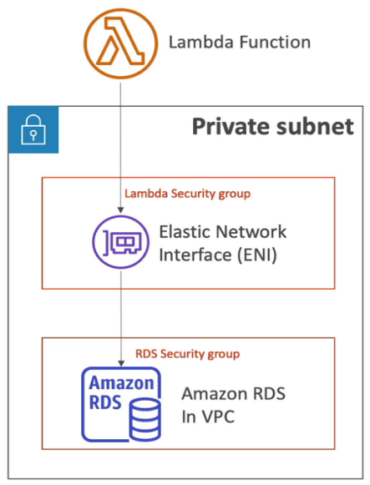 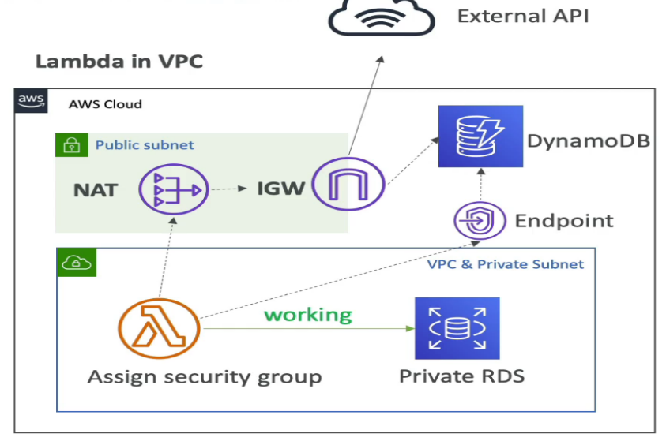

* To have internet access, deploy the lambda in a private subnet with a NAT gateway (in a public subnet). In this setting, AWS services outside the VPC can be accessed by the lambda function without traversing the public internet using VPC endpoints.

**💡 Irrespective of how Lambda is deployed, it will always be able to send logs to CloudWatch without any additional configuration.**

**Execution Context**

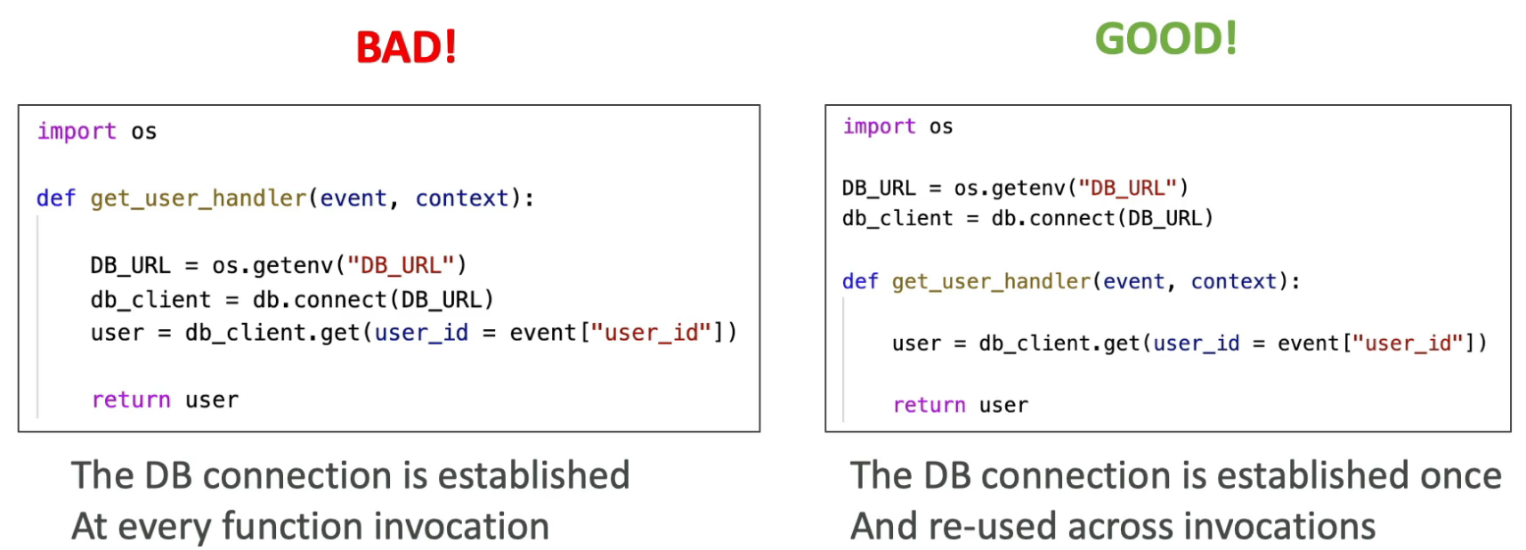

* Temporary runtime environment that runs the code outside of the Lambda handler
* Used to initialize external dependencies of the lambda handler
  + Create DB connections
  + Start web servers
  + Initialize SDKs
* Execution context is maintained as long as that instance of lambda function lives in anticipation of another invocation. If the same lambda instance (if it is still alive) is invoked again, it will reuse the execution context to save time.
* /tmp directory is included in the execution context
  + can be used as a transient cache across invocations
  + free up to 512 MB, max 10 GB
* **Best practice**: anything that takes time should be moved outside of the event handler (into execution context)

**Storage Options**

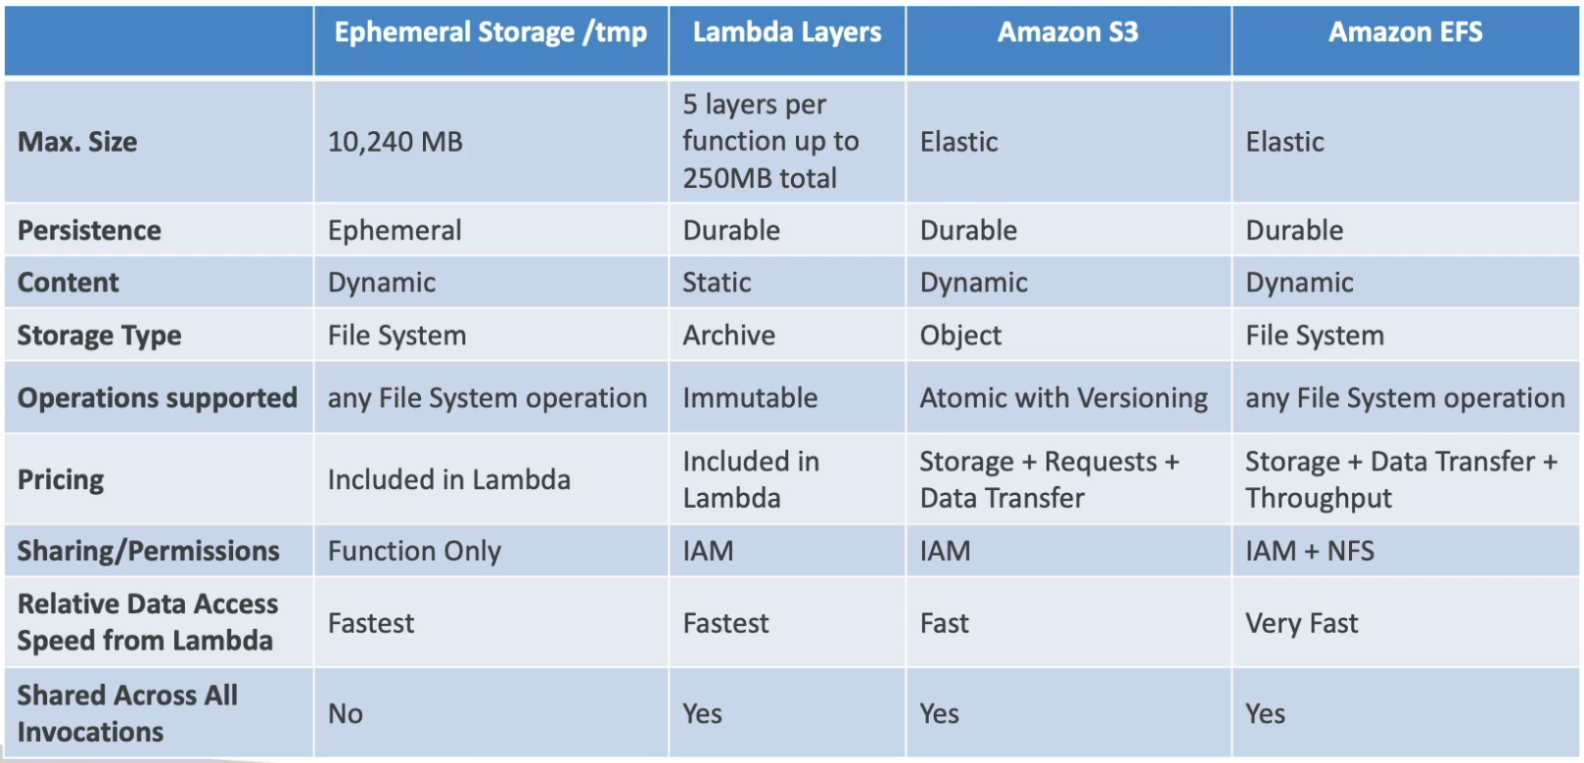

**EFS Mounting**

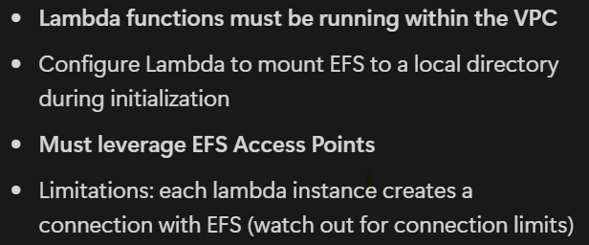 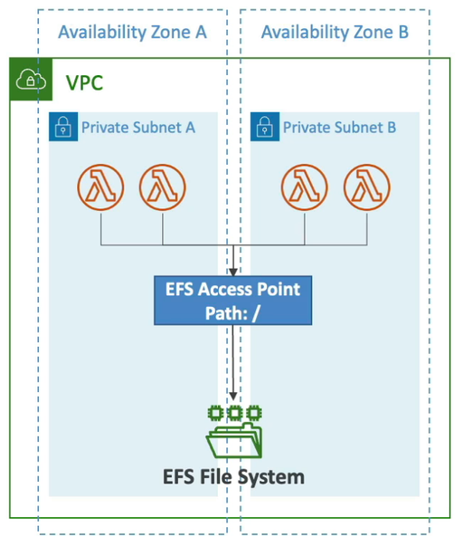

**EFS (Elastic File System)** is a **fully managed, scalable, shared file system** that can be mounted by multiple AWS services and compute instances.

* By **mounting an EFS file system to Lambda**, your function can:
  + **Read/write files persistently** (across invocations)
  + Share data between multiple Lambda functions or other AWS services
  + Handle large files or datasets that don’t fit in the Lambda /tmp storage (which is limited to 512 MB)

**How Does it Work?**

* You **configure your Lambda function** to connect to an existing EFS file system.
* The EFS file system is mounted into your Lambda’s execution environment at a specified **mount path** (e.g., /mnt/efs).
* Your Lambda function code can then access files just like on a normal filesystem.

**Key Points:**

| **Aspect** | **Details** |
| --- | --- |
| **EFS Type** | Network File System (NFS) |
| **Use case** | Persistent, shared, large-scale storage |
| **Lambda /tmp limit** | 512 MB (ephemeral storage) |
| **EFS storage size** | Virtually unlimited and persistent |
| **Performance** | Depends on throughput mode (bursting or provisioned) |
| **Setup Requirements** | - EFS in same VPC as Lambda - Mount targets in VPC subnets - Proper security group rules |

**Example Use Case:**

A Lambda function processes large media files or machine learning models stored on EFS, so it can load and save data beyond the ephemeral storage.

**How to Enable EFS Mounting in Lambda:**

1. **Create an EFS file system** in your AWS account.
2. **Create mount targets** in the same VPC subnets as your Lambda function.
3. **Attach security groups** that allow NFS traffic between Lambda and EFS.
4. In the Lambda console, under **File system**, configure the EFS file system and specify the **access point** and **local mount path**.
5. In your Lambda code, read/write files via the mount path.

***EFS Mounting in Lambda*** *allows your function to use a persistent, shared filesystem for data storage beyond Lambda’s temporary space — great for large files and sharing data between functions.*

**Concurrency**

* Concurrency soft limit across account: 1000 (can be raised by opening a support ticket)
* **Reserved concurrency**: concurrency hard limit for a lambda function
  + Recommended to reserve (limit) concurrency for every lambda function.
  + With unreserved concurrency, a function can throttle other functions.
  + To throttle a function, set its reserved concurrency to 0
* Each request over the concurrency limit will throttle
  + Synchronous invocation → return **ThrottleError 429**
  + Asynchronous invocation → retry (up to 6 hours) with exponential backoff (1 sec - 5 min)
* **Provisioned concurrency**: keep some lambda functions warm to prevent cold start
  + Specified number of lambda functions will be ready to serve requests at all times
  + **Application Auto Scaling** can control the provisioned concurrency on a schedule or based on a target metric.
* Required Concurrency = invocations_per_sec x avg_execution_time
* If the concurrency requirements are above the limit for the account, contact AWS to increase the quota.
* **Unreserved concurrency cannot go below 100**, so that functions that do not have reserved concurrency limits can still process requests. So, if your total account limit is 1000, you are limited to allocating 900 reserved concurrency to individual functions combined.

**⚙️ 1. Concurrency**

**🔹 What is it?**

**Concurrency** refers to the **number of Lambda function instances** running **at the same time** to handle incoming requests.

Each time a Lambda is invoked, AWS **allocates an instance** to run it. If many invocations happen at once, multiple instances run **concurrently**.

**✅ Example:**

If 100 events come in at once and your Lambda can scale, it can run **100 instances concurrently** (each handling one event).

**📊 Key Concepts:**

| **Term** | **Meaning** |
| --- | --- |
| **Unreserved concurrency** | The pool of concurrency available to all functions by default |
| **Reserved concurrency** | A concurrency limit **assigned to a specific function** |
| **Provisioned concurrency** | Keeps Lambda instances **pre-warmed** and ready to respond instantly |
| **Default quota** | 1,000 concurrent executions per Region (can be increased via support) |

**🚫 2. Throttling**

**🔹 What is it?**

**Throttling** happens when the **number of concurrent executions exceeds the allowed limit**.

When a function is throttled:

* New invocations are **rejected** with a 429 - TooManyRequestsException
* If using asynchronous or event source (like SQS), AWS **retries** automatically

**🧠 How throttling happens:**

| **Cause** | **Result** |
| --- | --- |
| Exceeding **account limit** (e.g. 1,000 concurrency) | Invocations are throttled |
| Exceeding **reserved concurrency** | Only that function is affected, others still run |

**Deployment**

**Packaging Dependencies**

* Code and dependencies need to be packaged into a zip file and uploaded directly to Lambda if less than 50 MB, otherwise upload to S3 and download to /tmp.
* Native libraries need to be compiled on Amazon Linux
* AWS SDK is installed by default on Lambda (no need to package it)

**Lambda Layers**

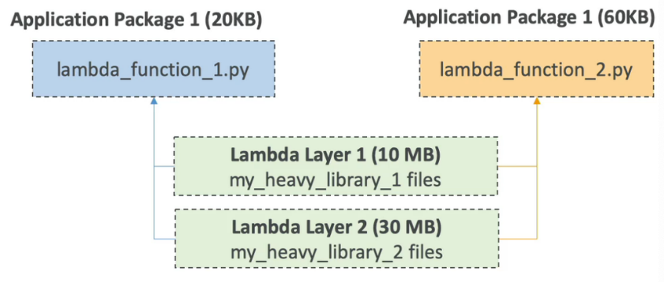

* Used to **separate dependencies from the application code** to reuse them
* Allow the application package to be small
* Lambda layers can be referenced by multiple functions
* Additional feature: **support custom runtimes** (allows Lambda functions to run any programming language)
* Up to 5 layers per function (max 250 MB total)

**Deployment with CloudFormation**

* Simple code (Python or NodeJS) **without dependencies** can be written directly in the CloudFormation template
* Reference the zip file stored in S3
  + S3ObjectVersion is required only if the bucket is versioned (recommended)
  + CloudFormation will only update (redeploy) the function if either S3Bucket , S3Key or S3ObjectVersion changes in the template.
* Deploy a lambda function in multiple AWS accounts

**Traffic-shifting with CodeDeploy**

* Automatically increases the percentage of traffic (x) going to the new version until 100%
* Integrated within the SAM framework
* **Pre & Post Traffic Hooks** to check the health of Lambda function after traffic shift. If something fails, CodeDeploy will rollback the deployment to the old version.

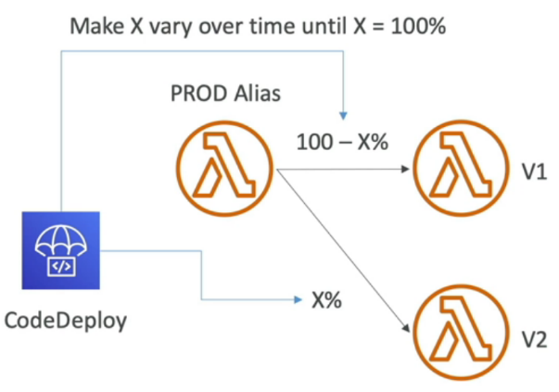

* Traffic-shifting strategies:
  + **AllAtOnce** - change to 100% immediately
  + **Linear** - grow traffic at regular intervals
    - Linear10PercentEvery3Minutes - increase traffic by 10% every 3 mins
  + **Canary** - try a small percentage, then 100%
    - Canary10Percent5Minutes - try 10% for 5 minutes
* AppSpec.yml can be used for deploying a new version of Lambda function
  + Name - name of the function
  + Alias - name of the alias that needs to be updated
  + CurrentVersion - current version
  + TargetVersion - new version

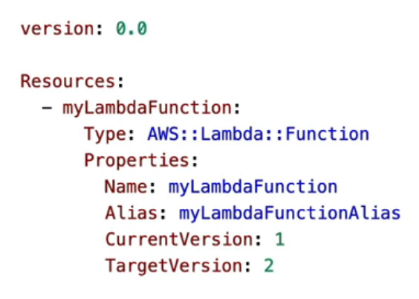

**Lambda Container Images**

* Docker images up to **10 GB** in size from ECR can be deployed on Lambda.
* Base image (in Dockerfile) must implement the **Lambda Runtime API**. Base images are available for **Python**, **NodeJS**, **Java**, **.NET**, **Go** and **Ruby**.
* We can create custom images, as long as they implement the Lambda Runtime API.
* Built container images can be tested locally using **Lambda Runtime Interface Emulator**
* Ease of shipping FaaS code as container images
* The lambda function and the ECR repo must be in the same AWS account.
* Best practices for building container images:
  + Use AWS-provided Base Images as they are stable and cached by Lambda service
  + Multi-Stage Builds: copy the built artifact and discard the build stage
  + Build from Stable to Frequently Changing layers as we go down the Dockerfile
  + Use a Single Repository for Functions with Large Layers (to take advantage of layer caching in Docker)

**Versions**

* When we work on a Lambda function we work on its unpublished version $LATEST (mutable) which always has the latest code and configuration.
* When we publish a Lambda function, we create an **immutable version** of the function. We cannot modify the code or configuration of a lambda version. We must create a new incremental version.
* Each version gets a unique ARN and is independents of other immutable versions and the $LATEST version.
* Old versions of the Lambda function can also be accessed.

**Aliases**

* **Pointers to Lambda function versions** (mutable)
* They provide a **stable endpoint** (does not keep changing with version)
* Multiple aliases can be created (eg. dev, test, prod), each pointing to a different version
* Canary deployment by assigning weights to different lambda versions for an alias
* **Aliases cannot reference other aliases**

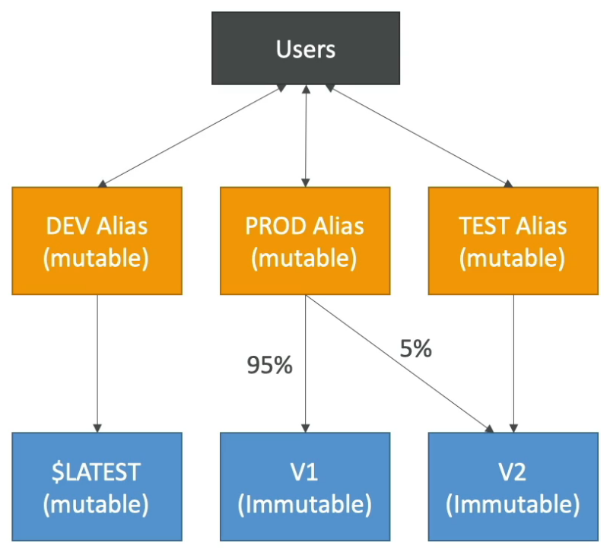

**Function URL**

* **HTTPS endpoints for Lambda functions** (without using an API gateway or ALB)
* Function URL can only be generated for $LATEST (unpublished function version) and aliases. **It cannot be generated for published function versions.**
* A unique **static URL** is generated for each alias or $LATEST which can only be accessed from public internet.

**Security**

* To access the URL from another domain, need to configure CORS
* **Resource-based policy -** control which accounts / CIDR / IAM principals can access the URL
  + Auth type: NONE - allow public and unauthenticated access
  + Auth type: AWS_IAM - use IAM to authenticate and authorize requests

**Profiling using CodeGuru**

* CodeGuru Profiler is integrated with Lambda to provide runtime performance
* Supported for Java and Python runtimes
* Just enable from the console
  + CodeGuru profiler is added to the function as a Lambda layer
  + Required environment variables are populated
  + AmazonCodeGuruProfilerAgentAccess policy is attached to the lambda function

**Step Functions**

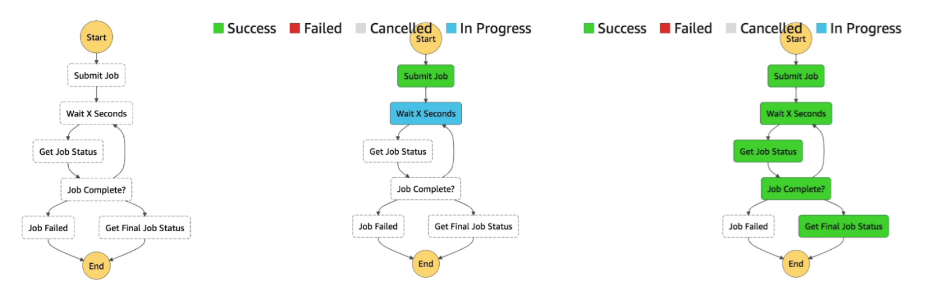

**Intro**

* **Serverless** workflow orchestration
* Model workflows as state machines (1 state machine per workflow)
* Written in JSON
* **Visual workflow execution**
* Execution event history shows the input and output of each step
* Step function has **amazing error handling capabilities** (can be offloaded from the application)

**Task**

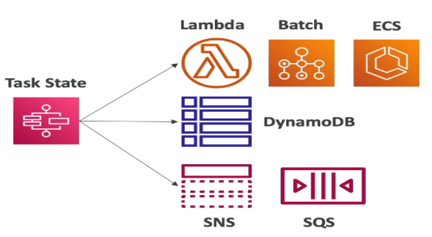

* Each task in the workflow could perform an action on an AWS service or launch another step function workflow.
* Task definition to invoke a Lambda function

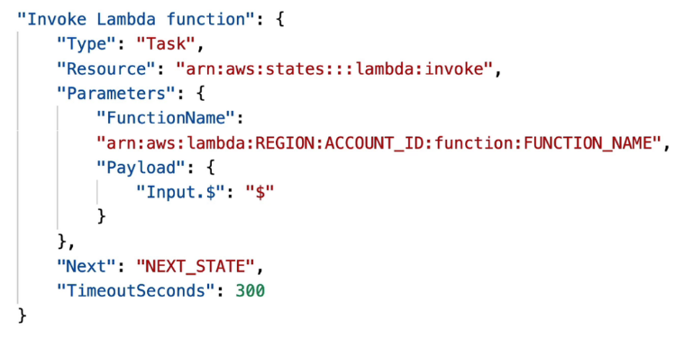

**States**

* **Choice State** - Test for a condition to send to a branch (or default branch)
* **Fail or Succeed State** - Stop execution with failure or success
* **Pass State** - Simply pass its input to its output or inject some fixed data
* **Wait State** - Provide a delay for a certain amount of time or until a specified time or date
* **Map State** - Dynamically iterate steps
* **Parallel State** - Begin parallel branches of execution (**asynchronous** execution)
* **Task State** - Run some code **synchronously**

**Error Handling**

* Handle errors in the state machine instead of the application code. This makes the application logic simpler. Also, step functions provide execution history.
* Predefined error codes:
  + States.ALL - any error
  + States.Timeout - task ran longer than TimeoutSeconds or no heartbeat received
  + States.TaskFailed - task execution failure
  + States.Permissions - insufficient privileges to execute code
* The state can also throw custom errors that can be caught in the step function (eg. a Lambda function throwing a custom error)

**Retry**

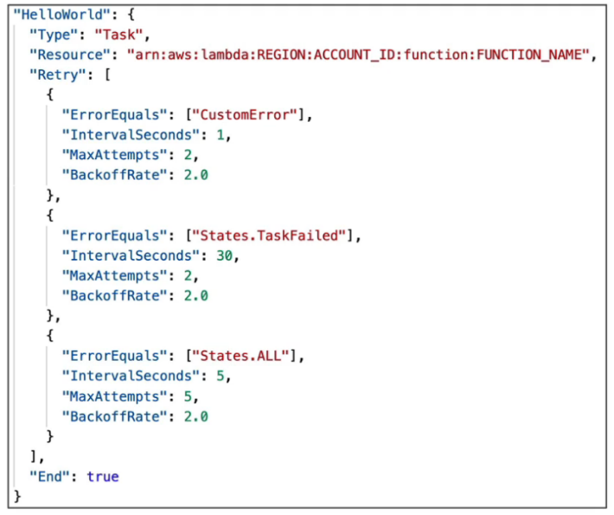

* Retry failed state
* Retry block is evaluated top to bottom
* BackoffRate - what factor the IntervalSeconds should be multiplied with at each retry
* When MaxAttempts are reached, the Catch block kicks in

**Catch**

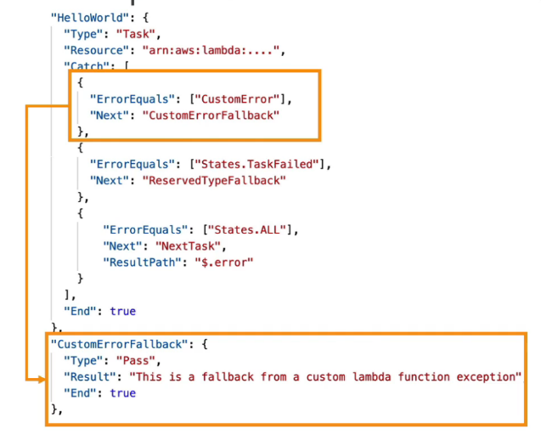

* Transition to failed path
* Catch block is evaluated top to bottom
* After all the retries have been exhausted, the state function goes into Catch
* If the error is of X type, go to the next state Y.
* ResultPath - a path that determines what input is sent to the state specified in the Next field. Example: it can be used to send the error to the Next state

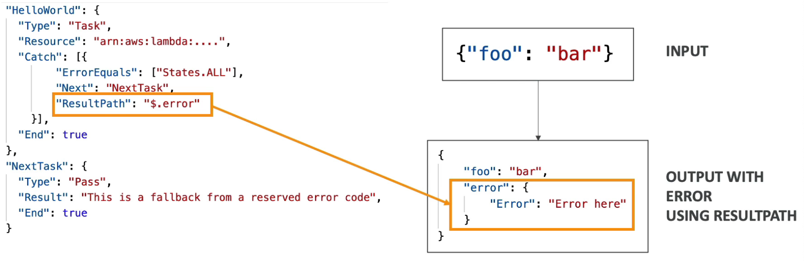

**Wait for Task Token**

* Used to integrate the workflow with an external task where the external task must finish the job before the workflow proceeds further.
* **Push-based** (the task pushes the work to the external application or worker which after completion invokes a callback API)
* The task is paused until it receives the callback (API call) with the TaskToken
* Append .waitForTaskToken to the Resource field to tell Step Functions to wait for the Task Token to be returned. Example: "Resource": "arn:aws:states:::sqs:sendMessage.waitForTaskToken"
* **Working**: The step function is paused during the Check Credit task execution, where we pass the TaskToken to the external application (push to SQS). After the external application is done processing, it makes a SendTaskSuccess API call with the result of processing and the passed TaskToken. This means the external task was executed successfully and the step function can continue execution. If the external application fails to process, it makes a SendTaskFailure API call which is treated as task failed.

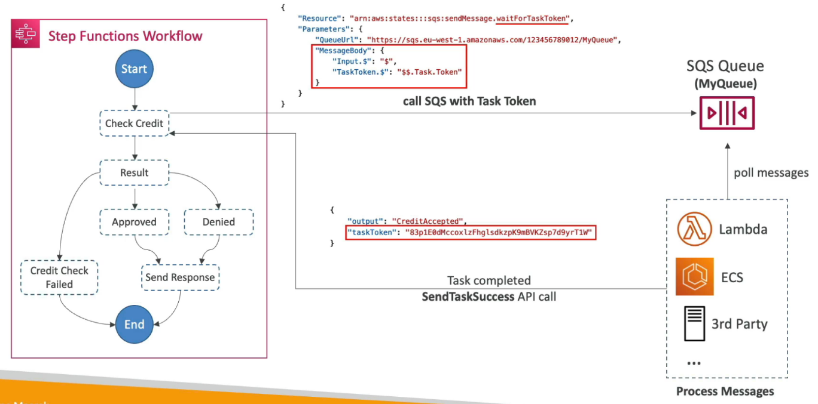

**Activity Tasks**

* **Activity Workers** (running on any compute resource) poll the workflow for tasks using GetActivityTask API.
* If an activity worker gets a task, it will complete it and send the response of success or failure as SendTaskSuccess or SendTaskFailure API call.
* **Pull-based** (tasks are pulled by the Activity Workers)
* TaskToken is used to identify which task got completed (same way as in Wait for Task Token)
* To keep the Task active:
  + Configure TimeoutSeconds on the step function - how long the task will wait for the activity worker to complete (max 1 year)
  + Send heartbeats periodically from the activity worker to the task using SendTaskHeartBeat at an interval less than HeartBeatSeconds parameter (set in the step function).

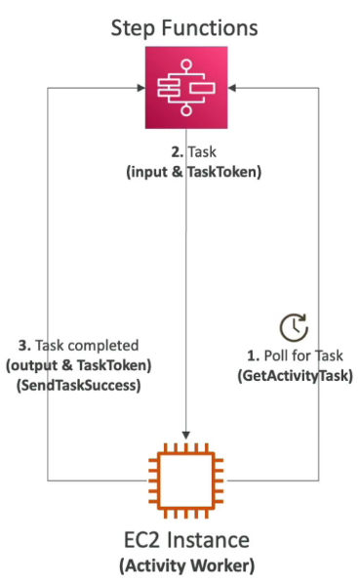

**Workflow Types**

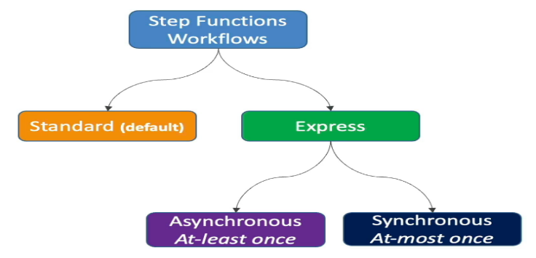

**Standard Workflows (default)**

* Max duration: 1 year
* Execution model: **Exactly-once Execution**
* Execution rate: Over 2,000 workflow executions per sec
* Execution history: **90 days in the console** (send to CloudWatch to retain for longer)
* Pricing: based on the number of state transitions
* Use cases: **Non-idempotent actions** (eg. payment processing)

**Express Workflows**

* Max duration: 5 min
* Execution rate: Over 100,000 workflow executions per sec
* Execution history: Not available in the console (must use CloudWatch)
* Use cases: IoT data ingestion, streaming data, backend for apps, etc.
* Types:
  + **Asynchronous** Express Workflows
    - Execution model: **At-least Once Execution** (the operation must be idempotent because there could be retries)
    - When the workflow is invoked, it just starts and doesn’t return the result of computation.
    - Use cases: where we don’t need immediate response (eg. messaging services)
  + **Synchronous** Express Workflows
    - Execution model: **At-most Once Execution**
    - When the workflow is invoked, it completes it and returns the response.
    - Can be invoked from **API Gateway** or **Lambda function**

**NETWORKING**

**VPC**

**Intro**

* **Regional resource**
* Soft limit of 5 VPCs per region
* Only the Private IPv4 ranges are allowed

**Subnets**

* Sub-ranges of IP addresses within the VPC
* **Each subnet is bound to an AZ**
* Subnets in a VPC cannot have overlapping CIDRs
* **Default VPC only has public subnets** (1 public subnet per AZ, no private subnet)
* **AWS reserves 5 IP addresses (first 4 & last 1) in each subnet**. These 5 IP addresses are not available for use. Example: if CIDR block 10.0.0.0/24, then reserved IP addresses are 10.0.0.0, 10.0.0.1, 10.0.0.2, 10.0.0.3 & 10.0.0.255

💡 To make the EC2 instances running in private subnets accessible on the internet, place them behind an internet-facing (running in public subnets) Elastic Load Balancer.

💡 There is no concept of Public and Private subnets. Public subnets are subnets that have:

* “Auto-assign public IPv4 address” set to “Yes”
* The subnet route table has an attached Internet Gateway

This allows the resources within the subnet to make requests that go to the public internet. **A subnet is private by default.**

Since the resources in a private subnet don't have public IPs, they need a NAT gateway for address translation to be able to make requests that go to the public internet. NAT gateway also prevents these private resources from being accessed from the internet.

**✅ What Can Be Asked About NAT Gateway in DVA-C02?**

**1. Basic Concept Understanding**

* 🔸 *What is a NAT Gateway used for?*
  + ✅ Allows instances in **private subnets** to access the **internet**
  + ❌ Does **not** allow inbound internet traffic

**2. Architecture & VPC Setup**

You may get **scenario-based questions**, like:

“An EC2 instance in a private subnet cannot access the internet. Which configuration is missing?”

✅ Correct answer may involve:

* No **route to NAT Gateway**
* NAT Gateway not in **public subnet**
* Missing **Elastic IP** on NAT Gateway

**3. Comparison Questions**

Expect comparisons like:

| **Feature** | **NAT Gateway** | **Internet Gateway** |
| --- | --- | --- |
| Direction | Outbound only (private to internet) | Bidirectional (public access) |
| Use case | For private subnet resources | For public subnet resources |

“Which VPC component allows resources in a **private subnet** to connect to the **internet**, but blocks inbound connections?”

✅ Answer: **NAT Gateway**

**4. Billing & Alternatives**

You may be asked about **cost-efficiency**:

“Which option offers the lowest cost for providing internet access to Lambda functions in private subnets?”

✅ Possible answer: **NAT Instance** (cheaper but not managed)  
🔁 NAT Gateway is **more reliable but costs more**

**5. Private vs Public Subnet Behavior**

“An EC2 instance has no public IP and is in a private subnet. How can you allow it to download software from the internet?”

✅ Correct setup:

* Instance in **private subnet**
* **Route to NAT Gateway**
* NAT Gateway in **public subnet**
* Public subnet has route to **Internet Gateway**

**📝 Key Exam Tips:**

| **Topic Area** | **Know This** |
| --- | --- |
| Use case | NAT GW = outbound internet from private subnets only |
| Subnet roles | NAT GW must be in **public subnet** |
| Routing | Private subnet must route 0.0.0.0/0 → NAT Gateway |
| Common mistakes | No Elastic IP, wrong subnet, no route |
| Cost consideration | NAT Gateway vs NAT Instance vs VPC endpoints |

**Internet Gateway (IGW)**

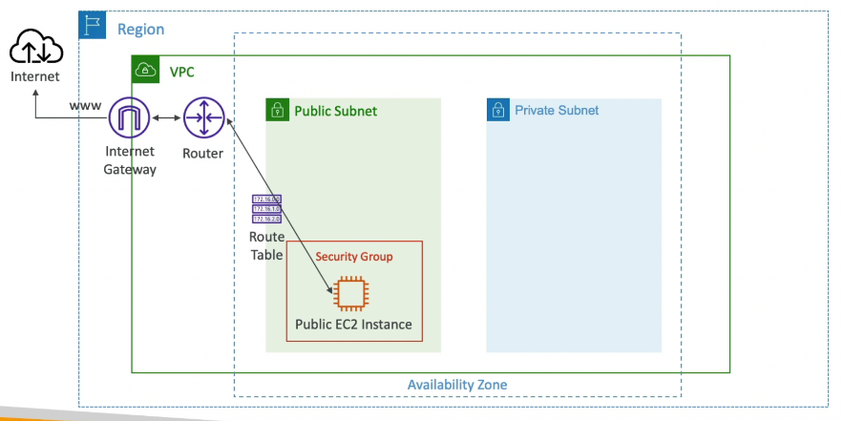

* Allows resources in a VPC to connect to the Internet

This means: An **Internet Gateway** is the component that lets your EC2 instances, containers, or other services **send traffic to** and **receive traffic from** the internet.

Without it, even if your instance has a public IP, it **can’t reach the internet** — there's no path.

Think of it as the **"door to the internet"** for your VPC.

* **Attached to the VPC** (not subnets)
* Should be used to **connect public resources to the internet** (use NAT gateway for private resources since they need network address translation)
* Route table of the public subnets must be edited to allow requests destined outside the VPC to be routed to the IGW

💡 IGW performs network address translation (NAT) for a public EC2 instance

When your **EC2 instance is in a public subnet**, has a **public IP**, and is connected to an **Internet Gateway (IGW)**, it can **send and receive internet traffic**. Here's how NAT plays a role:

**🔄 What actually happens:**

1. **Your EC2 instance has:**
   * A **private IP** (e.g., 10.0.1.10)
   * A **public IP** (e.g., 54.210.123.45), automatically assigned or manually attached
2. When the EC2 instance **sends traffic to the internet**:
   * It **originates** from its **private IP** (10.0.1.10)
   * The **Internet Gateway performs NAT** to replace the private IP with the **public IP** (54.210.123.45)
   * The external server **sees the public IP** and sends responses to it
3. The **IGW translates** the response from the internet **back to the private IP** of the instance

**🎯 Why this is NAT:**

* **NAT = Network Address Translation**
* It allows **private IP addresses** to communicate with the public internet by mapping them to a **public IP**

✅ In this case, the **IGW handles NAT for instances that have public IPs**, enabling **bidirectional communication**.

**🔍 NAT Summary:**

| **Context** | **NAT Role** |
| --- | --- |
| EC2 with public IP + IGW | IGW performs NAT (public ↔ private IP translation) |
| EC2 in private subnet | Needs a **NAT Gateway** (for **outbound-only** traffic) |
| No public IP, no NAT | No internet access unless behind NAT Gateway |

**🧠 Final Takeaway:**

When a **public EC2 instance** talks to the internet, the **IGW does the NAT work**, translating between the **private IP** (used inside the VPC) and the **public IP** (used on the internet).

**Network Address Translation (NAT) Instance**

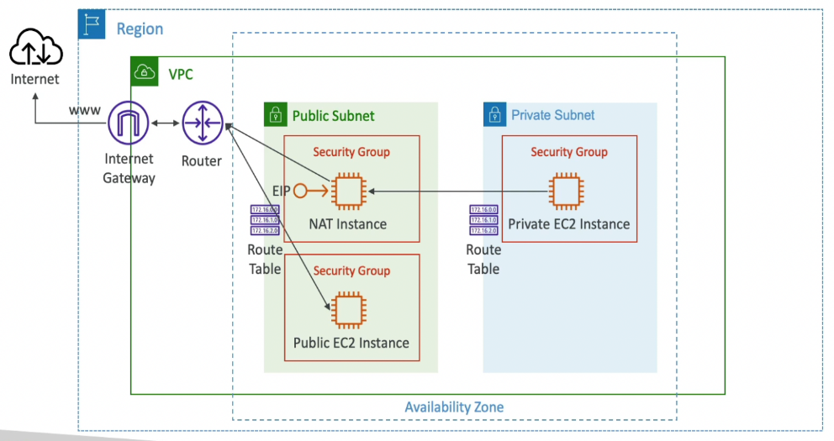 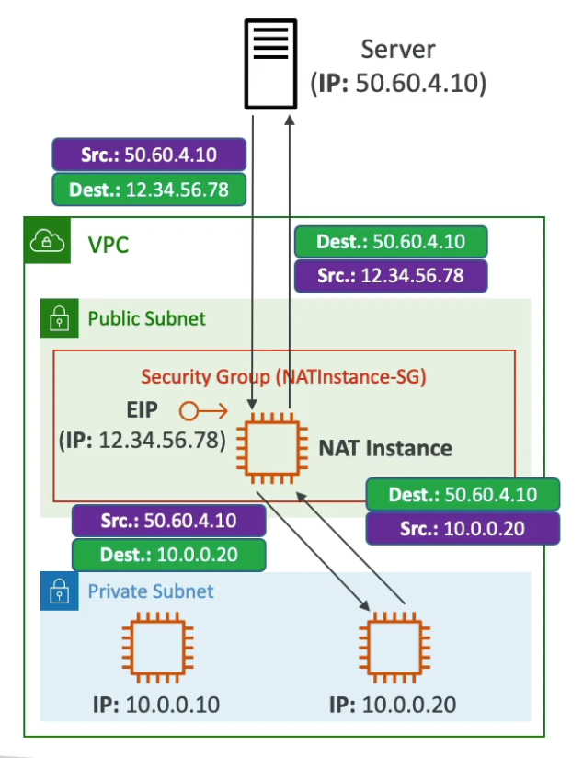

* A NAT instance is just a regular EC2 instance configured to act like a router.
* It sits in a public subnet (with internet access via an Internet Gateway).
* Private EC2 instances route their internet-bound traffic to the NAT instance.
* The NAT instance replaces their private IPs with its public IP, sends the request to the internet, and forwards the response back to the private instance.

**🎯 This is exactly like home routers that let multiple devices share one public IP to access the internet.**

**🛡️ It also blocks inbound traffic from the internet — so the private instances are safe from external attacks.**

**🔹Must disable EC2 setting: source / destination IP check on the NAT instance as the IPs can change.**

* By default, EC2 instances drop packets not addressed to their own IPs.
* A NAT instance forwards packets for other instances (i.e., it sends and receives traffic on behalf of private EC2s).
* So, you must disable the “source/destination check”, or the NAT instance will reject traffic it’s supposed to forward.

🔧 You can disable this in the EC2 console or via CLI:

**bash**

**aws ec2 modify-instance-attribute --instance-id i-1234567890abcdef0 --no-source-dest-check**

**🔹 Must have an Elastic IP attached to it**

* The NAT instance needs a public IP to reach the internet.
* You assign an Elastic IP (EIP) — a static public IP that doesn’t change across reboots or stop/start.
* This ensures consistent routing and makes it easier to manage firewall and route table settings.

**🔹 Route Tables for private subnets must be configured to route internet-destined traffic to the NAT instance (its elastic IP)**

* Private EC2 instances have no direct route to the Internet Gateway.
* Their route table should say:

**Destination: 0.0.0.0/0**

**Target: <NAT Instance ID or NAT Instance ENI>**

* **This sends all internet-bound traffic from private subnets to the NAT instance, which will then forward it out using its public IP.**

**🔹 5. Can be used as a Bastion Host**

* A Bastion Host is a secure jump server you use to connect to private instances via SSH.
* A NAT instance, since it's already in a public subnet with internet access, can also serve as a bastion if:
  + You allow inbound SSH (port 22) from a trusted IP (e.g., your office)
  + You use it to SSH into private instances inside the VPC

**🛑 Not always best practice to mix roles, but it's doable — especially in small/test environments.**

**✅** Summary Table:

| Concept | Explanation |
| --- | --- |
| NAT instance setup | EC2 in public subnet routes outbound internet for private subnets |
| Source/dest check | Must be disabled for NAT to work properly |
| Elastic IP | Needed so internet responses return correctly |
| Private subnet route table | Route 0.0.0.0/0 → NAT instance |
| Bastion host capability | Can also allow SSH into private EC2s |

**🧠 For DVA-C02 Exam:**

**You should know the difference between a NAT instance and NAT Gateway, and how to set up routing and security for private subnet internet access.**

| Feature | NAT Instance | NAT Gateway |
| --- | --- | --- |
| Type | EC2 instance manually configured for NAT | Fully managed AWS service |
| Scalability | Manual scaling required | Auto-scales up to 45 Gbps |
| Availability | Single-AZ unless manually replicated | Highly available within a single AZ |
| Maintenance | You manage OS updates, security patches | AWS handles all maintenance |
| Elastic IP | Must be manually attached | Assigned automatically at creation |
| Setup Complexity | Higher – requires manual route tables, source/dest check, etc. | Very simple setup |
| Security Group | Yes – supports EC2 security groups | No – uses NACLs only |
| Cost | Lower upfront, but more maintenance | Higher, but pay for simplicity and scale |
| Can be Bastion Host? | ✅ Yes | ❌ No |

For exams: NAT Gateway is preferred in production, NAT Instance might be used in lab/test environments.

**Disadvantages**

* Not highly available or resilient out of the box. Need to create an ASG in multi-AZ + resilient user-data script
* Internet traffic bandwidth depends on EC2 instance type
* You must manage Security Groups & rules:
  + Inbound:
    - Allow HTTP / HTTPS traffic coming from Private Subnets
    - Allow SSH from your home network (access is provided through Internet Gateway)
  + Outbound:
    - Allow HTTP / HTTPS traffic to the Internet

**NAT Gateway**

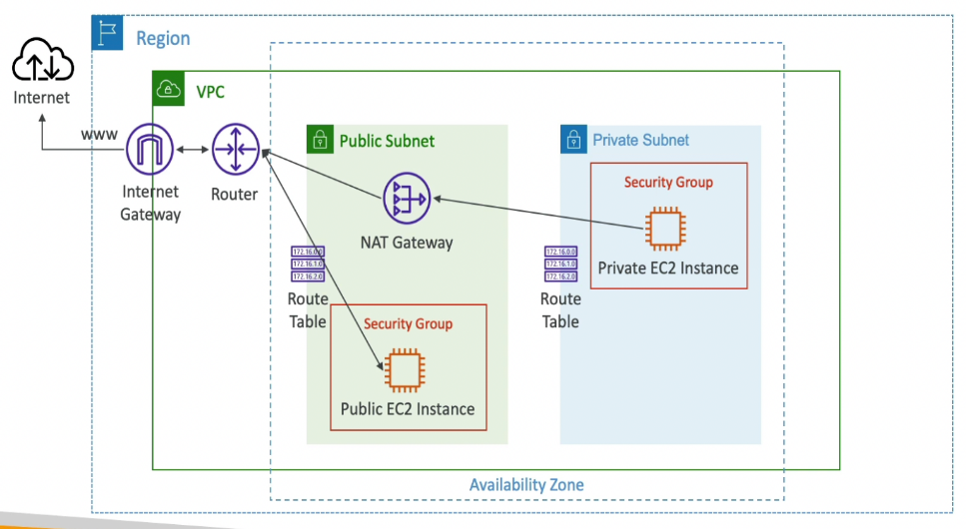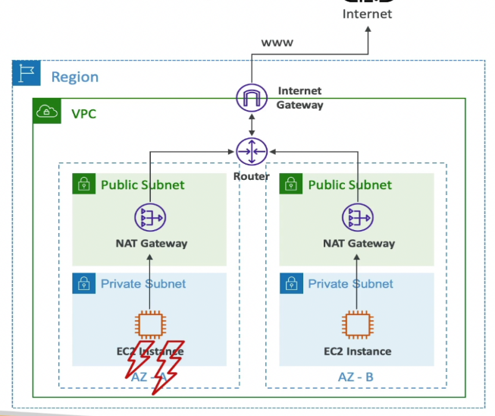

* AWS managed NAT with bandwidth autoscaling (up to 45Gbps)
* Preferred over NAT instances
* Uses an Elastic IP and Internet Gateway behind the scenes
* Created in a public subnet
* Bound to an AZ
* Cannot be used by EC2 instances in the same subnet (only from other subnets)
* Cannot be used as a Bastion Host
* Route Tables for private subnets must be configured to route internet-destined traffic to the NAT gateway
* No Security Groups to manage
* Pay per hour

**High Availability**

* Create NAT gateways in public subnets bound to different AZ all routing outbound connections to the IGW (attached to the VPC)
* No cross-AZ failover needed because if an AZ goes down, all of the instances in that AZ also go down.

**Network Access Control List (NACL)**

* NACL is a firewall at the subnet level
* One NACL per subnet but a NACL can be attached to multiple subnets
* **New subnets are assigned the Default NACL**
* **Default NACL allows all inbound & outbound requests**
* NACL Rules
  + Based only on IP addresses
  + Rules number: 1-32766 (lower number has higher precedence)
  + First rule match will drive the decision
  + The last rule denies the request (only when no previous rule matches)

**NACL vs Security Group**

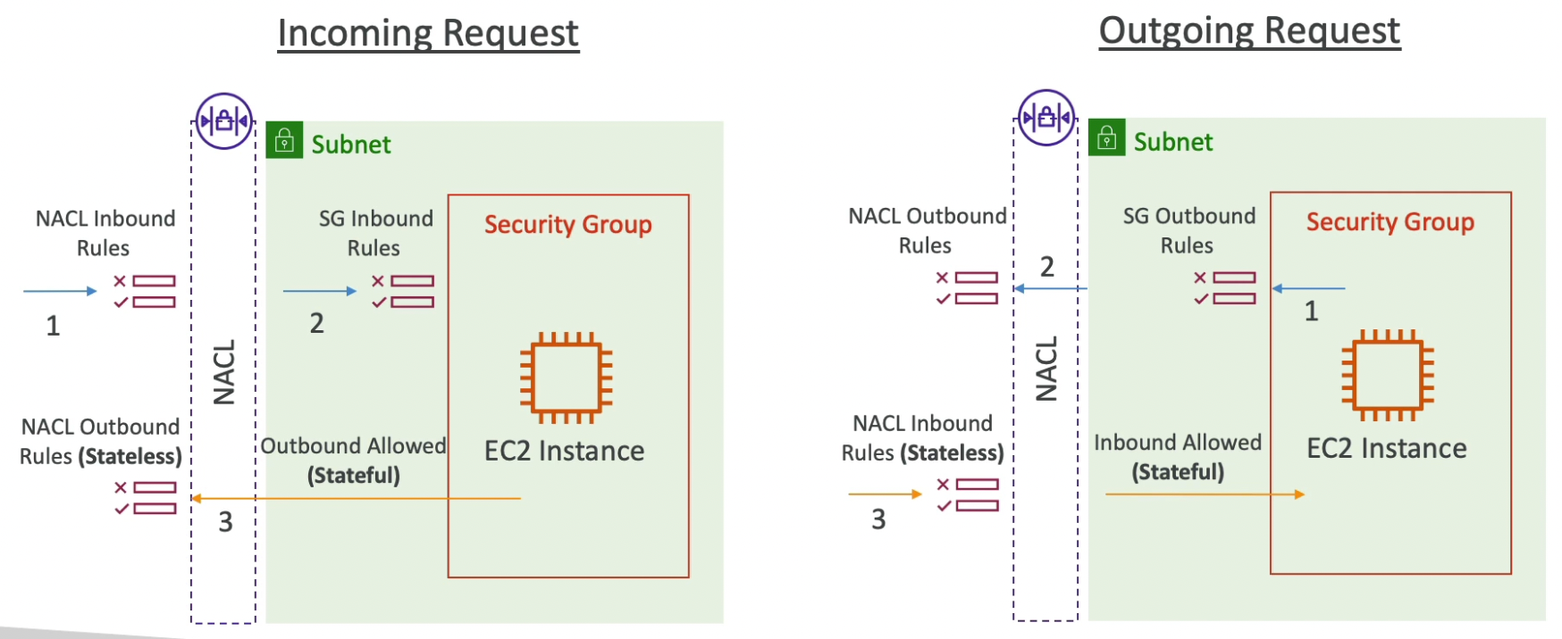

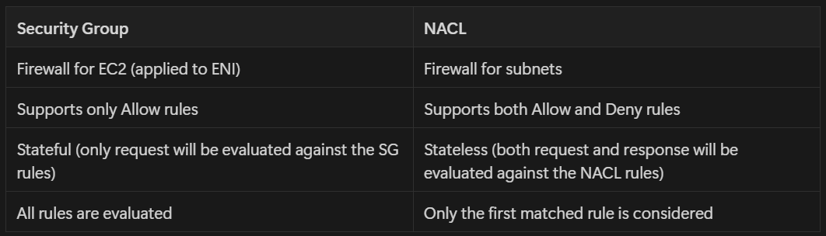

| **Feature** | **Security Group** | **Network ACL (NACL)** |
| --- | --- | --- |
| **Level of operation** | Instance-level (ENI) | Subnet-level |
| **Type** | **Stateful** — remembers traffic state | **Stateless** — does NOT remember traffic state |
| **Return traffic** | Allowed automatically | Must be explicitly allowed |
| **Default behavior** | Denies all **inbound**, allows all **outbound** | Allows all **inbound and outbound** |
| **Rules applied** | **Allow only** rules | **Allow and deny** rules |
| **Rule evaluation** | All rules are evaluated | Rules are evaluated in **number order** (lowest wins) |
| **Use case** | Control access to individual EC2, Lambda, RDS | Additional layer of control at subnet level |
| **Attached to** | Network Interface (ENI) | Subnet |
| **Number of rules** | Limited (~60 per group) | 20 per direction (default soft limit) |
| **Can block IPs?** | ❌ No (only allow) | ✅ Yes (can allow or deny specific IPs or ports) |
| **Common analogy** | Like a **firewall on the door of a server** | Like a **checkpoint at the subnet entrance** |

**🧠 Examples**

**✅ Security Group Example**

You allow:

* Inbound TCP 22 from your IP
* Outbound all

➡️ You can SSH into your EC2 instance, and responses go back automatically (stateful).

**✅ NACL Example**

You allow:

* Inbound HTTP (80)
* Outbound Ephemeral ports (1024–65535)

➡️ Responses are only allowed because you **explicitly permitted** the outbound return ports (stateless).

**🎯 When to Use Each**

| **Use Case** | **Use** |
| --- | --- |
| Controlling traffic **to/from individual instances** | ✅ Security Group |
| Adding **extra layer of subnet-level filtering** | ✅ NACL |
| Need to **block specific IPs or IP ranges** | ✅ NACL |
| Want **simpler management** with automatic return rules | ✅ Security Group |

**📝 Exam Tips for DVA-C02**

* **Security Groups are stateful, only allow rules** ✅
* **NACLs are stateless, allow and deny rules** ✅
* Return traffic in NACLs must be **explicitly allowed**
* SGs apply to **ENIs**, NACLs apply to **subnets**
* **Default NACL allows all** traffic in both directions
* **Custom NACLs** start by **denying everything**

**VPC Peering**

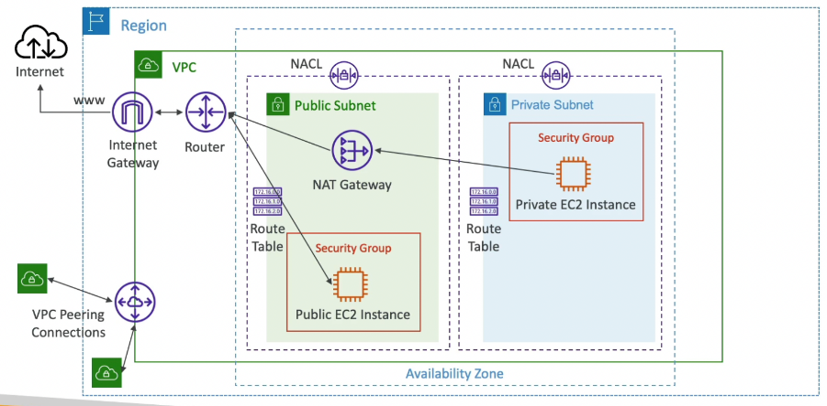

* Connect two VPCs (could be in different regions or accounts) using the AWS private network
* Participating VPCs must have non-overlapping CIDR
* VPC Peering connection is non-transitive (A - B, B - C != A - C) because it works based on route-table rules.
* Must update route tables in each VPC’s subnets to ensure requests destined to the peered VPC can be routed through the peering connection
* You can reference a security group in a peered VPC across account or region. This allows us to use SG instead of CIDR when configuring rules.

**VPC Endpoints**

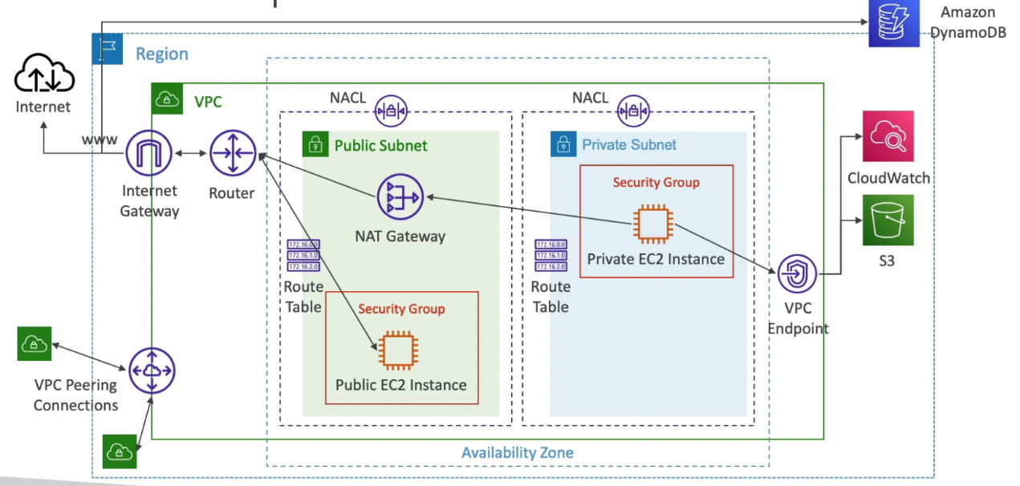

* **Private endpoints** within your VPC that allow AWS services to privately connect to resources within your VPC without traversing the public internet (cheaper)
* Powered by **AWS PrivateLink**
* **Route table is updated automatically**
* **Bound to a region** (do not support inter-region communication)
* Need to create separate endpoints for different resources
* Two types:
  + **Interface Endpoint**
    - Provisions an **ENI** (private IP) as an entry point per subnet
    - Need to **attach a security group to the interface endpoint** to control access
    - Supports most AWS services
  + **Gateway Endpoint**
    - Provisions a gateway
    - Must be used as a target in a route table
    - Supports only **S3** and **DynamoDB**

**VPC Flow Logs**

* Captures information about **IP traffic** going into your **interfaces**
* Three levels:
  + **VPC** Flow Logs
  + **Subnet** Flow Logs
  + **ENI** Flow Logs
* Can be configured to show accepted, rejected or all traffic
* Flow logs data can be sent to **S3** (bulk analytics) or **CloudWatch Logs** (near real-time decision making)
* Query VPC flow logs using **Athena** in S3 or **CloudWatch Logs Insights**

**Connecting to On-Premise**

* **Site-to-site VPN** - **IPSec encrypted** connection over the public internet
* **Direct Connect (DX)** - Dedicated connection
  + Not encrypted (but private connection)
  + Takes about 30 days to setup

**Route 53**

**Intro**

* Global Service
* AWS managed **Authoritative DNS** (customer can update the DNS records and have full control over the DNS)
* Also a Domain Registrar (for registering domain names)
* Only AWS service which provides 100% availability SLA (it will be **available all the time**, without any downtime)
* Affected by client's DNS caching (not suitable for Blue-Green Deployment if the client caches DNS queries)

**“Affected by client's DNS caching”** means:

When a DNS response (e.g., myapp.com → 192.0.2.10) is returned to a client (browser, app, etc.), it is often **cached locally**.

The **client stores** that DNS result for a certain **TTL (Time To Live)** — maybe 60 seconds, 5 minutes, or even longer.

**🔁 Why This Is a Problem in Blue/Green Deployments**

In **Blue/Green deployment**, you want to:

* Switch traffic from the **old (blue)** environment to the **new (green)** one
* Usually, this is done by changing the **DNS record** (e.g., update myapp.com to now point to the green environment)

🚨 **But if the client has cached the old DNS IP**, it:

* **Keeps sending traffic to the blue version**, even though DNS was updated
* Doesn't “see” the green version until cache expires
* This defeats the goal of an **instant cutover** or **gradual traffic shifting**

✅ **Blue/Green Deployment** is a deployment strategy that reduces **downtime** and **risk** by running two identical environments:

* **Blue = Current (live) environment**
* **Green = New version to be deployed**

Once the **green environment** is ready and tested, traffic is **switched** from **blue** to **green**, either all at once or gradually.

💡It is recommended to use DNS names or URLs instead of IPs wherever possible

**🧱 Main Functions of Route 53**

**1. 🧭 Domain Name Registration**

* You can **buy and manage domain names** (e.g., example.com) directly from AWS.

**2. 🌐 DNS Service**

* Translates **domain names** (e.g., myapp.com) to **IP addresses** (e.g., 192.0.2.1)
* Supports routing users to:
  + EC2 instances
  + Load balancers (ALB/NLB)
  + S3 buckets
  + CloudFront distributions

**3. ❤️ Health Checking**

* Can monitor endpoints (e.g., a web server)
* Routes traffic away from unhealthy resources

**🎯 DNS Record Types (for exam)**

| **Record Type** | **Purpose** |
| --- | --- |
| **A** | Maps domain to IPv4 address |
| **AAAA** | Maps domain to IPv6 address |
| **CNAME** | Maps one domain to another (alias) |
| **MX** | Mail exchange (for email servers) |
| **NS** | Nameserver delegation |
| **Alias** | AWS-specific — maps to AWS resources without using IPs (like S3, ELB, etc.) |

**🧠 Common Routing Policies (DVA-C02 relevant)**

| **Policy Type** | **Description** |
| --- | --- |
| **Simple** | One record = one IP or resource |
| **Weighted** | Split traffic based on weights (%) |
| **Latency-based** | Directs user to region with lowest latency |
| **Failover** | Routes to secondary if primary is unhealthy |
| **Geolocation** | Routes based on user’s location |
| **Geoproximity** | Routes based on user proximity to a region (used with Route 53 Traffic Flow) |
| **Multivalue Answer** | Returns multiple IPs with optional health checks |

**🛡️ Integration with AWS Services**

* Works tightly with:
  + **ELB (ALB/NLB)**
  + **CloudFront**
  + **S3 static websites**
  + **API Gateway**
  + **VPC endpoints (Private Hosted Zones)**

**📝 DVA-C02 Exam Tips:**

* Understand difference between **Alias** and **CNAME** records:
  + **Alias** records work with AWS resources and support **zone apex** (like example.com)
  + **CNAME** cannot be used at the root domain (e.g., example.com) — only for subdomains

**Alias vs CNAME Record – Key Differences**

| **Feature** | **Alias Record** | **CNAME Record** |
| --- | --- | --- |
| **AWS-specific?** | ✅ Yes – only in Route 53 | ❌ No – standard DNS feature |
| **Works at root domain?** | ✅ Yes – can be used at the **zone apex** (e.g., example.com) | ❌ No – can’t use at root domain (only subdomains) |
| **Targets** | AWS resources (e.g., S3, CloudFront, ELB, API Gateway) | Any domain name (e.g., example.net) |
| **Costs a DNS query?** | ❌ No – Alias queries to AWS resources are free | ✅ Yes – standard DNS query fees apply |
| **Can point to IP address?** | ✅ Yes (if AWS supports it) | ❌ No – only points to domain names |
| **Performance benefit?** | ✅ Faster for AWS services (resolves internally) | ❌ Normal DNS resolution |

**🧠 Use Case Examples**

**✅ Use Alias when:**

* You want to map **example.com → S3 website**, CloudFront, ELB, etc.
* You want to **avoid paying DNS query charges** for AWS targets
* You need to **use the root domain** (zone apex)

**✅ Use CNAME when:**

* You want to map **api.example.com → myapp.heroku.com**
* You don’t need to use the **root domain**
* You’re pointing to a **non-AWS external domain**

**📌 Key Rule for the Exam (DVA-C02):**

✅ **You can’t use a CNAME at the root domain (zone apex)**, but **you can use an Alias record** there.

* Know how Route 53 can be used for **failover** and **latency-based routing**
* You may see scenario questions like:

"How do you route traffic to the lowest-latency region automatically?"

✅ Use **Latency-based Routing**

**Hosted Zone**

* A container for DNS records that define how to route traffic to a domain and its subdomains.
* Hosted zone is queried to get the IP address from the hostname
* Two types:
  + **Public Hosted Zone**
    - resolves public domain names
    - can be queried by anyone on the internet
  + **Private Hosted Zone**
    - resolves private domain names
    - can only be queried from within the VPC

**Record Types**

* **A** - maps a hostname to IPv4
* **AAAA** - maps a hostname to IPv6
* **CNAME** - maps a hostname to another hostname
  + The target is a domain name which must have an A or AAAA record
  + **Cannot point to root domains (Zone Apex)** Ex: you can’t create a CNAME record for example.com, but you can create for something.example.com
* **NS** (Name Servers) - controls how traffic is routed for a domain
* **Alias** - maps a hostname to an AWS resource
  + **AWS proprietary**
  + Can point to root (zone apex) and non-root domains
  + **Alias Record is of type A or AAAA** (IPv4 / IPv6)
  + Targets can be
    - Elastic Load Balancers
    - CloudFront Distributions
    - API Gateway
    - Elastic Beanstalk environments
    - S3 Websites
    - VPC Interface Endpoints
    - Global Accelerator
    - Route 53 record in the same hosted zone
  + **Target cannot be EC2**

**Routing Policies**

**Simple**

* Route to one or more resources
* If multiple values are returned, client chooses one at random (client-side load balancing)
* **No health check** (if returning multiple resources, some of them might be unhealthy)

**Weighted**

* Route a fraction of request to multiple resources
* Health checks
* Use case: testing a new application version by sending a small amount of traffic
* Can be used for **Active-Active failover** strategy

**Latency-based**

* Redirect to the resource that has the lowest latency
* Health checks
* Can be used for **Active-Active failover** strategy

**Failover**

* Primary & Secondary Records (if the primary application is down, route to secondary application)
* Health check must be associated with the primary record
* Used for **Active-Passive failover** strategy

**Geolocation**

* Routing based on the client's location
* Should create a “Default” record (in case there’s no match on location)
* Use cases: restrict content distribution & language preference

**Geoproximity**

* Route traffic to your resources based on the proximity of clients to the resources
* Ability to shift more traffic to resources based on the defined bias.
  + To expand (bias: 1 to 99) → more traffic to the resource
  + To shrink (bias: -1 to-99) → less traffic to the resource
* Resources can be:
  + AWS resources (specify AWS region)
  + Non-AWS resources (specify Latitude and Longitude)
* Uses **Route 53 Traffic Flow**

**Multi-value**

* Route traffic to multiple resources (max 8)
* Health Checks (only healthy resources will be returned)

**Health Checks**

* HTTP Health Checks are only for public resources
* Allows for Automated DNS Failover
* Three types:
  + **Monitor an endpoint** (application or other AWS resource)
    - Multiple **global health checkers** check the endpoint health
    - Must configure the application firewall to allow incoming requests from the IPs of Route 53 Health Checkers
    - Supported protocols: HTTP, HTTPS and TCP
  + **Monitor other health checks** (Calculated Health Checks)
    - Combine the results of multiple Health Checks into one (AND, OR, NOT)
    - Specify how many of the health checks need to pass to make the parent pass
    - Usage: perform maintenance to your website without causing all health checks to fail
  + **Monitor CloudWatch Alarms** (to perform health check on private resources)
    - Route 53 health checkers are outside the VPC. They can’t access private endpoints in VPC or on-premises resources.
    - Create a CloudWatch Metric and associate a CloudWatch Alarm to it, then create a Health Check that checks the CW alarm.

**GoDaddy with Route 53**

**Use GoDaddy as registrar and Route 53 as DNS**: Once we register a hostname at GoDaddy, we need to update the name servers (NS) of GoDaddy to match the name servers of a public hosted zone created in Route 53. This way, GoDaddy will use Route 53’s DNS.

**DNS Resolution in Hybrid Cloud**

* To resolve DNS queries for resources in the VPC from the on-premises network, create an inbound endpoint on Route 53 Resolver and then DNS resolvers on the on-premises network can forward DNS queries to Route 53 Resolver via this endpoint.
* To resolve DNS queries for resources in the on-premises network from the VPC, create an outbound endpoint on Route 53 Resolver and then Route 53 Resolver can conditionally forward queries to resolvers on the on-premises network via this endpoint. To conditionally forward queries, create Resolver rules that specify the domain names for the DNS queries that you want to forward (such as [example.com](http://example.com/)) and the IP addresses of the DNS resolvers on the on-premises network that you want to forward the queries to.

**Misc**

* **Failure Threshold** is the parameter used by Route 53 health checks to determine if an endpoint is healthy. A failure occurs if an endpoint does not respond to a request.
* Route 53 can be used as a DNS to register a domain name, route the internet traffic, and perform health checks on resources. If being used for all three tasks, the order of setup must be sequential as above.

ELB

**Intro**

* Regional Service
* Supports Multi AZ
* Spread load across multiple EC2 instances
* Separate public traffic from private traffic
* Health checks allow ELB to know which instances are working properly (done on a port and a route, /health is common)
* **Does not support weighted routing**

**💡 Why ELB doesn’t support weighted routing:**

1. **ELB is regional and real-time**
   * It's meant to send traffic to healthy targets in **milliseconds**
   * It doesn't make DNS decisions or track “percentages” of requests
2. **Weighted routing is a DNS concept**
   * Weighted routing decisions happen **before** a request even reaches the ELB
   * This is the job of **Route 53**, which directs clients to different ELBs based on weights
3. **Responsibility Separation**
   * ELB = Fast in-region traffic balancer
   * Route 53 = Global traffic router / shaper

* If no targets are associated with the target groups ⇒ **503 Service Unavailable**

When your **Elastic Load Balancer (ELB)** has **no healthy instances (targets)** to send traffic to, it will return an **HTTP 503** error — meaning **Service Unavailable**.

* Targets are unreachable (possibly due to NACL or SG rules) ⇒ **504 Timeout Error**
* Using ALB & NLB, instances in peered VPCs can be used as targets using IP addresses.

**Types**

**Classic Load Balancer (CLB) - deprecated**

* **Load Balancing to a single application**
* Supports HTTP, HTTPS (layer 7) & TCP (layer 4)
* Health checks are HTTP or TCP based
* Provides a fixed hostname ([xxx.region.elb.amazonaws.com](http://xxx.region.elb.amazonaws.com))

**Application Load Balancer (ALB)**

* **Load balancing to multiple applications** (target groups) based on the request parameters
* Operates at Layer 7 (HTTP, HTTPS and WebSocket)
* Provides a fixed hostname ([xxx.region.elb.amazonaws.com](http://xxx.region.elb.amazonaws.com))
* ALB terminates the upstream connection and creates a new downstream connection to the targets
* **Security Groups can be attached to ALBs** to filters requests
* Great for micro services & container-based applications (Docker & ECS)
* Client info is passed in the request headers
  + Client IP ⇒ X-Forwarded-For
  + Client Port ⇒ X-Forwarded-Port
  + Protocol ⇒ X-Forwarded-Proto
* Target Groups
  + Health checks are done at the target group level
  + Target Groups could be
    - EC2 instances - HTTP
    - ECS tasks - HTTP
    - Lambda functions - HTTP request is translated into a JSON event
    - Private IP Addresses
* **Listener Rules** can be configured to route traffic to different target groups based on:
  + Path ([example.com/users](http://example.com/users) & [example.com/posts](http://example.com/posts))
  + Hostname ([one.example.com](http://one.example.com/) & [other.example.com](http://other.example.com/))
  + Query String ([example.com/users?id=123&order=false](http://example.com/users?id=123&order=false))
  + Request Headers
  + Source IP address
* Important Points
  + When the target type is IP, you can specify private IP addresses only.
  + If you specify targets using an instance ID, traffic is routed to instances using the primary private IP address specified in the primary network interface for the instance.
  + If you specify targets using IP addresses, you can route traffic to an instance using any private IP address from one or more network interfaces. This enables multiple applications on an instance to use the same port.

**Network Load Balancer (NLB)**

* Operates at Layer 4 (TCP, UDP)
* Can handle millions of request per seconds (extreme performance)
* **Lower latency** ~ 100 ms (vs 400 ms for ALB)
* **1 static public IP per AZ** (vs a static hostname for CLB & ALB)
* **Elastic IP can be assigned to NLB** (helpful for whitelisting specific IP)
* Maintains the same connection (TCP or UDP) from client all the way to the target application
* **No security groups can be attached to NLBs.** Since they operate on layer 4, they cannot see the data available at layer 7. They just forward the incoming traffic to the right target group as if those requests were directly coming from client. So, the **target instances must allow TCP traffic on port 80 from anywhere**.
* Within a target group, NLB can send traffic to
  + **EC2 instances**
    - If you specify targets using an instance ID, traffic is routed to instances using the **primary private IP address**
  + **IP addresses**
    - Used when you want to balance load for a physical server having a static IP.
  + **Application Load Balancer (ALB)**
    - Used when you want a static IP provided by an NLB but also want to use the features provided by ALB at the application layer.

**Gateway Load Balancer (GWLB)**

* Operates at layer 3 (Network layer) - IP Protocol
* Used to route requests to a fleet of 3rd party virtual appliances like Firewalls, Intrusion Detection and Prevention Systems (IDPS), etc.
* Performs two functions:
  + **Transparent Network Gateway** (single entry/exit for all traffic)
  + Load Balancer (distributes traffic to virtual appliances)
* Uses GENEVE protocol
* Target groups for GWLB could be
  + EC2 instances
  + IP addresses

**🔄 AWS Load Balancer Comparison: ALB vs. NLB vs. GWLB**

| **Feature** | **ALB (Application LB)** | **NLB (Network LB)** | **GWLB (Gateway LB)** |
| --- | --- | --- | --- |
| **Layer (OSI Model)** | Layer 7 (Application) | Layer 4 (Transport - TCP/UDP) | Layer 3/4 (Network/Transport) |
| **Use Case** | HTTP/HTTPS apps | TCP/UDP traffic, high performance | Deploy **security appliances** (firewalls, IDS/IPS) |
| **Protocols Supported** | HTTP, HTTPS, gRPC | TCP, UDP, TLS | All IP traffic (encapsulated via GENEVE) |
| **Content-based Routing** | ✅ Yes (e.g., path-based, host-based) | ❌ No | ❌ No |
| **IP-Based Target Support** | ✅ Yes | ✅ Yes | ✅ Yes |
| **TLS Termination** | ✅ Yes | ✅ Yes | ❌ No (does not inspect traffic) |
| **WebSockets Support** | ✅ Yes | ✅ Yes | ❌ N/A |
| **Sticky Sessions (Session Affinity)** | ✅ Yes (via cookies) | ✅ Yes (based on source IP) | ❌ No |
| **Target Types** | Instance, IP, Lambda | Instance, IP | IP only |
| **Cross-Zone Load Balancing** | ✅ Enabled by default | ✅ Optional | ✅ Optional |
| **Health Checks** | HTTP/HTTPS | TCP/HTTP/HTTPS | GENEVE-based |
| **Pricing Model** | Per LCU (Load Balancer Capacity Unit) | Per NCU (Network Capacity Unit) | Per hour + data processed |
| **Best For** | Web applications, microservices | High-performance/low-latency systems | Centralizing and scaling security appliances |

**🧠 When to Use Which?**

| **Use Case** | **Best Load Balancer** |
| --- | --- |
| Web applications (Layer 7) | **ALB** |
| Gaming, VoIP, low-latency TCP/UDP | **NLB** |
| Firewall or third-party virtual appliance insertion | **GWLB** |
| Routing based on URL path or hostname | **ALB** |
| Millions of requests/sec with low latency | **NLB** |
| Transparent traffic inspection/mirroring | **GWLB** |

**🔐 Security Differences**

* **ALB** supports WAF integration (Web Application Firewall)
* **NLB** does not support WAF
* **GWLB** is designed for routing through **3rd-party security appliances**

**✅ DVA-C02 Exam Tips**

* ALB is the **only load balancer** that supports **Lambda targets**
* ALB is the **only one with content-based routing**
* NLB is used for **TCP/UDP at scale**, with **static IP support**
* GWLB is **not for general traffic distribution** — it's for **traffic inspection**

**🔍 1. Content-Based Routing**

**✅ Definition:**

**Content-based routing** means the load balancer makes routing decisions **based on the content of the HTTP request**, such as the **URL path**, **host header**, **query string**, or **HTTP headers**.

**💡 Example:**

Imagine you have two microservices:

* /api/users handled by **Service A**
* /api/orders handled by **Service B**

With content-based routing on an **ALB**, you can route:

* Requests to example.com/api/users → **Target Group A**
* Requests to example.com/api/orders → **Target Group B**

📌 ALB supports routing rules like:

* Path-based: /images/* → image service
* Host-based: admin.example.com → admin service
* Header-based: User-Agent: mobile → mobile site

**🚀 Benefits:**

* Deploy multiple services under one domain
* Useful for **microservices and container-based** architectures
* Reduces need for multiple load balancers

**🔐 2. TLS Termination (a.k.a. SSL Termination)**

**✅ Definition:**

**TLS termination** means the load balancer **decrypts incoming encrypted HTTPS traffic**, and then forwards it as plain HTTP to the backend.

**🔐 How it works:**

1. **Client sends HTTPS** request to ALB
2. **ALB decrypts** it using a TLS certificate (stored in ACM)
3. ALB forwards the **HTTP request** to the backend target

**🔁 Optional Setup:**

If you want **end-to-end encryption**, you can:

* Re-encrypt the request at ALB
* Use **TLS passthrough** (supported by **NLB**, not ALB)

**🚀 Benefits of TLS Termination:**

* **Offloads decryption** work from EC2 targets (saves CPU)
* Simplifies certificate management (managed at the ALB level)
* Enables **content-based routing** (since request is decrypted)

**🧠 Summary Table**

| **Feature** | **Content-Based Routing** | **TLS Termination** |
| --- | --- | --- |
| Supported by | ALB only | ALB & NLB |
| Uses | Route based on path, host, etc. | Decrypt HTTPS traffic at ALB |
| Main Benefit | Intelligent traffic routing | Reduce backend CPU usage |
| Example | /api/products → Service A | HTTPS → decrypted → HTTP |

**Sticky Sessions (Session Affinity)**

* Requests coming from a client is always redirected to the same instance based on a cookie. After the cookie expires, the requests coming from the same user might be redirected to another instance.
* **Only supported by CLB & ALB** because the cookie can be seen at layer 7
* Used to ensure the user doesn’t lose his session data, like login or cart info, while navigating between web pages.
* **Stickiness may cause load imbalance**
* Cookies could be
  + **Application-based** (TTL defined by the application)
  + **Load Balancer generated** (TTL defined by the load balancer)
* ELB reserved cookie names (should not be used)
  + AWSALB
  + AWSALBAPP
  + AWSALBTG

**Cross-zone Load Balancing**

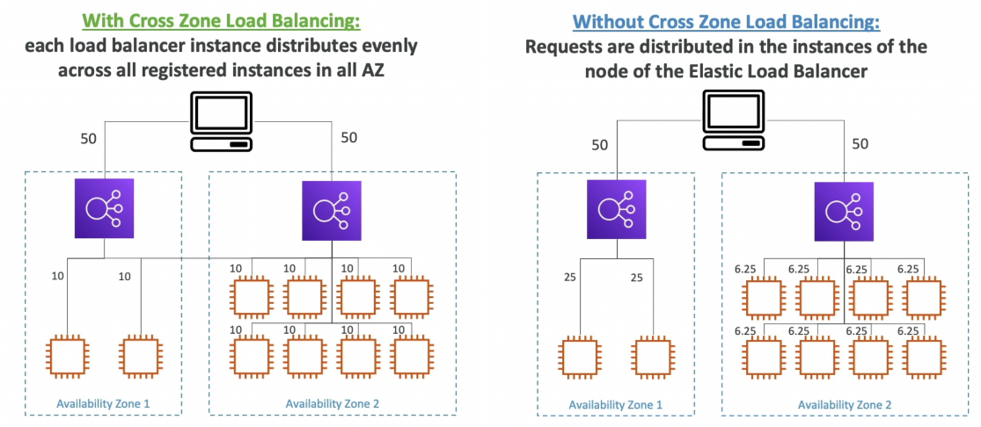

* Allows ELBs in different AZ containing unbalanced number of instances to distribute the traffic evenly across all instances in all the AZ registered under a load balancer.
* Supported Load Balancers
  + Classic Load Balancer
    - Disabled by default
    - No charges for inter AZ data
  + Application Load Balancer
    - Always on (can’t be disabled)
    - No charges for inter AZ data
  + Network Load Balancer
    - Disabled by default
    - Charges for inter AZ data

**In-flight Encryption (SSL Certificates)**

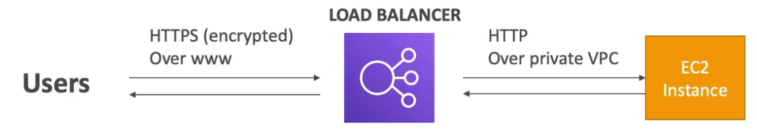

* Use an **NLB with a TCP listener** & terminate SSL on EC2 instances
* Use an **ALB with an HTTPS listener**, install SSL certificates on the ALB & terminate SSL on the ALB
* Communication between ALB & EC2 instances can happen over HTTP inside the VPC
* **Server Name Indication (SNI)**
  + SNI allows us to load multiple SSL certificates on one Load Balancer to serve multiple websites securely
  + **Only works for ALB & NLB** (CLB only supports one SSL certificate)
  + Newer protocol, not every client supports it yet
  + **Supported in CloudFront** also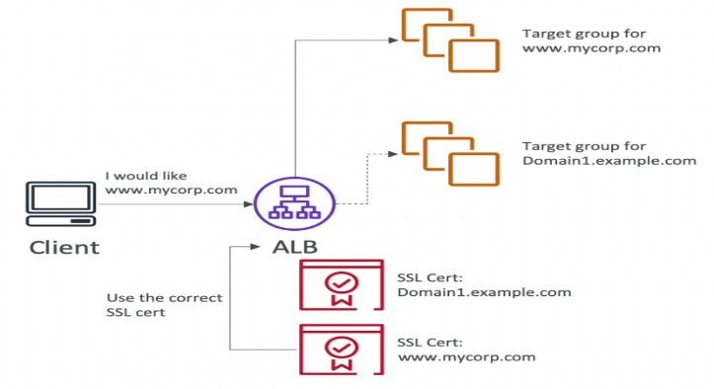

**Connection Draining (De-registration Delay)**

* When an instance is to be de-registered from the ELB, the in-flight requests being served by that instance are given some pre-defined time to complete before the ELB de-registers it.
* ELB stops sending new requests to the EC2 instance which is de-registering
* Set manually (0 to 3600 seconds) (**default: 300 seconds**)

💡 For instances behind an ELB and using ASG, increase the de-registration delay to ensure that the in-flight requests are completed before the ELB deregisters an instance which is to be terminated by the ASG.

When you're using:

* **ELB (Elastic Load Balancer)** to distribute traffic across EC2 instances, and
* **ASG (Auto Scaling Group)** to automatically add/remove EC2 instances,

…you might run into a problem where:

**💥 The ASG tries to terminate an instance while it’s still handling requests.**

This can cause:

* **Client errors**, if the instance is killed before it finishes responding
* **Dropped traffic** or half-loaded web pages

**🧠 Solution: Use Deregistration Delay**

**🔧 Deregistration Delay (in ELB Target Group settings):**

This tells the **ELB (Elastic Load Balancer)** to **wait before removing an EC2 instance** after it's marked for termination by the **ASG (Auto Scaling Group)**.

It gives the instance time to finish "in-flight" requests (active connections) before being shut down.

**Access Logs**

* Captures detailed information about requests sent to the load balancer
* Used to analyze traffic patterns and troubleshoot issues
* Disabled by default

**Security Groups for a public facing ELB**

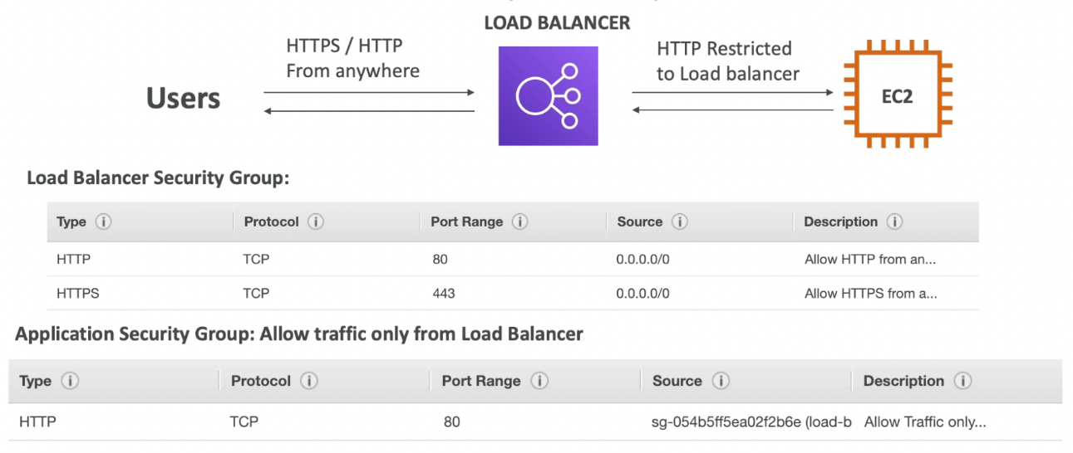

ELB will be publicly available on the internet, so it’s security group should allow HTTP and HTTPS traffic from anywhere. EC2 should only allow traffic from the ELB, so the its security group should allow HTTP requests from ELB’s security group.

**API Gateway**

**Intro**

* Serverless REST APIs with **TLS termination** (all of the APIs created with API Gateway expose **HTTPS** endpoints only)
* API versioning
* Multiple environment (dev, test, prod)
* Request throttling
* Authentication and Authorization
* Supports API keys
* Supports **WebSocket**
* Cache API responses
* Generate SDK and API specifications
* Swagger / OpenAPI config supported (import or export)
* Transform and validate requests and responses
* Firewall can be implemented using Web Application Firewall (WAF)

**Integration**

**Integration Types**

* MOCK - API gateway returns a mock (hardcoded) response (useful in development)
* AWS_PROXY (Lambda Proxy)
  + Incoming request from the client is **proxied to the lambda function** as a JSON event (request specific params like status code is automatically handled by API gateway)
  + Used to create serverless REST APIs
  + **Cannot modify the request & response in API gateway** (no mapping template)
  + The entire processing of request happens in the Lambda function

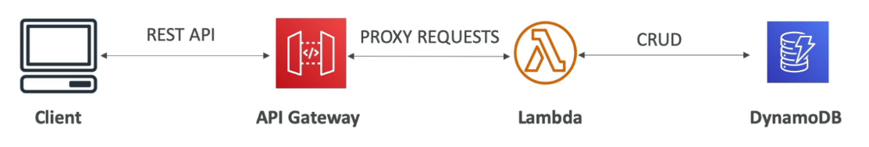

* AWS
  + To integrate with AWS resources or a Lambda function (custom integration)
  + Can modify integration requests and responses using **mapping templates**
* HTTP_PROXY
  + Incoming request is proxied to any HTTP backend
  + **Request & response cannot be modified** (no mapping template)
  + Option to add HTTP headers in the request (eg. API key)

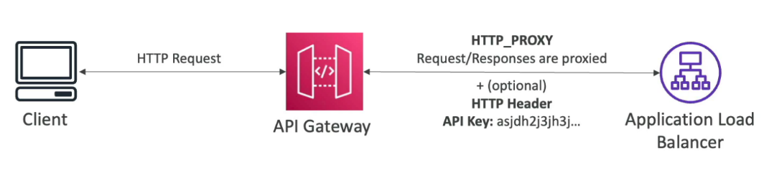

* HTTP
  + To integrate with any HTTP endpoint
  + Can modify integration requests and responses using **mapping templates**

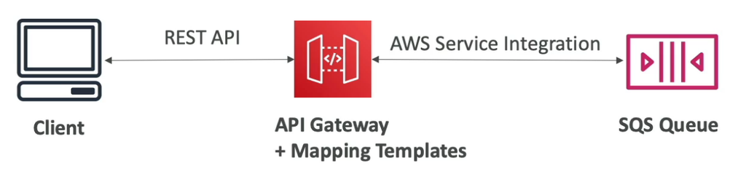

**Mapping Templates**

* Used to modify requests and responses
  + Modify query string parameters
  + Modify body content
  + Add headers
* Uses **Velocity Template Language (VTL)**
* Content-Type must be application/json or application/xml
* Example: Exposing a SOAP backend as a REST API

Use mapping template to convert requests and responses between JSON and XML.

**Endpoint Types**

* **Edge-Optimized** (default)
  + For global clients
  + Requests are routed through the CloudFront edge locations (improves latency)
  + The API Gateway lives in only one region but it is accessible efficiently through edge locations
* **Regional**
  + For clients within the same region
  + Could manually combine with your own CloudFront distribution for global deployment (this way you will have more control over the caching strategies and the distribution)
* **Private**
  + Can only be accessed within your VPC using an **Interface VPC endpoint** (ENI)
  + Use resource policy to define access

**Deployments**

* Deploy the API to get the API Gateway endpoint
* If you make changes to the API, a new version is internally created. You need to deploy the API for the changes to take effect.
* **Versions (changes) are deployed to stages** (no limit on the number of stages)
* Metrics and logs are separate for each stage
* Each stage has independent configuration and can be rolled back to any version (the whole history of deployments to a stage is kept)
* Handling breaking changes using multiple stages

We want to create a new version of the application which involves breaking changes at the API level. In this case, we can deploy a new stage (v2) and build our new application there. Since multiple stages can co-exist, we can have both the versions working and once all the users have migrated to v2, we can bring down v1.

**Stage Variables**

* Environment variables for API gateway
* Can be changed without redeploying the API
* Stage variables are passed to **context** object in lambda functions
* Format to access stage variables in API gateway - ${stageVariables.variableName}
* Example: Stage variables to point to Lambda Aliases

Stage variables can be used to point to different Lambda aliases. Each stage points to a different lambda alias depending on the value of a stage variable. To shift traffic, we can modify the alias weights without making changes to the API gateway.

The lambda function in API gateway - <function-name>:${stageVariables.variableName}

This will require adding resource-based policies on all the aliases to allow the API gateway to invoke them.

For every stage, create a stage variable with the value as name of the alias it should point to.

**Canary Deployment**

* Use a **canary stage** with the new application version
* Can override stage variables for Canary deployment

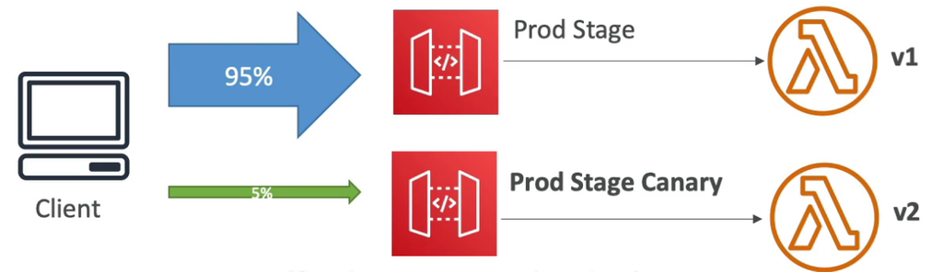

**OpenAPI Spec**

* Define REST APIs as configuration (YAML or JSON)
* Also allows to import AWS specific parameters and extensions
* Export as OpenAPI spec to generate SDK for clients
* API schema can also be defined in the OpenAPI spec
  + Allows API gateway to validate incoming requests for correct schema
  + Returns 400 status code if the validation fails
  + Reduces unnecessary calls to the backend
  + Examples:
  + 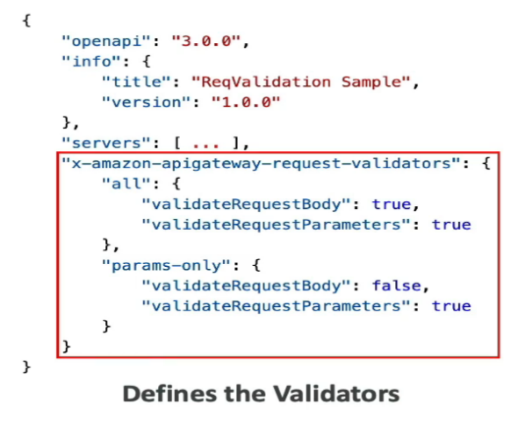
  + 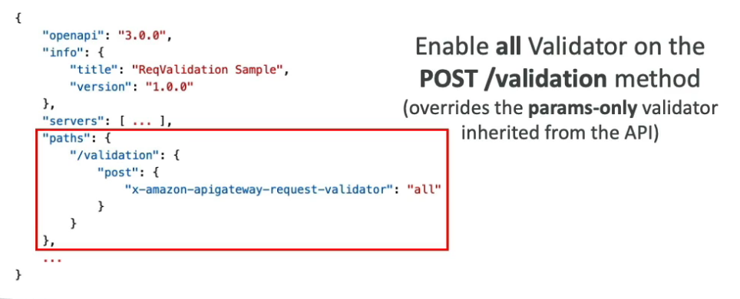
  + 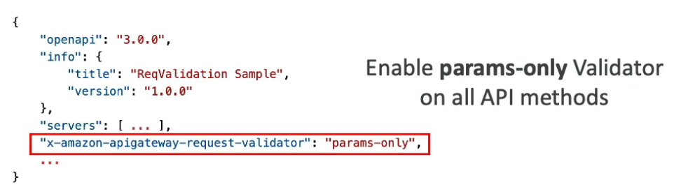

**Caching API Responses**

* Reduces the number of calls made to the backend
* **TTL: 0 s - 1 h (default 300 sec)**
* Caching at the stage level
* Ability to override cache settings at the method level
* Cache capacity: 0.5 GB - 237 GB
* Cache can be encrypted
* Caching is expensive (use only in production)

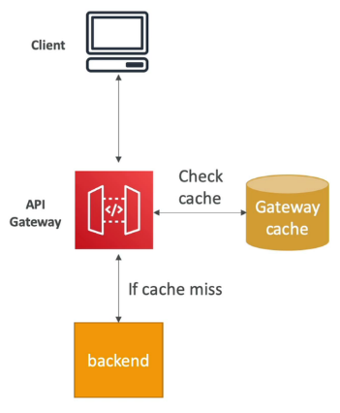

**Cache Invalidation**

* Invalidate the entire cache from console
* Clients can invalidate the cache for a request by adding a header Cache-Control: max-age=0 in the request. This will send the request to the backend and update the cache with the response.

Recommended to impose an IAM policy to allow only the clients to invalidate the cache. Without an IAM policy or Authorization Disabled, anyone can invalidate the cache.

* Tick the Require authorization checkbox to only allow authorized clients to invalidate the cache.

**Usage Plans**

* Used to monetize the APIs
  + Which clients can access what stages and methods
  + Throttling and quota limits for each client
* Clients use API keys to access the APIs (passed in X-API-Key header)
* Throttling limits are applied for each API key
* Clients are billed based on the API calls using their API keys

**Steps to setup a Usage Plan**

* Create the API and deploy them to the right stages
* Generate API keys and distribute them to the customers
* Create a usage plan with the desired throttle and quota limits
* **Associate** API stages and **API keys with the usage plan** using CreateUsagePlanKey API

**Observability**

**Logging**

* Logs contain the request and response passing through API gateway
* **Can be enabled at the stage level**
* Can override the logging settings at the API level
* Sent to CloudWatch logs (set Log Level: ERROR, DEBUG, INFO)
* Two types of logs:
  + **Execution Logs**: log requests, responses, etc.
  + **Access Logs**: who accessed the API and how

**Tracing**

* Enable X-Ray to trace API calls

**Metrics**

* Metrics are available at the stage level
* Can enable detailed metrics
* Key metrics:
  + CacheHitCount & CacheMissCount
  + Count - request count within a period
  + IntegrationLatency - how long the backend takes to reply to the API gateway
  + Latency - how long client had to wait to get a response from API gateway (includes integration latency and other API Gateway overheads such as authorization)
  + 4XXError - client side error count
  + 5XXError - server sider error count

**Performance**

* **Max timeout: 29 sec**
* Throttling limit - 10,000 req/sec across all APIs (account level soft limit)
  + 429 Too Many Requests error in case of throttling
  + If one API is getting too many requests, it can throttle other APIs
  + Set stage limits or method limits to prevent overuse
  + Create a usage plan to throttle per customer

**Cross Origin Resource Sharing (CORS)**

* Enable if you will receive API calls from another domain
* The response of pre-flight request must contain Access-Control-Allow-Origin header to allow the cross-origin client to make API calls.
* When the integration type is proxy-based, the responses are proxied to the client without modification by API gateway. So, CORS needs to be handled by the backend itself.
* For non-proxy integrations, CORS can be handled by API gateway.
* MaxAgeSeconds specifies the TTL used by browser to cache pre-flight response
* The client-side JS in the website (www.example.com) wants to make an API call to the backend hosted via API gateway at api.example.com. The browser will first make a pre-flight request to the backend asking what methods are allowed for www.example.com. If CORS is enabled, API gateway will allow the required methods.

**🌐 Scenario Recap.** You have:

* A website: www.example.com (served to the user's browser)
* A backend API hosted at: api.example.com (on **Amazon API Gateway**)
* The website uses **JavaScript (JS)** in the browser to make API calls to the backend

This setup creates a **cross-origin request**, meaning the browser is calling a **different domain** than the one the page came from.

**🔐 What's the Issue?**

**This triggers something called CORS (Cross-Origin Resource Sharing).**

By default, browsers **block cross-origin API calls** **for security reasons**, unless the backend **explicitly allows it**.

**🔁 What Happens Internally?**

**Step-by-step breakdown of the process:**

1. 🔍 **Pre-flight Request** (done by the browser automatically)
   * Before making the actual API call (e.g., GET, POST), the browser sends an **OPTIONS** request to api.example.com.
   * This is to **ask permission**:

"Hey API, I’m from www.example.com, and I’d like to do a POST — is that OK?"

1. ✅ **CORS Response from API Gateway**
   * If **CORS is enabled** on the **Amazon API Gateway**, it replies with headers like:

http

Access-Control-Allow-Origin: https://www.example.com

Access-Control-Allow-Methods: GET, POST, OPTIONS

Access-Control-Allow-Headers: Content-Type

1. 🚀 **Actual Request Happens**
   * If the CORS pre-flight is approved, the browser sends the actual API request (like POST, GET, etc.)

**✅ Key CORS Headers You Must Configure in API Gateway**

| **Header** | **Purpose** |
| --- | --- |
| Access-Control-Allow-Origin | Specifies the allowed origin (www.example.com) |
| Access-Control-Allow-Methods | Specifies allowed HTTP methods (e.g., GET, POST) |
| Access-Control-Allow-Headers | (Optional) Specifies custom headers client can send |

**💡 Why This Matters (for exams and real-world):**

* If **CORS is not configured**, the browser will block the request — even if the API is valid.
* **Amazon API Gateway** allows you to **enable CORS per method** (e.g., for GET, POST, etc.)
* The **OPTIONS** method (pre-flight) must also be **configured to return the CORS headers**.

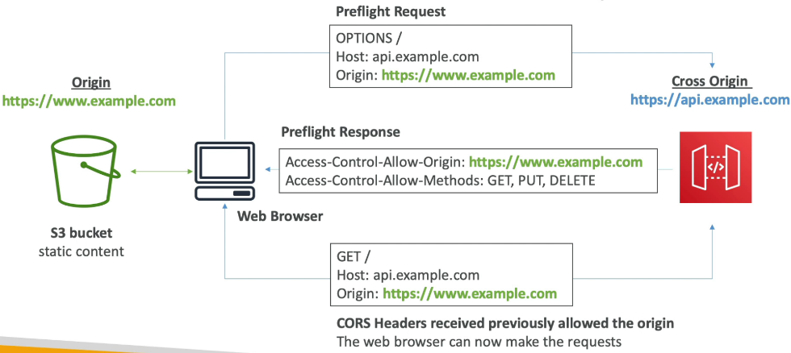

**TLS Termination**

* TLS certificates can be referenced from ACM
* Edge-Optimized endpoint → certificate must be in us-east-1
* Regional endpoint → certificate must be in the same region as API Gateway
* Must setup CNAME or A-alias record in Route 53 to point to the API gateway endpoint

**User Authentication**

**IAM**

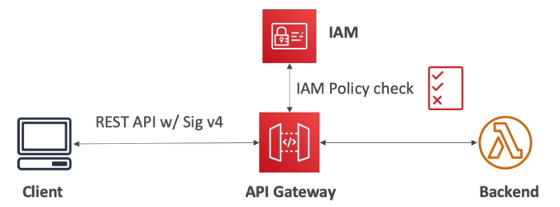

* IAM User or Role for authentication
* IAM Policy applied to principals for authorization (access control)
* Fully integrated with API gateway (no custom implementation needed)
* Good to provide access within AWS
* Leverages **SigV4** to sign the credentials in the header
* **Resource-based policies** can be used to allow the following access to API gateway
  + IAM Users and Roles in another account (cross-account access)
  + IP Addresses
  + VPC Endpoint

**Cognito User Pools (CUP)**

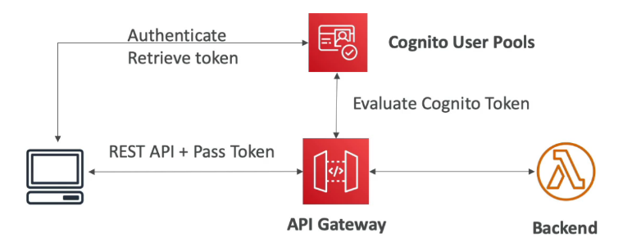

The client first authenticates themselves to CUP and get the token. They pass the token along with the request to API gateway. API gateway verifies the token with Cognito before forwarding the request to the backend.

* Cognito is AWS managed identity provider. It fully manages user lifecycle and expires tokens automatically.
* Fully integrated with API gateway (no custom implementation needed)
* **Only provides authentication** (access to the API) (authorization needs to be managed in the backend)
* Good to provide access to external users

**Lambda Authorizer**

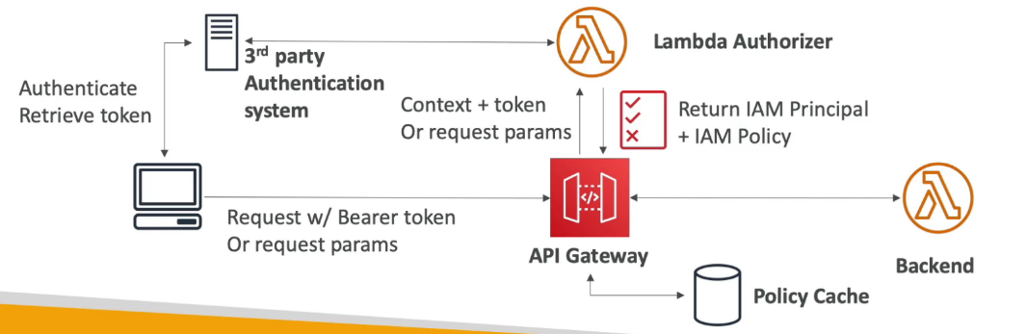

The client authenticates themselves to a 3rd party IDP and retrieve the token. The token is passed along with the request to the API gateway. The lambda authorizer takes the token, decodes it and determines the required IAM permissions. It can optionally verify the token with the IDP. The lambda authorizer then creates an IAM principal and policy granting the required permissions.

* Custom authorization logic (manual integration)
* Authentication is handled externally
* Authorization is performed by the lambda function
* Enable caching the result of authorization (recommended)
* Recommended to use this and not just rely on API keys for enhanced security.
* Two types:
  + **Token-based Lambda authorizer** (Token Authorizer) uses JWT or OAuth **for 3rd party authentication system**
  + **Request parameter-based Lambda authorizer** (Request Authorizer) receives the caller's identity in a combination of headers, query string parameters, stageVariables, and $context variables.

**API Types**

**REST**

* Standard APIs that we mostly create
* Supports resource-based policy
* **Does not support OIDC and OAuth 2.0 natively**

**HTTP**

* **Low-latency** & cost-effective **proxies** to Lambda or any HTTP endpoint (no data mapping)
* Supports OIDC and OAuth 2.0
* No usage plans and API keys
* Does not support resource-based policies
* **Cheaper than REST APIs**

**WebSocket**

* 2 - way communication between the client and the server
* Connection is persistent and stateful
* Used in real-time chat application, collaboration platforms, multiplayer games and financial trading platforms.
* The backend can be anything (AWS services or any HTTP endpoint)
* Establishing a WebSocket Connection

The client sends a request to the WebSocket url (wss://[some-uniqueid].execute-api.[region].amazonaws.com/[stage-name]) of API gateway. This establishes a persistent connection between the client and the API gateway. The API gateway calls a Lambda function (onConnect) and passes the connectionId which is then stored in DynamoDB (stateful).

* Client → Server Messaging

Once the WebSocket connection is established, the client can keep on sending messages (frames) to the server on the same WebSocket URL through the same persistent connection. The sent frames will invoke another lambda function to perform the desired action.

* Server → Client Messaging

A lambda function can make an HTTP POST request (signed by SigV4) to the **Connection URL** (WebSocket URL + /@connections/[connectionId]) to send messages to the client through the API gateway.

* Operations on WebSocket Connection URL (WebSocket URL + /@connections/[connectionId])
  + POST - Send a message from the Server to the connected WS Client
  + GET - Get the latest connection status of the connected WS Client
  + DELETE - Disconnect the connected Client from the WS connection
* **Routing**: Incoming JSON messages from the client are routed to different backend based on the **Route Key Table** (defined in API gateway). We can specify route selection expression to route based on a field in the JSON message. If no match, it is sent to the $default route.

**Amazon ECS**

Elastic Container Service.

**Intro**

* AWS managed container orchestration platform
* Integrates with ALB for load balancing to ECS tasks(ECS can work with the Application Load Balancer (ALB) to distribute incoming traffic across your containers, ensuring high availability and reliability.)
* EFS is used as persistent multi-AZ shared storage for ECS tasks (Amazon Elastic File System (EFS) provides scalable and shared storage that can be accessed by multiple ECS tasks across different Availability Zones.)
* It doesn't automatically handle resource provisioning, balancing load, auto-scaling, monitoring, and placing your containers across your cluster. Use **Elastic Beanstalk** for that.

**Launch Types**

**EC2 Launch Type**

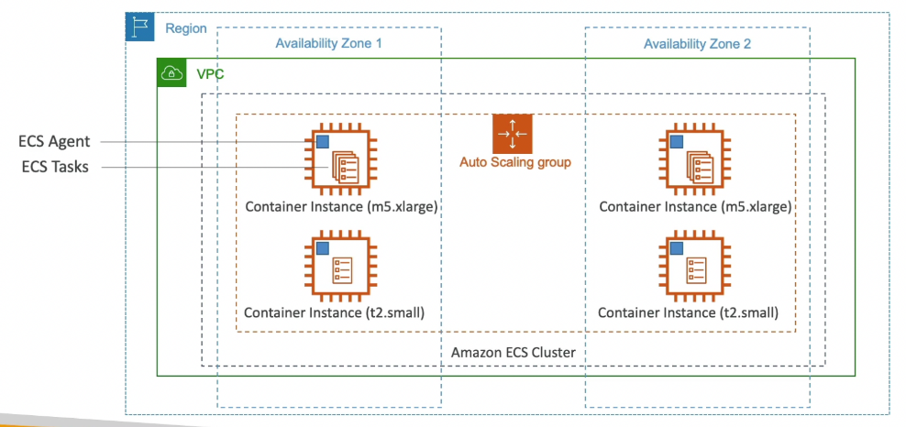

* **Not Serverless**
* Containers run on underlying EC2 instances
* ECS takes care of launching & stopping containers (ECS tasks)
* You must provision & maintain EC2 instances (use ASG)
* **EC2 instances have ECS agent running on them as a docker container**
* Inside a VPC spanning multiple AZ, there is an ECS cluster spanning multiple AZ. Inside the ECS cluster, there will be an ASG responsible for launching container instances (EC2). On every EC2 instance, ECS agent will be running (happens automatically if you choose the AMI for ECS when launching the instance) which registers these instances to the ECS cluster. This will allow the ECS cluster to run Docker containers (ECS tasks) on these instances.

💡 The ECS configuration is present in the /etc/ecs/ecs.config file in the EC2 instances. To modify properties such as the ECS cluster to which this instance should attach to, modify this file in the instance or in the user data of ASG.

**Fargate Launch Type**

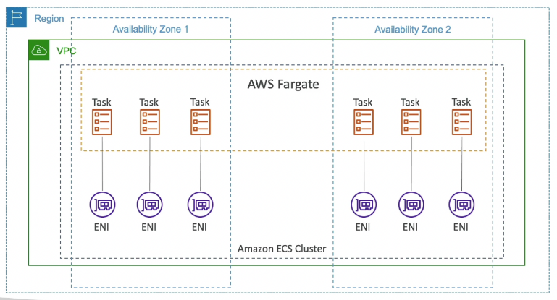

* **Serverless**
* No need to provision infrastructure
* No need to worry about infrastructure scaling
* ECS launches the required containers based on the CPU / RAM needed (**we won’t know where these containers are running**)
* VPC and ECS cluster are setup the same way as in EC2 launch type, but instead of using ASG with EC2 instances, we have a Fargate cluster spanning multiple AZ. The Fargate cluster will run ECS tasks anywhere within the cluster and attach an ENI (private IP) to each task. So, if we have a lot of ECS tasks, **we need sufficient free private IPs**.

**🧭 What Are ECS Launch Types?**

In Amazon ECS (Elastic Container Service), a **launch type** determines how your containerized applications run:

* **EC2 Launch Type**: You manage the EC2 instances that run your containers.
* **Fargate Launch Type**: AWS manages the infrastructure; you focus solely on your containers.[nops.io](https://www.nops.io/blog/aws-ecs-pricing/?utm_source=chatgpt.com)

**⚙️ EC2 Launch Type**

**🔑 Key Points:**

* **Infrastructure Management**: You provision and manage EC2 instances.[nops.io](https://www.nops.io/blog/aws-ecs-pricing/?utm_source=chatgpt.com)
* **Cost Efficiency**: Potentially more cost-effective for long-running applications.[nops.io+3reddit.com+3reddit.com+3](https://www.reddit.com/r/aws/comments/10ymexh?utm_source=chatgpt.com)
* **Scalability**: Requires manual scaling or setup of Auto Scaling groups.[reddit.com+1cloudzero.com+1](https://www.reddit.com/r/aws/comments/qrzsb7?utm_source=chatgpt.com)
* **Use Cases**: Suitable for applications with steady workloads or specific infrastructure requirements.[reddit.com+3nops.io+3reddit.com+3](https://www.nops.io/blog/aws-ecs-pricing/?utm_source=chatgpt.com)

**🧪 Example:**

Imagine you're running a web application that needs to handle consistent traffic. With EC2, you can choose instance types that match your performance needs and scale them as required.

**🚀 Fargate Launch Type**

**🔑 Key Points:**

* **Serverless**: No need to manage underlying infrastructure.[nops.io](https://www.nops.io/blog/aws-ecs-pricing/?utm_source=chatgpt.com)
* **Pay-as-You-Go**: Charges are based on the CPU and memory your containers use.[nops.io](https://www.nops.io/blog/aws-ecs-pricing/?utm_source=chatgpt.com)
* **Simplified Operations**: AWS handles provisioning, scaling, and load balancing.
* **Use Cases**: Ideal for microservices, batch jobs, or applications with variable workloads.[engr-syedusmanahmad.medium.com](https://engr-syedusmanahmad.medium.com/about-aws-elastic-container-service-ecs-b25ddbc6aa5a?utm_source=chatgpt.com)

**🧪 Example:**

If you're deploying a microservice that handles sporadic requests, Fargate allows you to focus on the code while AWS takes care of the infrastructure.

**📊 Comparison Table**

| **Feature** | **EC2 Launch Type** | **Fargate Launch Type** |
| --- | --- | --- |
| **Infrastructure** | Managed by you | Managed by AWS |
| **Cost Model** | Pay for EC2 instances | Pay for CPU and memory usage |
| **Scaling** | Manual or Auto Scaling groups | Automatic scaling by AWS |
| **Management** | Requires more operational overhead | Minimal management required |
| **Best For** | Long-running, steady workloads | Variable or unpredictable workloads |

**IAM Roles for ECS Tasks**

An IAM Role for ECS Tasks is an AWS Identity and Access Management (IAM) role that grants your ECS tasks permissions to interact with other AWS services securely. When you run a task in ECS, you can associate it with a specific IAM role, allowing the containers within that task to perform actions like accessing S3 buckets, writing logs to CloudWatch, or interacting with DynamoDB.

* **EC2 Instance Profile** (IAM role for the EC2 instance)
  + Used by the ECS agent to:
    - Make API calls to ECS service
    - Send container logs to CloudWatch
    - Pull Docker image from ECR

**🧭 What Is an EC2 Instance Profile?**

An **EC2 Instance Profile** is a container for an **IAM Role** that grants permissions to an EC2 instance. When you launch an EC2 instance, you associate it with an instance profile, allowing applications running on that instance to access AWS services securely without embedding access keys.

**🔑 Key Points**

* **Role Association**: An instance profile contains an IAM role that defines permissions.
* **Automatic Creation**: When you create an IAM role via the AWS Management Console and specify it for an EC2 instance, AWS automatically creates an instance profile with the same name.
* **Accessing Permissions**: Applications on the EC2 instance can access AWS services using temporary credentials provided by the instance profile.

1. **Access Permissions**: Applications on the EC2 instance use the instance profile to obtain temporary credentials and access AWS services.

**📊 Comparison: IAM Role vs. Instance Profile**

| **Component** | **IAM Role** | **Instance Profile** |
| --- | --- | --- |
| **Definition** | Set of permissions (policies) | Container for an IAM role |
| **Usage** | Assigned to AWS services or users | Assigned to EC2 instances |
| **Creation** | Manually by users | Automatically created when associating a role with EC2 |
| **Access** | Directly by AWS services or users | Indirectly by EC2 instances via metadata |

* **Task Execution Role**
  + Allows ECS tasks to access AWS resources
  + Each task can have a separate role
  + **Use different roles for the different ECS Services**
  + Task Role is defined in the task definition
  + Use taskRoleArn parameter to assign IAM policies to ECS Task Execution Role
  + Ex. Reference sensitive data in **Secrets Manager** or **SSM Parameter Store**

**ECS Services**

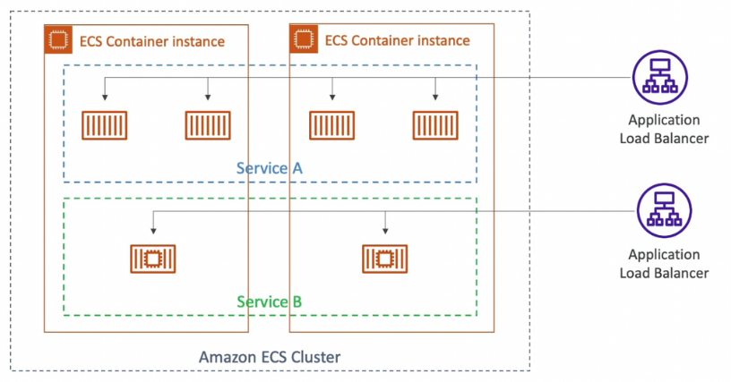

* An ECS Service is a **collection of long-running ECS tasks** (eg. web application) that perform the same function
* We can use ALB to send requests to these tasks
* **Service CPU Usage** or the **SQS queue length** for a service are used for scaling

**Load Balancing**

**EC2 Launch Type**

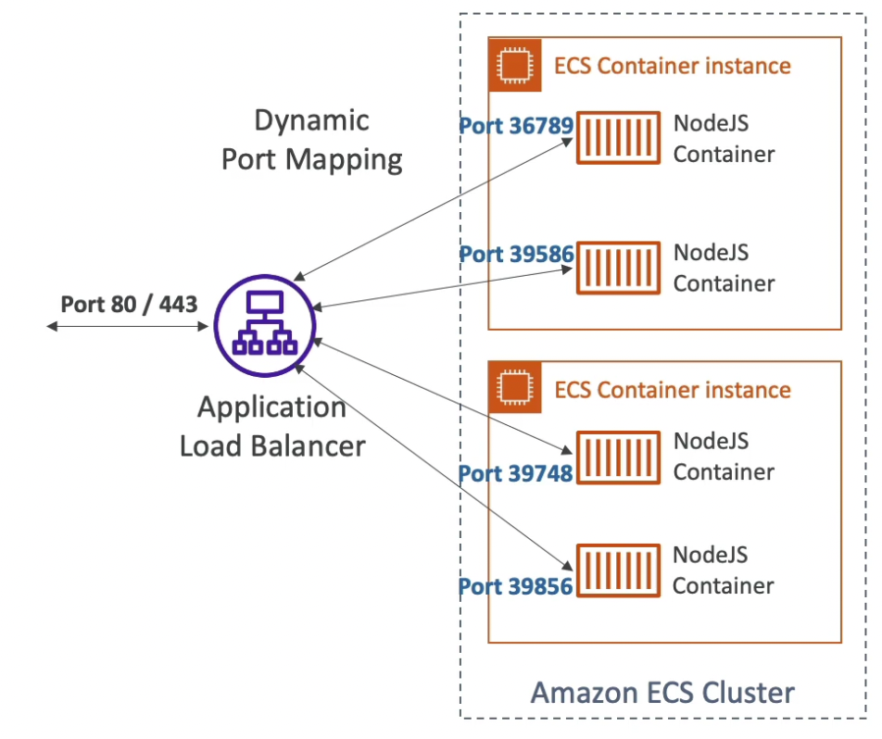 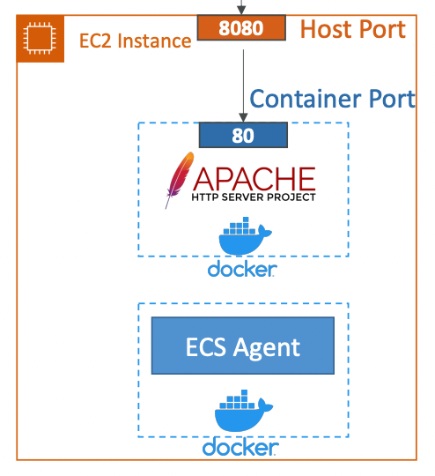

* For every container, the container port is mapped to a random free port on the host (instance). So the application running inside that container will be reached by the ALB on that random port. Set the host port as 0 for this to work.
* **Dynamic Host Port Mapping** - Once the ALB is registered to a service in the ECS cluster, it will automatically find the right port on the EC2 Instances. This only works with ALB, not CLB.
* You **must allow on the EC2 instance’s security group any port from the ALB security group** because it may attach on any port

**Fargate Launch Type**

* **Each task has a unique IP but the same container port**
* The ALB connects to each task directly on its IP and container port since these containers are not run on a defined host (instance).
* You **must allow on the ENI’s security group the task port from the ALB security group**

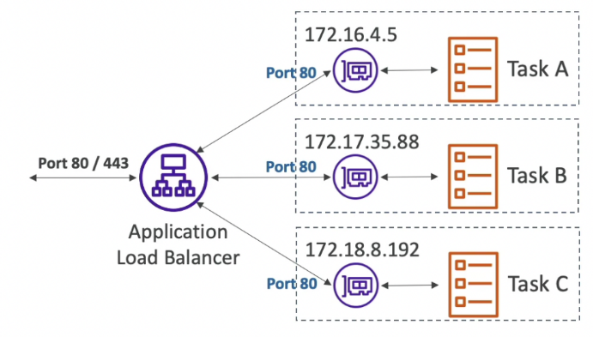

**Rolling Updates**

A Rolling Update is a deployment strategy in Amazon ECS that gradually replaces running tasks with new versions. This approach ensures that your application maintains availability during the update process.

* **Minimum healthy percentage** - determines how many tasks, running the current version, we can terminate while staying above the threshold
* **Maximum percentage** - determines how many new tasks, running the new version, we can launch while staying below the threshold

**🧩 How Rolling Updates Work in ECS**

1. **Initiation**: You update your ECS service with a new task definition revision.[tomgregory.com+2aws.amazon.com+2blog.alterway.fr+2](https://aws.amazon.com/blogs/compute/automating-rollback-of-failed-amazon-ecs-deployments/?utm_source=chatgpt.com)
2. **Replacement**: ECS starts new tasks with the updated definition while stopping the old ones.
3. **Health Checks**: ECS monitors the health of new tasks; if a task fails, ECS retries or rolls back the deployment.[aws.amazon.com+3aws.amazon.com+3tomgregory.com+3](https://aws.amazon.com/blogs/compute/automating-rollback-of-failed-amazon-ecs-deployments/?utm_source=chatgpt.com)
4. **Completion**: Once all new tasks are running and healthy, the deployment is considered successful.[aws.amazon.com](https://aws.amazon.com/blogs/compute/automating-rollback-of-failed-amazon-ecs-deployments/?utm_source=chatgpt.com)

**⚙️ Key Configuration Parameters**

* **Minimum Healthy Percent**: Specifies the lower limit on the number of running tasks during a deployment.[tomgregory.com](https://tomgregory.com/aws/aws-ecs-deployments-step-by-step/?utm_source=chatgpt.com)
* **Maximum Percent**: Specifies the upper limit on the number of running tasks during a deployment.[aws.amazon.com+3tomgregory.com+3blog.alterway.fr+3](https://tomgregory.com/aws/aws-ecs-deployments-step-by-step/?utm_source=chatgpt.com)

These parameters control the deployment pace and ensure service availability.

**✅ Advantages of Rolling Updates**

* **Zero Downtime**: Maintains application availability throughout the deployment.
* **Controlled Rollout**: Allows for gradual updates, reducing the risk of widespread issues.
* **Automatic Rollback**: ECS can automatically roll back to the previous version if health checks fail.

Min: 50% and Max: 100% and starting number of tasks 4 Min: 100% and Max: 150% and starting number of tasks 4

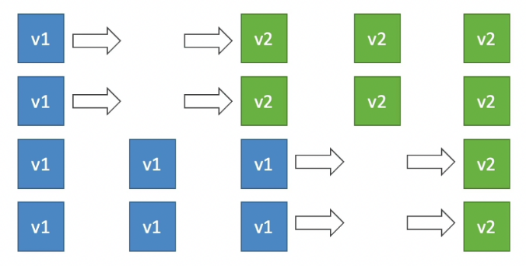 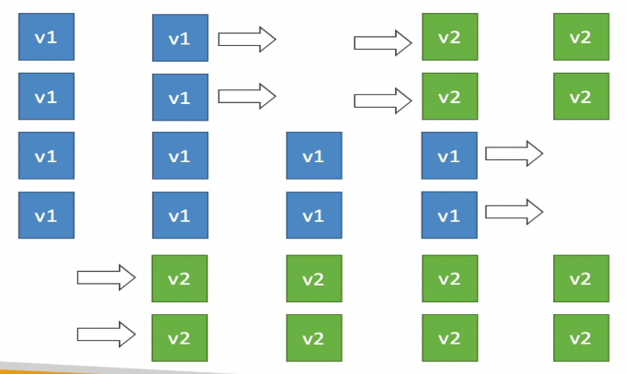

**Secrets in ECS tasks**

* Store the secrets in Secrets Manager or Parameter Store and encrypt them using KMS
* Reference the secrets in container definition with the name of the environment variable
* Create an **ECS task execution role** and reference it with your task definition, which allows access to both KMS and the Parameter Store/Secrets Manager.
* Supported for both EC2 and Fargate launch types

**🔐 What Are Secrets in ECS Tasks?**

In Amazon ECS, **secrets** refer to sensitive information—such as database credentials, API keys, or passwords—that your containers need to function securely. Instead of hardcoding these secrets into your application code or Docker images, ECS allows you to inject them into your containers at runtime using services like **AWS Secrets Manager** or **AWS Systems Manager Parameter Store**.

**🧩 How to Use Secrets in ECS Task Definitions**

You can specify secrets in your ECS task definition by using the secrets parameter. Here's how:

1. **Define the Secret in Secrets Manager**:
   * Store your secret in AWS Secrets Manager.
   * Note the ARN (Amazon Resource Name) of the secret.
2. **Reference the Secret in the Task Definition**:
   * In your ECS task definition, under the container definitions, use the secrets parameter to reference the secret.[reddit.com](https://www.reddit.com/r/aws/comments/znpasr?utm_source=chatgpt.com)

Example:

json

CopyEdit

"secrets": [

{

"name": "DB_PASSWORD",

"valueFrom": "arn:aws:secretsmanager:region:account-id:secret:secret-name:AWSCURRENT"

}

]

* This injects the secret value as an environment variable named DB_PASSWORD into your container.[reddit.com+1reddit.com+1](https://www.reddit.com/r/aws/comments/emstbl?utm_source=chatgpt.com)

**🛠️ Important Considerations**

* **IAM Role Permissions**:
  + Ensure that the ECS task execution role has the necessary permissions to access the secret in Secrets Manager.[reddit.com](https://www.reddit.com/r/aws/comments/nxm5ye?utm_source=chatgpt.com)

Example policy:

json

CopyEdit

{

"Version": "2012-10-17",

"Statement": [

{

"Effect": "Allow",

"Action": "secretsmanager:GetSecretValue",

"Resource": "arn:aws:secretsmanager:region:account-id:secret:secret-name-????"

}

]

}

* **Secret Rotation**:
  + If your secret is set to rotate, ECS will automatically fetch the latest version when the task starts.
* **Environment Variable Naming**:
  + The name field in the secrets parameter defines the environment variable name inside the container.[reddit.com](https://www.reddit.com/r/aws/comments/zdoerm?utm_source=chatgpt.com)

**✅ Best Practices**

* **Use Secrets Manager for Sensitive Data**:
  + Store sensitive information like database credentials in Secrets Manager to benefit from encryption and automatic rotation.
* **Avoid Hardcoding Secrets**:
  + Never hardcode secrets in your application code or Docker images. Always inject them at runtime.
* **Implement Least Privilege**:
  + Grant the ECS task execution role only the permissions it needs to access the required secrets.

**Bind Mounts**

* **Shared volume between multiple containers** running the same application (same definition file).
* Bind mount lifecycle
  + EC2 Tasks: lifecycle of EC2 instances since the volumes exist on the host
  + Fargate Tasks: lifecycle of the ECS task [20 GiB (default) - 200 GiB]

**Shared File System in ECS**

* **EFS can be mounted as a shared file system between ECS tasks**
* Works for both EC2 and Fargate launch types
* ECS Fargate + EFS ⇒ serverless

**🧭 What Is ECS Fargate?**

**Amazon ECS Fargate** is a serverless compute engine for containers. It allows you to run containers without managing the underlying EC2 instances. You simply define your application, specify the CPU and memory requirements, and Fargate handles the rest, including provisioning, scaling, and managing the infrastructure.

**🗄️ What Is Amazon EFS?**

**Amazon Elastic File System (EFS)** is a fully managed, scalable, and elastic file storage service. It provides a simple, scalable, elastic file system for Linux-based workloads, allowing multiple Amazon EC2 instances or ECS tasks to access the same data concurrently. EFS automatically scales storage capacity up or down as you add or remove files, eliminating the need to provision storage in advance.[rnanthan.medium.com](https://rnanthan.medium.com/deploying-jfrog-artifactory-oss-on-aws-fargate-with-efs-and-alb-349fbb258af6?utm_source=chatgpt.com)

**🔗 ECS Fargate + EFS: A Serverless Architecture**

Combining ECS Fargate with EFS enables you to run serverless applications that require persistent storage. With this setup:

* **Serverless Compute**: Fargate manages the compute resources, allowing you to focus solely on your application code.
* **Persistent Storage**: EFS provides scalable and shared file storage accessible by your ECS tasks.
* **Simplified Management**: No need to manage EC2 instances or storage provisioning; AWS handles the infrastructure.

This combination is ideal for applications that require persistent storage, such as content management systems, media processing applications, or any workload that needs to store and share data across multiple tasks.

**✅ Key Benefits**

* **Scalability**: EFS automatically scales storage as needed, and Fargate adjusts compute resources based on demand.
* **High Availability**: EFS is designed for high availability and durability, ensuring your data is accessible when needed.
* **Cost Efficiency**: Pay only for the resources you use, with no upfront costs or long-term commitments.
* **Simplified Operations**: Focus on your application logic without worrying about managing servers or storage infrastructure.

**ECS Service Auto Scaling**

* Auto scale the number of ECS tasks in a service
* **AWS Application Auto Scaling** can be used to scale on metrics:
  + ECS Service Average CPU Utilization
  + ECS Service Average Memory Utilization
  + ALB Request Count Per Target
* The above metrics can be used to setup target tracking or step scaling for ECS tasks. Scheduled scaling can also be used.
* Easier to setup on Fargate launch type because we don’t have to scale the underlying resource.
* For EC2 launch type, auto-scaling EC2 instances:
  + Using ASG to scale out based on CPU utilization
  + **ECS Cluster Capacity Provider** - automatically scales out EC2 instances when the service is missing capacity.

**Task Definition**

* Analogous to Docker Compose
* Tells ECS how to run the docker containers
* **Only 1 IAM Role can be defined per Task Definition.** All the tasks within a service will assume that role.
* Environment variables in Task Definitions
  + Hardcoded (defined in the task definition file)
  + Referenced from Parameter Store
  + Referenced from Secrets Manager
  + Imported as Environment Files from S3 bucket

**Task Placement**

This is to be decided only in EC2 launch type.

**Task Placement Strategy**

* **Binpack**
  + Fill up an instance (in terms of CPU or memory) and only then provision a new instance.
  + Minimize cost (number of instances)
  + Example: Binpack on memory

**Task Placement**

This is to be decided only in EC2 launch type.

**Task Placement Strategy**

* **Binpack**
  + Fill up an instance (in terms of CPU or memory) and only then provision a new instance.
  + Minimize cost (number of instances)
  + Example: Binpack on memory
  + 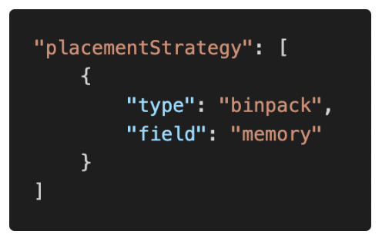
* **Random**
  + Randomly select an instance to place the task.
  + 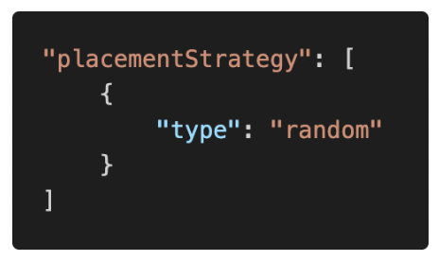
* **Spread**
  + Spread the tasks on a parameter
  + Maximize availability
  + Example: spread on AZ
  + 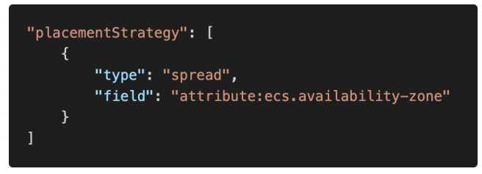
* Task placement strategy can be mixed such as spread on AZ and binpack on memory:

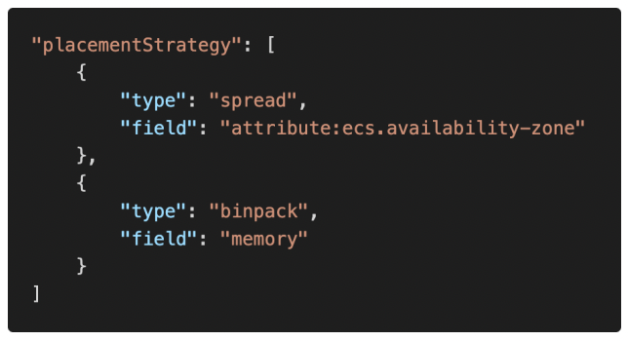

**Task Placement Constraints**

* distinctInstance - place each task on a different instance
* memberOf - place task on instances that satisfy an expression (eg. only on T2 family of instances)

**Troubleshooting Steps**

* Verify that the Docker daemon is running on the container instance.
* Verify that the container agent is running on the container instance.
* Verify that the IAM instance profile has the necessary permissions.

**Misc**

* You can use EventBridge to run Amazon ECS tasks when certain AWS events occur. Ex: set up a CloudWatch Events rule that runs an Amazon ECS task whenever a file is uploaded to an S3 bucket.
* For tracing, create a Docker image that runs the X-Ray daemon, upload it to a Docker image repository, and then deploy it to your Amazon ECS cluster. Configure the task definition file to allow your application to communicate with the daemon container.
* Use **advanced container definition parameters** to define environment variables for a task.

**Elastic Container Registry (ECR)**

* AWS managed **private** Docker repository
* **Pay for the storage you use** to store docker images (no provisioning)
* Integrated with ECS & **IAM for security**
* Storage backed by S3
* Can upload Docker images on ECR manually or we can use a CICD service like **CodeBuild**

**Pulling Images from ECR**

* $(aws ecr get-login --no-include-email) - login to ECR
* docker pull <repo-url>/<image>

**AWS CoPilot**

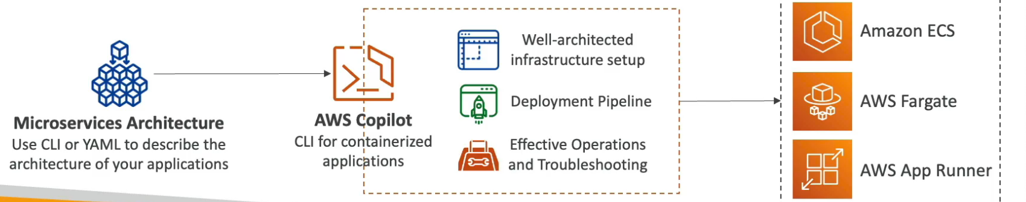

* **CLI tool (not a service)** to build, release, and operate production-ready containerized apps without worrying about infrastructure setup.
* Automatically creates **well-architected infrastructure**
* Containerized apps can be run on:
  + ECS
  + Fargate
  + AppRunner
* Automated deployments with one command using CodePipeline
* Deploy to multiple environments
* Provides troubleshooting, logs, health status, etc.

**Infrastructure**

**ASG**

**Intro**

* Regional Service (cannot span multiple regions)
* Supports Multi AZ
* Automatically add or remove instances (scale horizontally) based on the load
* Free (pay for the underlying resources)
* IAM roles attached to an ASG will get assigned to the launched EC2 instances
* ASG can terminate instances marked as unhealthy by an ELB (and hence replace them)

💡 If you have an ASG with running instances and you delete the ASG, the instances will be terminated and the ASG will be deleted.

**Scaling Policies**

* **Scheduled Scaling**
  + Scale based on a schedule
  + Used when the load pattern is predictable
* **Simple Scaling**
  + Scale to certain size on a CloudWatch alarm
  + Ex. when CPU > 90%, then scale to 10 instances
* **Step Scaling**
  + Scale incrementally in steps using CloudWatch alarms
  + Ex. when CPU > 70%, then add 2 units and when CPU < 30%, then remove 1 unit
  + Specify the **instance warmup time** to scale faster

*In Amazon EC2 Auto Scaling, the* ***instance warmup time*** *is a crucial setting that defines how long Amazon EC2 Auto Scaling waits after launching a new instance before considering it as part of the Auto Scaling group's capacity and before aggregating its metrics for scaling decisions. This delay ensures that the instance has sufficient time to initialize and stabilize, providing more accurate metrics for scaling operations.*

* **Target Tracking Scaling**
  + ASG maintains a CloudWatch metric and scale accordingly (automatically creates CW alarms)
  + Ex. maintain CPU usage at 40%
  + **Target Tracking Scaling** is a policy in Amazon EC2 Auto Scaling that automatically adjusts the number of EC2 instances in your Auto Scaling group to maintain a specified target value for a chosen metric. This approach simplifies scaling by continuously monitoring the metric and making real-time adjustments, much like a thermostat maintains a set temperature.

**⚙️ How It Works**

* + **Choose a Metric**: Select a CloudWatch metric that reflects your application's performance, such as CPU utilization, network traffic, or request count per target.
  + **Set a Target Value**: Define the desired value for the chosen metric. For example, you might set a target of 50% CPU utilization.
  + **Automatic Scaling**: Amazon EC2 Auto Scaling continuously adjusts the number of instances to keep the metric as close as possible to the target value.

This method eliminates the need for manually configuring CloudWatch alarms and scaling adjustments, streamlining the scaling process.

* **Predictive Scaling**
  + Historical data is used to predict the load pattern using ML and scale automatically

**Launch Configuration & Launch Template**

Both are used with **Auto Scaling Groups (ASG)** to define how EC2 instances should be launched.

**What they define for an ASG:**

* **AMI (Amazon Machine Image)** — which OS and software your instances run
* **Instance Type** — like t3.micro, m5.large, etc.
* **EC2 User Data** — scripts or commands to run when the instance boots
* **EBS Volumes** — attached storage for the instance
* **Security Groups** — firewall rules for the instance
* **SSH Key Pair** — to securely connect to the instance
* **Min / Max / Desired Capacity** — controls the number of instances the ASG maintains
* **Subnets** — which VPC subnets the instances launch in (i.e., network location)
* **Load Balancer** — attach your instances to a Classic or Application Load Balancer
* **Scaling Policy** — rules that tell ASG when/how to add or remove instances

**Launch Configuration (Legacy)**

* It **cannot be updated** once created — if you want to change something, you must create a new launch configuration and update the ASG to use it.
* Does **not support Spot Instances** — only On-Demand instances.
* Simpler, older method for ASG instance settings.

**Launch Template (Recommended & Newer)**

* Supports **versioning** — you can create new versions when you change settings, and choose which version your ASG uses.
* Can be **updated** easily by creating new versions without recreating the whole template.
* Supports **both On-Demand and Spot Instances** — great for cost optimization.
* AWS **recommends** using Launch Templates over Launch Configurations for flexibility and new features.

**TL;DR**

| **Feature** | **Launch Configuration** | **Launch Template** |
| --- | --- | --- |
| Update-able? | No (must recreate) | Yes (versioned, can update) |
| Supports Spot Instances? | No | Yes |
| Versioning? | No | Yes |
| AWS Recommendation | Legacy | Recommended |

**Scaling Cooldown**

* After a scaling activity happens, the ASG goes into cooldown period (**default 300 seconds**) during which it does not launch or terminate additional instances (ignores scaling requests) to allow the metrics to stabilize.
* Use ready-to-use AMI to launch instances faster to be able to reduce the cooldown period

**Health Checks**

* By default, ASG uses the EC2 status check (not the ELB health check). This could explain why some instances that are labelled as unhealthy by an ELB are still not terminated by the ASG.
* To prevent ASG from replacing unhealthy instances, suspend the **ReplaceUnhealthy** process type.

💡 When an instance is unhealthy, ASG creates a new scaling activity for terminating the unhealthy instance and then terminates it. Later, another scaling activity launches a new instance to replace the terminated instance.

**Termination Policy**

* Select the AZ with the most number of instances
* Delete the instance with the oldest launch configuration
* Delete the instance which is closest to the next billing hour

**Rebalancing AZs**

ASG ensures that the group never goes below the minimum scale. Actions such as changing the AZ for the group or explicitly terminating or detaching instances can lead to the ASG becoming unbalanced between AZs. In such cases, ASG compensates by **rebalancing** the AZs by **launching new instances before terminating the old ones**, so that rebalancing does not compromise the performance or availability of the application.

**Lifecycle Hooks**

* Used to perform extra steps before launching or terminating an instance. Example:
  + Install some extra software or do some checks (during pending state) before declaring the instance as "in service"
  + Before the instance is terminated (terminating state), extract the log files
* **Without lifecycle hooks, pending and terminating states are avoided**

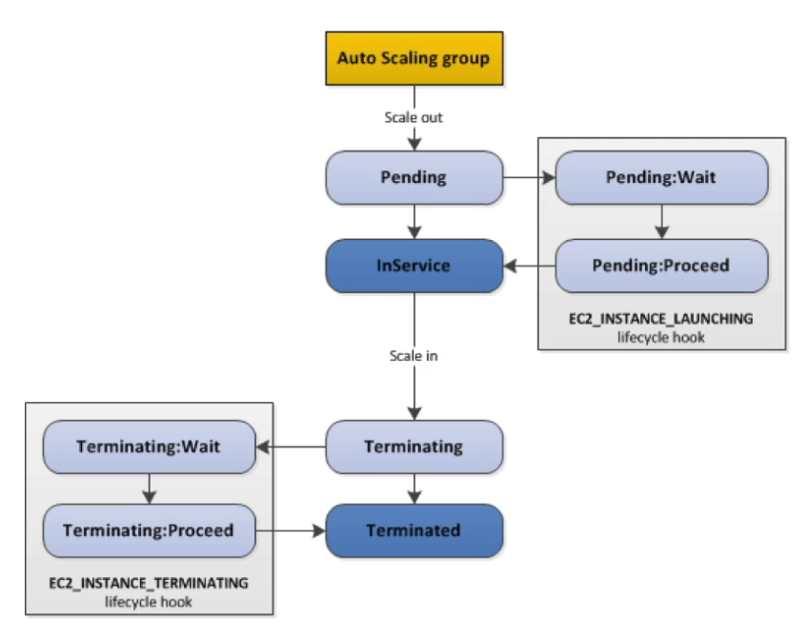

**Instance Refresh**

* StartInstanceRefresh API call to update the instances to the latest launch template (doesn’t happen automatically if we just update the launch template)
* Can specify **minimum healthy percentage** (for rolling update)
* Can specify **warm-up time** (how long to wait for the new instances to become ready to use)

**Instance Refresh** is a feature for Auto Scaling Groups that lets you **automatically replace** the instances in your ASG with new ones — without having to delete and recreate the entire ASG or manually terminate instances.

**Why use Instance Refresh?**

* When you update the **Launch Template or Launch Configuration** (e.g., new AMI, updated User Data, different instance type), the existing instances still run the old configuration.
* **Instance Refresh** helps to **roll out those updates** by gradually replacing old instances with new ones that use the latest settings.
* It helps ensure your fleet stays up-to-date with minimal downtime and controlled disruption.

**Key Features:**

* **Rolling updates**: It replaces instances in batches to avoid taking down your entire application.
* **Customizable behavior**: You can control how many instances are replaced at a time, wait time between batches, and health check settings.
* **Health checks integration**: Instance Refresh waits for new instances to become healthy before moving on to replace more instances.

**How it works in simple steps:**

1. You trigger an **Instance Refresh** on your ASG (either manually or automatically when you update your launch template).
2. ASG starts **terminating old instances** in batches.
3. For each terminated instance, it launches a new one using the **latest launch template/configuration**.
4. It waits for the new instances to pass health checks.
5. Continues until all instances are updated.

**CloudFormation**

CloudFormation is an **Infrastructure as Code (IaC)** service from AWS that lets you **define and manage AWS resources** using templates written in JSON or YAML.

**Why use CloudFormation?**

* Automates the creation, update, and deletion of AWS resources in a **safe and repeatable** way.
* Helps manage **complex stacks** of resources (like EC2, RDS, VPCs, S3 buckets, IAM roles, etc.) all in one place.
* Enables **version control** and easy replication of infrastructure.
* Removes manual errors and speeds up deployment.

**Intro**

* Infrastructure as Code (IaC) - version control, easy replication
* Supports most AWS services
* Declarative programming
* Free, pay for the underlying resources
* CloudFormation stacks are isolated from each other
* Deleting a stack deletes every single resource or artifact created by that stack.

**Templates**

* **Templates are uploaded and referenced from S3**. To update a template, we cannot edit the previous version. We need re-upload a new version of the template and CloudFormation will find out what needs to be modified to reach the desired state.
* Deploying Templates
  + Manual - editing templates in the **CloudFormation Designer (GUI)**
  + Automated - editing templates in a YAML file and using CLI to deploy the templates (recommended for automation)

**What are Templates?**

* Templates are **blueprints** written in JSON or YAML that describe **all the AWS resources** you want to create and manage with CloudFormation.
* They define the **desired state** of your infrastructure — what resources to create, their settings, dependencies, and configurations.

**Templates & S3**

* When working with large or reusable templates, you typically **upload the template file to an S3 bucket**.
* CloudFormation references the template from this S3 location when creating or updating stacks.
* **Important:** You **cannot edit an existing template version directly in S3.**
  + Instead, if you want to update your infrastructure, you **upload a new version** of the template file to S3.
  + CloudFormation compares the **new template** to the current state and determines what changes are needed to update your stack accordingly.
  + This ensures your infrastructure **drifts as little as possible** from the desired state.

**Deploying Templates**

You have two main ways to deploy and manage your templates:

1. **Manual (GUI-based):**
   * Using the **CloudFormation Designer**, a visual interface in the AWS Console.
   * You can **edit, create, and deploy templates graphically**.
   * Good for quick testing or small templates.
   * Not ideal for automation or large infrastructure setups.
2. **Automated (CLI-based, Recommended):**
   * Write your templates as **YAML or JSON files** locally.
   * Use the **AWS CLI commands** (e.g., aws cloudformation deploy, aws cloudformation create-stack) to deploy or update stacks.
   * Ideal for integrating with **CI/CD pipelines** or automated workflows.
   * Easier to version control (Git) and collaborate with teams.

**Resources**

* **Mandatory field**
* Resource types are of the form AWS::aws-product-name::data-type-name
* Template contents are static (no dynamic code generation allowed)

**What are Resources?**

**Resources** are the **essential and mandatory part** of every CloudFormation template.

They define **the AWS components you want to create and manage**, such as EC2 instances, S3 buckets, Lambda functions, IAM roles, etc.

Without the Resources section, a template can't create anything.

**Key points about Resources:**

* **Mandatory field:** Every CloudFormation template must have a Resources section. It’s where you specify all the AWS resources you want to provision.
* **Resource Types format:**  
  Resources use a specific naming pattern for their types:

ruby

AWS::aws-product-name::data-type-name

For example:

* + AWS::EC2::Instance (an EC2 virtual server)
  + AWS::S3::Bucket (an S3 storage bucket)
  + AWS::Lambda::Function (a Lambda serverless function)
* **Static template contents:**  
  The template itself is **static** — meaning you **cannot include dynamic code or scripts that generate resource definitions on the fly** inside the template.  
  You define everything upfront. Any dynamic behavior has to be done **outside** the template (e.g., in your deployment pipeline or by using parameters, mappings, or conditions).

**Parameters**

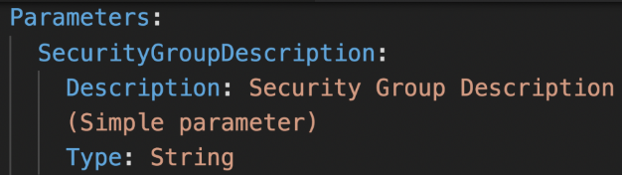 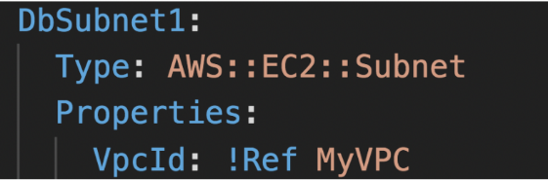

* Dynamic input variables in CloudFormation templates. When deploying the template, the user will be asked to enter values for the defined parameters.
* Parameters can be referenced using !Ref
* Parameters can be modified without having to re-upload the template
* AWS creates some default parameters (**Pseudo Parameters**) that can be used in the template.

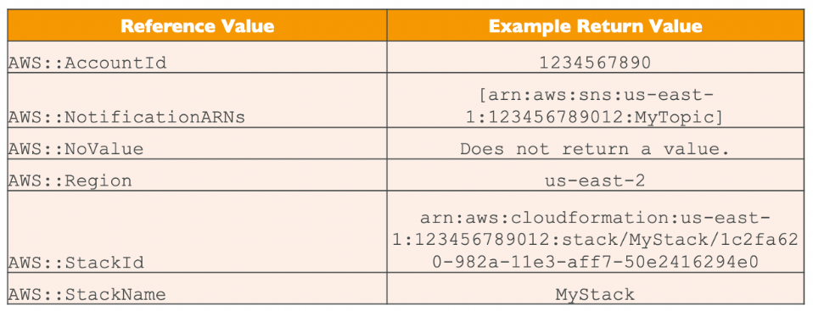

* Supported parameter types:

String – A literal string

Number – An integer or float

List<Number> – An array of integers or floats

CommaDelimitedList – An array of literal strings that are separated by commas

AWS::EC2::KeyPair::KeyName – An Amazon EC2 key pair name

AWS::EC2::SecurityGroup::Id – A security group ID

AWS::EC2::Subnet::Id – A subnet ID

AWS::EC2::VPC::Id – A VPC ID

List<AWS::EC2::VPC::Id> – An array of VPC IDs

List<AWS::EC2::SecurityGroup::Id> – An array of security group IDs

List<AWS::EC2::Subnet::Id> – An array of subnet IDs

* All the parameters are independent of each other.

**Mappings**

* Static variables hardcoded in the template
* Mappings are great when the value can be deduced from variables such as Region, AZ, AWS Account ID, etc.
* Fn::FindInMap or !FindInMap is used to fetch the value from a map

!FindInMap [MapName, TopLevelKey, SecondLevelKey] (always this syntax)

* Example: Select the AMI based on the region and architecture

**What are Mappings?**

**Mappings** are like **static lookup tables** hardcoded inside your CloudFormation template.

They let you define **key-value pairs** that your template can reference to select values based on some criteria — like region, availability zone, or account ID.

These are **static** (not dynamic) and don’t accept input during stack creation.

**When to use Mappings?**

* When you need to **choose values conditionally** based on fixed inputs, such as:
  + Selecting an **AMI ID based on AWS Region**
  + Choosing different **parameters per environment or region**
  + Defining **account-specific settings**

**How to use Mappings?**

* Use the intrinsic function **Fn::FindInMap** (or shorthand !FindInMap) to retrieve values.
* The syntax is always:

yaml

!FindInMap [ MapName, TopLevelKey, SecondLevelKey ]

where:

* + MapName = name of the mapping block
  + TopLevelKey = first-level key to lookup (e.g., region name)
  + SecondLevelKey = second-level key to lookup (e.g., AMI type)

**Example Mapping: Choose AMI based on region and architecture**

Yaml

Mappings:

RegionMap:

us-east-1:

AMI: ami-0ff8a91507f77f867

us-west-2:

AMI: ami-0bdb828fd58c52235

Resources:

MyEC2Instance:

Type: AWS::EC2::Instance

Properties:

ImageId: !FindInMap [RegionMap, !Ref "AWS::Region", AMI]

InstanceType: t2.micro

* Here, based on the AWS region where the stack runs, the template selects the correct AMI ID from the map.
* !Ref "AWS::Region" dynamically gets the current region, which acts as the **TopLevelKey**.
* The **SecondLevelKey** is AMI to get the AMI ID value.

**Outputs**

* Export output values after the stack creation (optional)
* Exported outputs can be imported by other CloudFormation stacks using !ImportValue function along with their export names.
* Exported output name must be unique within the region.
* We cannot delete a stack if its outputs are being referenced by another stack
* Example: In the network template, export the SSH security group and import them in other stacks to apply to EC2 instances.

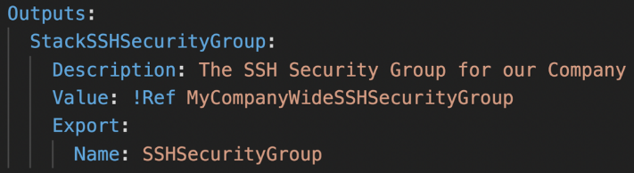 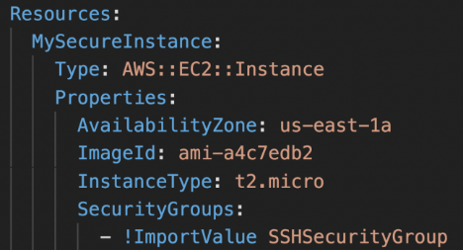

**Conditions**

* Control the creation of **resources** or **outputs** based on a condition
* **Conditions cannot be used within the Parameters section**
* Conditions can reference other conditions for nesting
* Supported functions: And, Or, Not, Equals, If
* Example: CreateProdResources will be True only if EnvType is prod.



MountPoint resource will be created only if CreateProdResources is True.

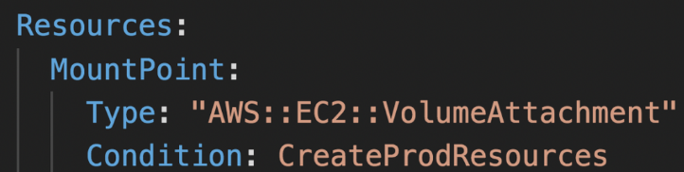

**Intrinsic Functions**

**What are Intrinsic Functions?**

* Intrinsic functions are **built-in special functions** provided by CloudFormation that help you **add logic, dynamic references, or perform operations inside your templates**.
* They let you **manipulate data**, **reference resources**, **get environment info**, and **insert values dynamically** within a static template.
* Without intrinsic functions, templates would be purely static and less useful.

**Common use cases for intrinsic functions:**

* Referencing values like AWS region, stack name, or outputs from other resources.
* Combining strings.
* Selecting values from mappings.
* Getting attributes from created resources.
* Performing condition-based logic.

**Common Intrinsic Functions (some key ones):**

| **Function** | **Description** | **Syntax Example** |
| --- | --- | --- |
| Ref | References a parameter or resource logical ID. | !Ref MyInstance |
| Fn::GetAtt | Gets an attribute of a resource (e.g., ARN). | !GetAtt MyBucket.Arn |
| Fn::Join | Joins a list of strings into one string. | !Join [":", ["a", "b", "c"]] |
| Fn::FindInMap | Looks up a value in a mapping. | !FindInMap [RegionMap, us-east-1, AMI] |
| Fn::If | Conditional logic based on a condition. | !If [ConditionName, ValueIfTrue, ValueIfFalse] |
| Fn::Sub | Substitute variables in a string. | !Sub "arn:aws:s3:::${BucketName}" |

* Ref - returns the ID of a resource or value of a parameter

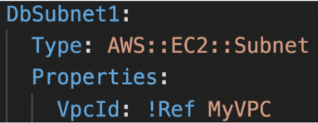

* GetAtt - get an attribute of a resource

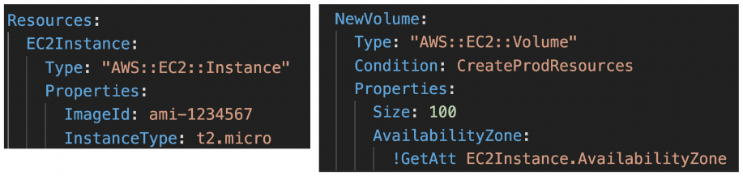

* FindInMap - get a value from a mapping

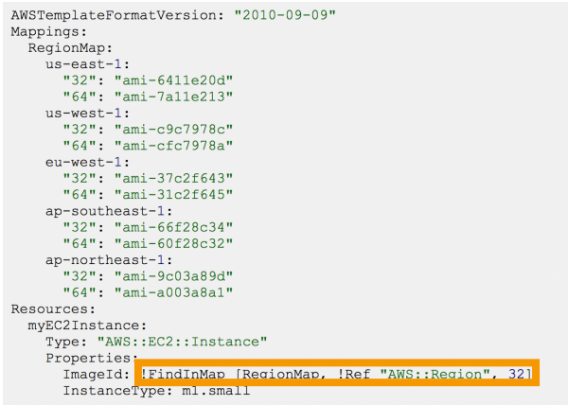

* ImportValue - import exported outputs from other templates

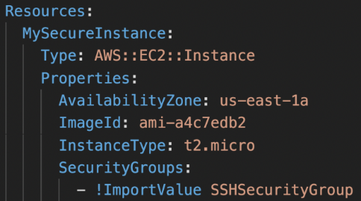

* Join - join comma-delimited list of values

!Join [ ":", [a, b, c] ] ⇒ "a:b:c"

* Sub - substitute variables with a string

**Rollbacks**

* Two methods:
  + **Rollback all stack resources (default)** - rollback the entire stack to the last known stable state (deletes everything in the failed stack)
  + **Preserve successfully provisioned resources** - resources that were successfully provisioned will be preserved, failed resources will be rolled back to the last known stable state
* During stack creation, rolling back to the previous state means deleting the entire stack.
* During stack update, rolling back to the previous state will delete the failed stack and bring up the previous version.

**ChangeSets**

When we upload a new template to update a stack, ChangeSets show what changes are going to happen to the stack, before creating the stack. If we want to modify the template, we can do that at this stage. Once we are happy, we can execute the change set for the stack to update.

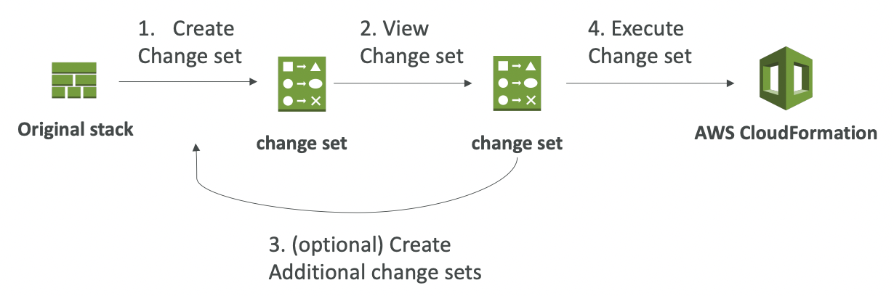

**Nested Stack**

* Allow us to reuse repeated patterns or common components across multiple stacks (**best practice**).
* To update a nested stack, always update the parent (root stack) first
* **Cross Stacks are used when stacks have different lifecycles** (export a value from a stack and import it in other stacks) whereas **Nested Stacks are used when the components can be reused**.

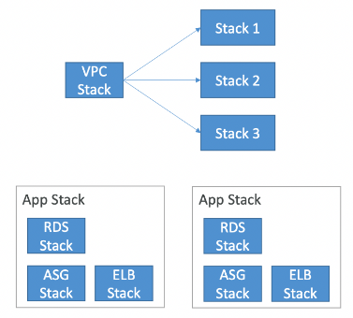

Above: cross stack Below: nested stack

**StackSets**

* Used to create, update or delete stacks across **multiple accounts or regions** with a single operation.
* Admin account creates StackSets. Trusted accounts can create, update or delete stack instances from StackSets.

**Drift**

* CloudFormation doesn’t prevent against manual configuration changes to the stack. This causes drift in the stack.
* Feature to detect drift in the stack (Select a stack → Action → Detect Drift)
* Shows what is the expected and actual configuration of drifted resources
* Not all resources are supported yet

**Stack Notifications**

* Enable SNS integration when creating a stack to **send stack events to an SNS topic**
* A lambda function can be used to filter for specific events and perform some action (eg. send an email whenever the stack rolls back)

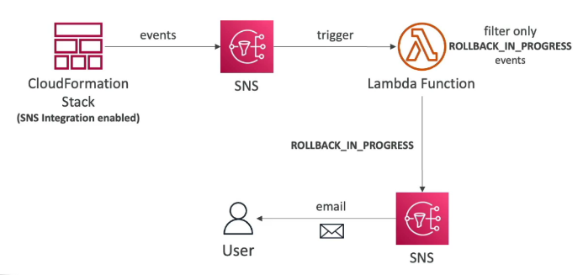

**Stack Policies**

* By default, all update actions are allowed to all the resources during a stack update
* **Stack Policy defines the update actions that are allowed or denied on specific resources during stack update**
* Helps protect some resources from unintentional updates
* When you create a stack policy, all update operations on all the stack resources are denied. You need to explicitly allow update operations on the resources.
* Example: allow updates on all resources except the production database

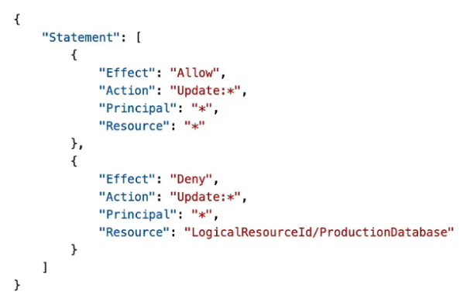

**Misc**

* If the stack is stuck in a DELETE_FAILED state because some resource failed to be deleted, modify the template to retain the resource and manually delete it after the deployment.

**Elastic Beanstalk**

**Intro**

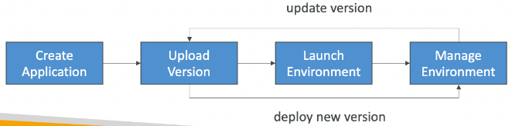

* **PaaS** which provides platform for developers to write and easily deploy code. It automatically creates the necessary infrastructure (EC2, ELB, SG, etc.) in AWS.
* Good for non-serverless applications
* Automatically handles capacity provisioning, load balancing, scaling, application health monitoring, instance configuration, etc. but **we have full control over the configuration.**
* **Free** (pay for the underlying resources spawned by Beanstalk)
* Supports versioning of application code
* Can create multiple environment (dev, test, prod)
* Supports the deployment of web applications from **Docker** containers and automatically handles load balancing, auto-scaling, monitoring, and placing containers across the cluster.
* Supports pretty much any programming language and even Docker containers.
* Beanstalk CLI helps manage the applications from CLI.
* Beanstalk uses CloudFormation under the hood to provision resources.

When you create an **Elastic Beanstalk environment**, AWS automatically uses **CloudFormation** (behind the scenes) to **provision and manage the underlying AWS resources** your application needs.

**In other words:**

You don’t see it directly, but **Elastic Beanstalk generates a CloudFormation stack** that:

* Launches EC2 instances
* Sets up load balancers (like ALB)
* Creates Auto Scaling Groups
* Attaches security groups
* Optionally creates an RDS database
* Configures CloudWatch for monitoring

All of this is managed **automatically**, without you needing to write a CloudFormation template yourself.

**Why is this important?**

1. **You can customize resources**:
   * Using .ebextensions, you can **inject custom CloudFormation configurations** into the environment.
   * This allows advanced users to fine-tune what Beanstalk provisions (e.g., extra IAM roles or security groups).
2. **You can view the stack**:
   * If you go to the **CloudFormation console**, you'll see a stack that was created by Beanstalk.
   * Any update to the Beanstalk environment triggers an update to this stack.
3. **Rollback and drift detection**:
   * Since it uses CloudFormation, updates are safer and can **roll back on failure**.
   * It can also detect **drift** (i.e., differences between the actual infrastructure and what Beanstalk expects).

**Components**

* **Application**: collection of Beanstalk components (environment, versions, config, etc.)
* **Application Version**: version of your application code
* **Environment**: collection of AWS resources running an application version
  + Environments are created under the application
  + Only 1 application version can be running at a time in an environment
  + Can create multiple environments (dev, test, prod) with separate configurations inside an application

Elastic Beanstalk is structured into several logical layers to help you manage applications, versions, and environments efficiently.

**🔹 1. Application**

* A **container** for everything related to your project in Beanstalk.
* Think of it like the *top-level folder* that includes:
  + Your **application versions**
  + One or more **environments**
  + Configuration templates

💡 **You can have multiple environments inside one application**, each running different versions/configs.

**🔹 2. Application Version**

* A specific **deployable version** of your application code.
* It could be a .zip, .war, or .jar file that contains your source code, dependencies, etc.
* Stored in **Amazon S3**.
* You can create **many versions**, but each **environment can only run one version at a time**.

✅ Useful for rollbacks: You can redeploy older versions easily if something goes wrong.

**🔹 3. Environment**

* A **running instance** of your application version using AWS resources like:
  + EC2, ELB (ALB), Auto Scaling, RDS, etc.
* Each environment:
  + Runs **one application version** at a time.
  + Has its own **set of AWS resources**.
  + Can be updated, scaled, or deleted **independently**.

🛠️ Common practice:

* Create separate environments for **dev**, **test**, and **production** inside a single Beanstalk application.

**Web Server & Worker Environment Tier**

* Web Environment (Web Server Tier): clients requests are directly handled by EC2 instances through a load balancer.
* Worker Environment (Worker Tier): clients’s requests are put in a SQS queue and the EC2 instances will pull the messages to process them. Scaling depends on the number of SQS messages in the queue.

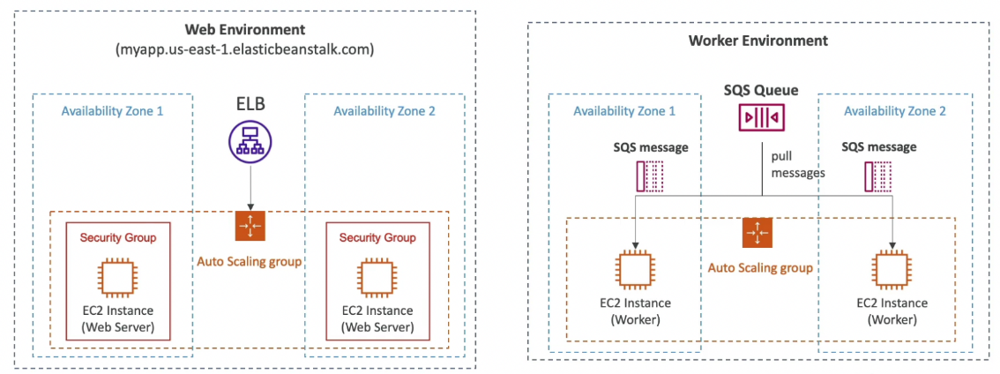

**🌐 Web Server & Worker Environment Tiers in Elastic Beanstalk**

Elastic Beanstalk offers **two environment tiers**, each built for a specific type of application workload:

**1. Web Environment (Web Server Tier)**

**✅ What is it?**

* This is the **default and most common** tier.
* It's designed for applications that **serve HTTP/S traffic** — like websites, APIs, or web apps.
* Requests from users (browsers, apps) go through a **Load Balancer**, which distributes them to the **EC2 instances** running your app.

**🔍 Why use it?**

* Ideal for **interactive apps**, REST APIs, web dashboards, or anything that serves immediate client responses.
* AWS handles:
  + Load balancing
  + Auto scaling based on traffic
  + Health checks
  + SSL termination if needed

**💡 Example Use Cases:**

* Web apps like Django, Node.js, or Flask websites
* REST APIs serving frontend applications
* Single Page Apps with a backend server

**2. Worker Environment (Worker Tier)**

**✅ What is it?**

* This tier is for **background processing** or **asynchronous tasks**.
* Instead of sending requests directly to your app, users send them to an **Amazon SQS queue**.
* **EC2 instances pull messages from the queue** and process them **independently** of the user’s request/response cycle.

**🔍 Why use it?**

* Useful when tasks **take time** and shouldn't block the user (like resizing images, sending emails, processing payments).
* Worker tier apps are **event-driven**, and AWS manages the **polling, scaling**, and **message acknowledgment**.
* Scaling is based on the **queue depth** (number of unprocessed SQS messages).

**💡 Example Use Cases:**

* Sending confirmation emails after a user registers
* Processing file uploads or image conversions
* Batch-processing database updates or reports

**Deployment Modes**

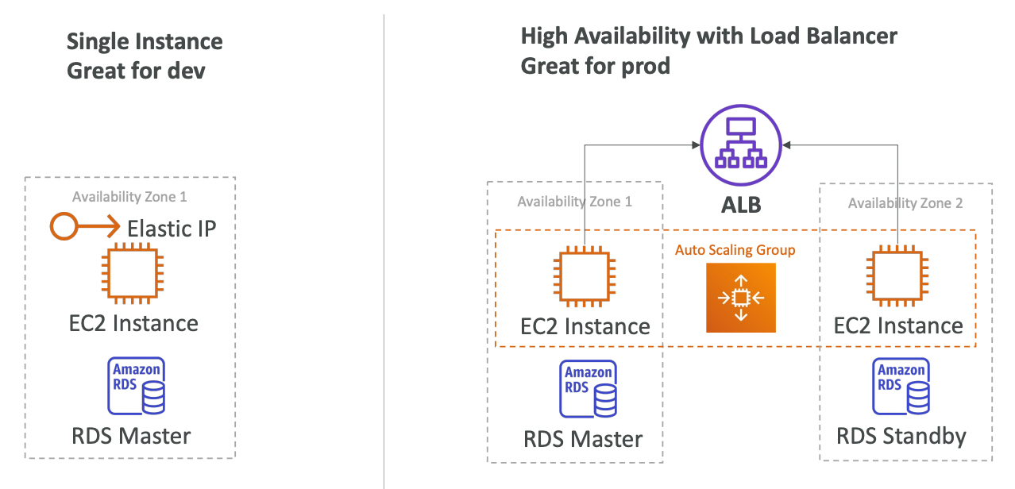

**🧾 Elastic Beanstalk Deployment Modes – Complete Summary**

| **Deployment Mode** | **What It Is** | **Speed** | **Availability** | **Cost Impact** | **Manual/Auto** | **Drawbacks** | **Best Use Case** |
| --- | --- | --- | --- | --- | --- | --- | --- |
| **All at Once** | Deploys new version to **all instances simultaneously** | 🔥 Fastest | ❌ Downtime possible | 💸 Low | ✅ Automatic | No rollback support; full downtime if app restarts slowly | Dev/test environments |
| **Rolling** | Updates **a few instances at a time**, keeping the rest running | ⚡ Moderate | ⚠️ Reduced capacity | 💸 Low | ✅ Automatic | Mixed app versions during deployment; reduced instance capacity | Low-traffic production or staging |
| **Rolling w/ Additional Batch** | Like rolling, but **adds new instances temporarily** to avoid capacity drop | 🐢 Slower | ✅ Maintains capacity | 💸 Medium | ✅ Automatic | Higher resource usage temporarily; slightly slower | Production apps needing zero downtime |
| **Immutable** | Creates **new set of instances** with new version; swaps traffic only if healthy | 🐢 Slowest | ✅ Full availability | 💸 High | ✅ Automatic | Highest cost (runs double resources); longer deployment | Mission-critical production environments |
| **Blue/Green** | Manually deploys to a **separate environment**; **CNAME swap** to redirect traffic after testing | ⚙️ Variable | ✅ Full availability | 💸 High | ❌ Manual | Needs extra environment; manual work (or automation); DNS propagation delay | Controlled rollouts, pre-release validation |

**🧠 Quick Notes:**

* **Immutable** = safest **automatic** method → no mix of old/new code.
* **Rolling** = balances speed & availability but may serve mixed app versions.
* **Blue/Green** = safest **manual** method → good for testing before release.
* **All at Once** = fastest but risky → avoid in production.

**Lifecycle Policy**

* Lifecycle policy to phase out old versions based on:
  + **Days** (delete versions older than x days)
  + **Count** (keep latest x versions)
* Up to 1000 application version deployed simultaneously
* Option to retain the old version’s source bundle in S3

**EB Extensions**

* Configure EB environment through config files
* Config files should be present in .ebextensions/ directory in the root of the source code
* Config files should have .config extension and should be in YAML or JSON format
* Lifecycle of resources managed by EB Extensions are tied to the EB environment
* Through EB Extensions, we have the ability to add resources (RDS, ElastiCache, etc.) through CloudFormation, which cannot be done from the EB console.

**EB Cloning**

* Clone an **environment** with the **same configuration**
* Useful to deploy a test version of your application
* Data present in DB will not be cloned, only the configuration will be cloned
* After cloning an environment, we can change the configuration

**EB Migration**

* **If some change cannot be done in an environment** (eg. changing the load balancer type), **we need to migrate our environment.**
* Steps for migration
  + Create a new application environment with the same configuration except the required change (cannot clone)
  + Perform a CNAME swap or Route 53 update to route all traffic to the new environment

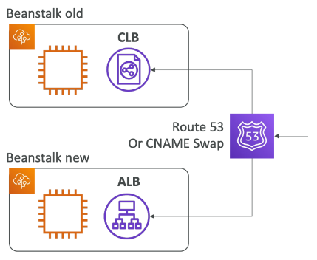

**⚠️ Why migrate?**

Some configuration changes **cannot be applied directly** to a running EB environment.  
Examples include:

* Changing the **load balancer type** (Classic → Application LB)
* Switching from **single-instance** to **high-availability**
* Moving to a different **platform version**
* Replacing the **VPC** or **subnet configuration**
* Changing **environment tier** (web ↔ worker)

These changes require **creating a new environment from scratch**.

**🔧 Migration Steps**

**1. Manually create a new environment**

* Use the same configuration as the existing one (except for the change you need).
* You **cannot clone the environment** directly from the console — you’ll need to:
  + Reconfigure manually in the console, **or**
  + Use the same .ebextensions and config files, **or**
  + Use saved configuration templates (if available).

**2. Deploy your application code**

* Use the same application version (or newer).
* Ensure it behaves as expected in the new environment.

**3. Switch traffic to the new environment**

* Use **CNAME swap**:  
  In the Beanstalk console, you can **swap environment URLs** so users are routed to the new environment.

Example:

sql

old-env.elasticbeanstalk.com → new-env.elasticbeanstalk.com

* Alternatively, if using **custom domains** with **Route 53**, update DNS records to point to the new environment.

**Decoupling DB from EB Environment**

* **Production environments should not have DB as a part of the environment as its lifecycle gets tied to the environment.**
* Steps to decouple an RDS DB already present in an EB environment:
  + Create a snapshot of the DB (for safety)
  + Go to RDS console → Protect RDS from deletion
  + Create a new EB environment without RDS and connect the application to the existing RDS (using connection string passed in the environment variable)
  + Perform a CNAME swap or Route 53 update to route all traffic to the new environment
  + Terminate the old environment (RDS won’t be deleted)
  + Delete CF stack (which is in DELETE_FAILED state)

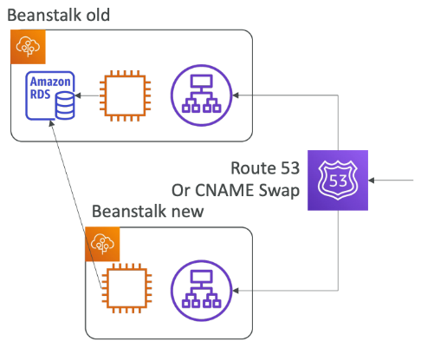

**📌 What it means:**

When you create an Elastic Beanstalk (EB) environment, AWS gives you the **option to include an RDS (Relational Database Service) instance** *within* that environment.

But **best practice** is to **decouple** the database — i.e., **create the RDS instance outside of EB** and connect to it manually.

**🚫 Problems with a Coupled Database (RDS inside EB)**

| **Problem** | **Description** |
| --- | --- |
| **Tied to EB lifecycle** | If you **terminate** the EB environment, the RDS instance is **deleted too** (unless manually backed up). |
| **Poor separation of concerns** | Treating your app and data layer as a single unit makes **scaling, managing, and updating harder**. |
| **No shared access** | You **can’t share** the RDS easily with other apps or services if it lives inside the EB environment. |
| **Limited backup strategy** | Managing backups and failover becomes trickier when RDS is embedded. |

**✅ Benefits of Decoupling (Best Practice)**

| **Benefit** | **Description** |
| --- | --- |
| ✅ **Data persistence** | RDS instance **survives** even if the EB environment is deleted or recreated. |
| ✅ **Easier environment management** | You can tear down and recreate EB environments without touching your DB. |
| ✅ **Reusability** | Same database can be used across **multiple environments** (e.g., dev, test, prod). |
| ✅ **Improved security and control** | You can manage DB settings, backups, replication, and failover separately. |
| ✅ **Cleaner CI/CD workflows** | Infrastructure and database pipelines can be managed **independently**. |

**🧠 DVA-C02 Exam Tip:**

* **Never put a production database inside Elastic Beanstalk**.
* On the exam, if you see a question about **preserving data**, **multi-environment architecture**, or **scalability**, the correct answer usually involves **creating the RDS separately** and connecting to it via VPC or endpoint.

**Running containerized applications on EB**

**Single Container**

* **Running the application as a single container does not use orchestration solutions like ECS.** It runs it directly on an EC2 instance.
* Need to provide either:
  + Dockerfile - EB will build and run the Docker container (doesn’t require a pre-built docker image in a container repository)
  + Dockerrun.aws.json (v1) - describes where the prebuilt Docker image is along with how to run it (ports, volumes, etc.)

**Multi Container**

* **Running the application in a multi-container setup creates an ECS cluster along with task definition and executions.** It also provisions ELB in **high availability mode**.
* Runs multiple containers in each EC2 instance.
* Requires Dockerrun.aws.json (v2) at the root of the source code. It is used by EB to generate the ECS task definition.
* The Docker images must be pre-built and stored in a container repository.

**HTTPS on Elastic Beanstalk**

* TLS certificate can be loaded on to the load balancer in either of the two ways:
  + From the EB console under load balancer configuration
  + In the .ebextensions/securelistener-alb.config file
* SSL cert can be provisioned using ACM or CLI
* Must configure a SG rule to allow incoming traffic on port 443

**📌 What is it?**

Adding **HTTPS (TLS/SSL)** support to your Elastic Beanstalk environment means securing your application so that **data is encrypted between users and your application**.

This is done by **attaching a TLS certificate to the load balancer**, so it can serve secure traffic over **port 443** (HTTPS).

**⚙️ Key Steps to Set Up HTTPS on EB**

**✅ 1. Provision a TLS/SSL Certificate**

* Use **AWS Certificate Manager (ACM)** to request or import a certificate.
* You can do this via:
  + AWS Console
  + AWS CLI:

css

aws acm request-certificate --domain-name yourdomain.com --validation-method DNS

**✅ 2. Attach the Certificate to the Load Balancer**

There are **two ways** to do this in Elastic Beanstalk:

| **Method** | **Description** |
| --- | --- |
| **Console method** | Go to EB → Configuration → Load Balancer → Add HTTPS listener (port 443) and attach the certificate. |
| **.ebextensions method** | Use a config file like .ebextensions/securelistener-alb.config to automate HTTPS setup via code. Useful for CI/CD and version control. |

**✅ 3. Allow Incoming Traffic on Port 443**

* Update your **Elastic Beanstalk environment’s security group** to allow **inbound traffic on port 443**.
* If you skip this, HTTPS requests will be **blocked**.

**🧠 DVA-C02 Exam Tips**

* Know that **ACM certs are free** and automatically renew.
* EB uses **Elastic Load Balancers (ALB or CLB)**, and the **TLS cert must be attached to the listener** on port 443.
* Be familiar with .ebextensions as a way to configure Beanstalk environments as **code**.
* Don’t forget the **security group rule** — no HTTPS without it!

**Redirect HTTP to HTTPS on Beanstalk**

* Can be done in either of two ways:
  + Configure EC2 instances to redirect HTTP to HTTPS
  + Configure ALB with a rule (preferred)
* Health Checks should not be redirected

**Custom Platform**

* If your app’s language is incompatible with Beanstalk and does not use Docker, we can use Beanstalk and need to create a custom platform.
* Steps to create custom platform:
  + Define an AMI using Platform.yaml file
  + Build the platform using **Packer** (open-source tool to create AMIs)

**Deployment options for Update**

**All at once**

* Bring down the old version and then bring up the new version
* **Downtime**
* Fastest deployment
* No additional cost

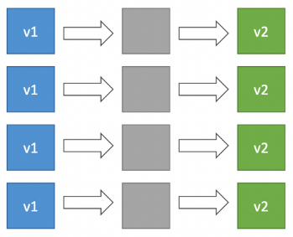

**Rolling updates**

* Update a portion of applications in buckets
* Application can be running below capacity
* Long deployment
* No additional cost

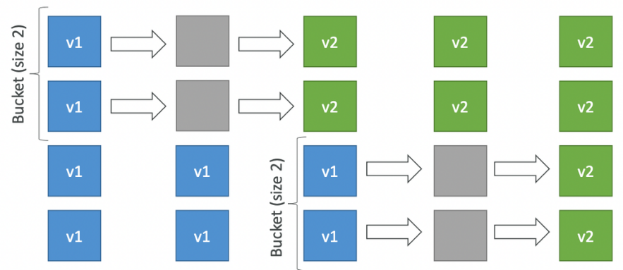

**Rolling with additional batches**

* Run rolling updates while adding a bucket size (batch) of new applications that will be removed after deployment.
* Application can be running above capacity (small additional cost)
* Long deployment
* Good for prod environment

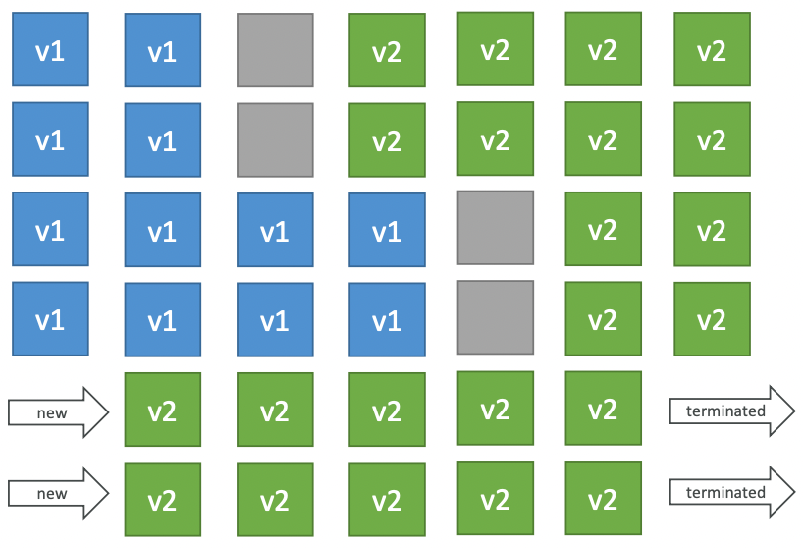

**Immutable**

* New version is deployed to new instances on a temporary ASG. The instances in the temporary ASG are moved to the current ASG. The instances running the old application version in the current ASG are terminated and the temporary ASG is discarded.
* Longest deployment
* Zero downtime
* High cost (double capacity needed)
* **Quick rollback** (just delete the temporary ASG)

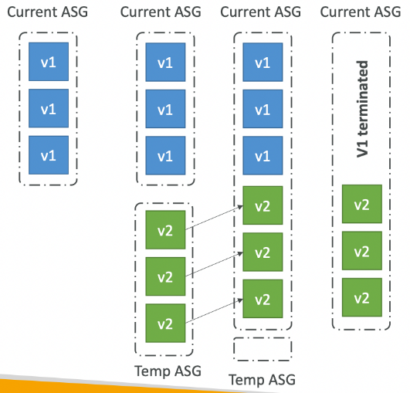

**Blue / Green**

* Create an environment with new application version. Send a small amount of traffic to the new application version (environment) using **Route53 weighted routing** policy. If the new version is working fine, direct all the traffic to the new version (using Application URL swap which internally does a CNAME swap in Route53) and delete the old application environment.
* Zero downtime
* High cost (double capacity needed)
* Not directly available in Beanstalk

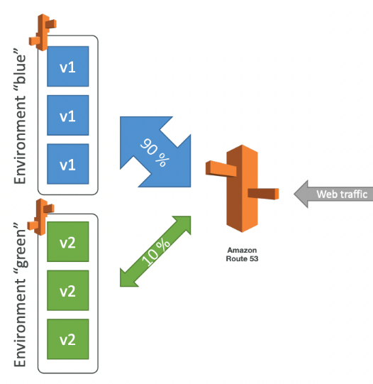

**Deployment Comparisons**

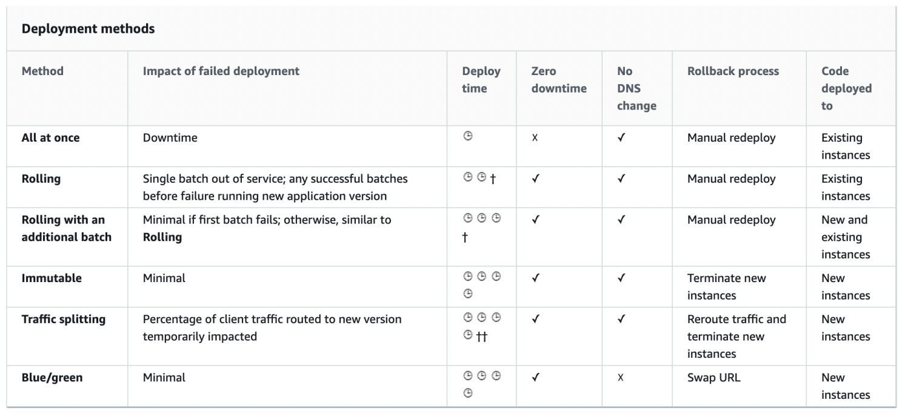

**Misc**

* To deploy a new application version through the console, you'll need to upload a source bundle that meets the following requirements:
  + Consist of a **single** ZIP file or WAR file
  + Not exceed 512 MB
  + Not include a parent folder or top-level directory (subdirectories are fine)
* To deploy a worker application that processes periodic background tasks, the application bundle must include a cron.yaml file.
* EBS can configure EC2, CloudWatch and ALB. It cannot configure **Lambda** or CloudFront.
* Environment variables can be defined in env.yaml present in the root of the source bundle.
* To deploy a new version of the application, package your application as a zip or war file and deploy it using eb deploy command.
* To migrate an EB environment between accounts, create a saved configuration in the first account and download it to your local machine. Make the account-specific parameter changes and upload to the S3 bucket in second account. From Elastic Beanstalk console, create an application from **Saved Configurations**.

**Serverless Application Model (SAM)**

**Intro**

* IaC (YAML) for deploying serverless applications easily

**IaC = Infrastructure as Code**

* You **define and manage cloud infrastructure** using **code**, not the AWS Console.
* In AWS SAM, this is done using a **YAML template** — a readable, structured file that describes your entire **serverless application stack**.
* Abstraction over [CloudFormation](https://www.notion.so/CloudFormation-04e6f48e0b2a409b96b23c525e855400?pvs=21) to allow developers to easily deploy their code
  + - *SAM templates are* ***translated into full CloudFormation templates*** *when deployed.*
    - *This means you get all the power of CloudFormation* ***without writing verbose syntax****.*
* Can deploy Lambda, API Gateway and DynamoDB locally for development using **SAM CLI** and **AWS Toolkits**
* Uses **CodeDeploy** under the hood to update Lambda functions

**Workflow & Commands**

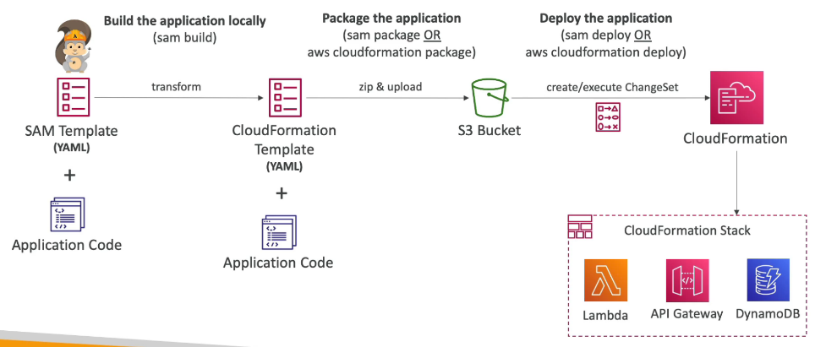

* sam build - Fetch dependencies & build the application. If the application code does not require building, skip this command and run sam package directly.
* aws cloudformation package or sam package - Convert the SAM template to CloudFormation template, package the application code and the CloudFormation template and upload to an S3 bucket (must be created beforehand).
* aws cloudformation deploy or sam deploy - Deploy the application package from S3 (creates and executes Change Set in CloudFormation)
  + A **Change Set** is a **preview** of the changes AWS CloudFormation will make to your stack **before it actually applies them**.
  + Think of it as a **"dry run"** of your infrastructure changes.
* sam publish - publish serverless app to SAR (only needs the CF template, the code is referenced from S3)

| **Concept** | **Description** |
| --- | --- |
| **Change Set** | A preview of how your CloudFormation stack will change before applying it |
| **SAR** | A repository of ready-to-deploy serverless apps built using SAM |
| **Change Set Use** | Prevent destructive changes in infrastructure |
| **SAR Use** | Speed up serverless development with reusable components |

**Template**

* Transform: "AWS::Serverless-2016-10-31' - indicates that the YAML file is a SAM template (required)
* Resources - resources to be created (required)
  + AWS::Serverless::Function - define a Lambda function
  + AWS::Serverless::Api - define an API gateway
  + AWS::Serverless::SimpleTable - define a DynamoDB table
  + AWS::Serverless::Application - use an application from SAR

**Policy Templates**

* List of templates to grant permissions to Lambda functions easily
* Important policy templates:
  + S3ReadPolicy - read-only permission to objects in an S3 bucket
  + SQSPollerPolicy - allow the function to poll an SQS queue
  + DynamoDBCrudPolicy - allow CRUD operations on a DynamoDB table
  + DynamoDBReadPolicy - allow read operations on a DynamoDB table

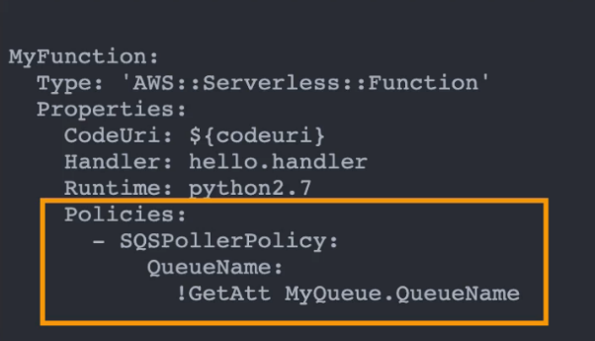

**SAM +** [**CodeDeploy**](https://www.notion.so/CodeDeploy-501622c866554d27bce00d177f9d47fe?pvs=21)

* SAM uses CodeDeploy under the hood to update Lambda functions every time we update the code and deploy.
* Gradually shifts traffic to the new Lambda version using **Aliases**
* Optional **Pre & Post Traffic Hooks** (run on separate Lambda functions) to validate the deployment before the traffic shift starts and after it ends
* Optional **Automated Rollback** using CloudWatch Alarms
* Configure the deployment strategy in the Properties section of the Lambda function.

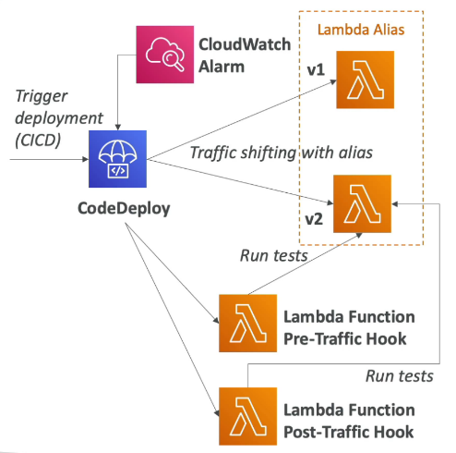 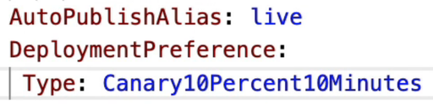

**🚀 SAM + CodeDeploy: Safe Lambda Deployments**

**✅ What is it?**

When you deploy a Lambda function using **AWS SAM**, it can automatically use **AWS CodeDeploy** behind the scenes to:

* Gradually shift traffic to the **new version** of your function
* Run optional **validation hooks** before and after the deployment
* Roll back **automatically** if there’s a problem

**🔄 How Does It Work?**

**1. Traffic shifting using aliases**

* Lambda functions have **versions** and **aliases**.
* SAM + CodeDeploy uses an alias (like Prod) to **point to your live Lambda version**.
* During deployment, it **gradually shifts traffic** from the old version to the new one.

🧠 This avoids "all-at-once" rollouts and reduces the risk of bugs affecting all users immediately.

**2. Deployment Configurations (Strategies)**

You configure how traffic shifts in the template.yaml file:

Yaml

AutoPublishAlias: live

DeploymentPreference:

Type: Linear10PercentEvery1Minute

**Common strategies:**

| **Type** | **Behavior** |
| --- | --- |
| Canary10Percent5Minutes | Shift 10% of traffic, wait 5 mins, then shift the rest |
| Linear10PercentEvery1Minute | Shift 10% more every 1 minute until 100% |
| AllAtOnce | Immediate full rollout (least safe) |

**3. Pre & Post Traffic Hooks (Optional)**

You can define **Lambda functions** to run:

* **Before the traffic shift** begins → PreTrafficHook
* **After the shift** finishes → PostTrafficHook

These can:

* Run automated tests
* Ping health checks
* Validate logs, metrics, etc.

If these fail, the deployment can be **aborted or rolled back**.

**4. CloudWatch Alarms for Auto Rollback (Optional)**

* You can link a **CloudWatch Alarm** to the deployment.
* If it triggers (e.g., errors, throttles, latency), CodeDeploy will **automatically roll back** to the previous Lambda version.

**Local Deployment**

* Can deploy Lambda, API Gateway and DynamoDB locally for development using **SAM CLI** and **AWS Toolkits**
* sam local start-lambda - start a lambda function locally (local endpoint)
* sam local invoke - invoke the local lambda endpoint with a payload
  + If the function makes API calls to AWS, make sure to specify --profile option
* sam local start-api - starts a local HTTP server along with the lambda code as backend
  + Changes made to the function code are automatically reloaded
* sam local generate-event - generate local mock events for lambda functions
  + Example: generate an S3 PutObject event and use it to invoke the lambda function

sam local generate-event s3 put --bucket <bucket> --key <key> | sam local invoke -e - <function_id>

**Serverless Application Repository (SAR)**

* Repository for serverless applications packaged using SAM
* Packaged applications can be shared
  + Publicly
  + With specific AWS accounts
* The packaged applications can be directly deployed (no duplicate work)
* Application can be customized using **environment variables**

**Cloud Development Kit (CDK)**

**Intro**

* **IaC to define infrastructure using programming languages** (instead of declarative config files as in the case of CloudFormation and SAM)
* A step above CloudFormation (static type checks during programming which is not available in YAML config files)
* Supports JavaScript/TypeScript, Python, Java and .NET
* Deploy infrastructure and application code together
* The code is compiled to a CloudFormation template using **CDK CLI**
* Great for Lambda functions and Docker containers
* Contains high-level components called **constructs**

**Construct**

* Component that encapsulates everything CDK needs to create the final CloudFormation stack
* Can represent a single AWS resource (e.g. S3 bucket) or multiple related resources (e.g. worker queue with compute)
* **AWS Construct Library** - a collection of Constructs included in AWS CDK which contains Constructs for every AWS resource
* **Construct Hub** - repository of constructs created by AWS, 3rd parties, and open-source CDK community

**🏗️ What is a Construct in AWS CDK?**

**✅ Construct = Reusable building block**

A **construct** is an **object in code** that defines one or more AWS resources.  
You use constructs to **model cloud infrastructure in code** (in TypeScript, Python, Java, etc.) using AWS CDK.

Think of constructs like Lego blocks for AWS resources.

**🧱 Layers of Constructs**

Constructs come in **three layers**, each adding more abstraction and reuse:

**🥇 1. *L1: CloudFormation Constructs (Cfn)*\***

* These are **low-level constructs** that map **1:1 to CloudFormation resources**.
* Automatically generated by CDK from CloudFormation resource specs.
* Prefixed with Cfn, e.g., CfnBucket, CfnFunction

**🧠 Use when:**

* You want **complete control** over the resource configuration.
* A newer AWS feature isn’t yet abstracted in higher layers.

python

from aws_cdk.aws_s3 import CfnBucket

bucket = CfnBucket(self, "MyBucket", bucket_name="my-raw-s3-bucket")

**🥈 2. L2: AWS Construct Library**

* These are **higher-level, opinionated** constructs.
* Represent common AWS services with sensible defaults.
* Easier to use than L1 — includes auto-wiring, permissions, etc.
* **Resource methods** to work easily with resources (eg. bucket.urlForObject())

**🧠 Use when:**

* You want to **create resources easily and quickly**.
* You’re okay with best practices and some abstraction.

python

from aws_cdk.aws_s3 import Bucket

bucket = Bucket(self, "MyBucket", versioned=True)

CDK will automatically create related resources like bucket policies behind the scenes.

**🥉 3. L3: Patterns / Custom Constructs**

* These are **custom-built, reusable groupings** of resources (like mini architectures).
* Created by AWS or your team.
* Often found in the **AWS Solutions Constructs** library or custom CDK libraries.
* Available for common architectures:
  + aws-apigateway.LambdaRestApi - represents an API gateway backed by a Lambda function
  + aws-ecs-patterns.ApplicationLoadBalancerFargateService - represents an architecture that includes a Fargate cluster with ALB

**🧠 Use when:**

* You want to **reuse an entire architecture pattern** (e.g., Lambda + API Gateway + DynamoDB).
* You want to reduce boilerplate and enforce standards.

python

from aws_solutions_constructs.aws_apigateway_lambda import ApiGatewayToLambda

api_lambda = ApiGatewayToLambda(self, "MyApiLambda",

lambda_function_props={

"runtime": lambda_.Runtime.PYTHON_3_11,

"handler": "app.handler",

"code": lambda_.Code.from_asset("lambda")

}

)

**🎯 Summary Table**

| **Layer** | **Name** | **Description** | **Example Use** |
| --- | --- | --- | --- |
| L1 | CloudFormation | 1:1 mapping to AWS resources | CfnBucket, CfnFunction |
| L2 | AWS Construct Lib | Easy-to-use with sensible defaults | Bucket, Function, Table |
| L3 | Patterns | Pre-built architectures, reusable patterns | ApiGatewayToLambda, custom stack |

**🧠 DVA-C02 Exam Tips**

* Know that **constructs define AWS resources in code** using CDK.
* Understand the **three layers**:  
  L1 (raw), L2 (useful), L3 (opinionated + reusable).
* Use **L2/L3** when productivity is important.
* Use **L1** when you need full control or access to latest features.

**Bootstrapping**

* **Provisioning resources for CDK before deploying CDK apps in an AWS environment** (combination of account & region)
* Before using CDK to deploy an app in any AWS environment, we need to deploy a CloudFormation stack called **CDK Toolkit** in that environment, using the command ****cdk bootstrap aws://<aws_account>/<aws_region>.
* If CDKToolkit is not deployed, we’ll get an error: “***Policy contains a statement with one or more invalid principal***”.
* The CDKToolkit stack contains:
  + S3 Bucket - to store files
  + IAM Roles - to grant permissions to perform deployments

**Commands**

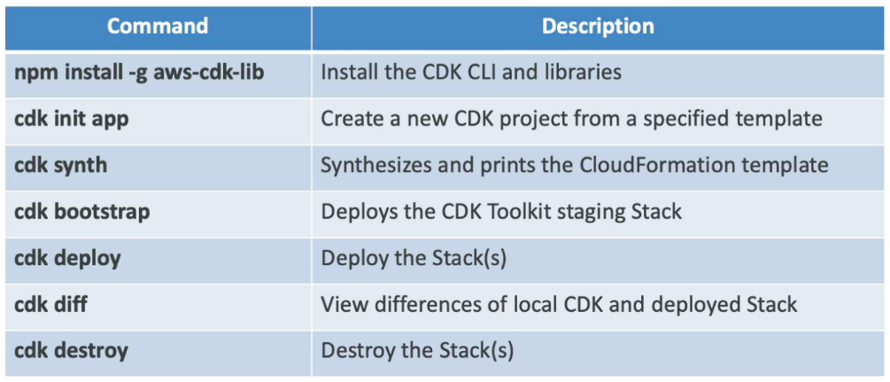

**Testing**

* Use **CDK Assertions Module** along with testing frameworks like Jest or PyTest for testing the resources created by CDK.
* Two types:
  + **Fine-grained Assertions** (common) - test specific aspects of the CloudFormation template
  + **Snapshot Tests** - test the synthesized CloudFormation template against a previously stored baseline template
    - To import a CloudFormation template:
      * Template.fromStack() - for stack built in CDK
      * Template.fromString() - for stack build outside CDK

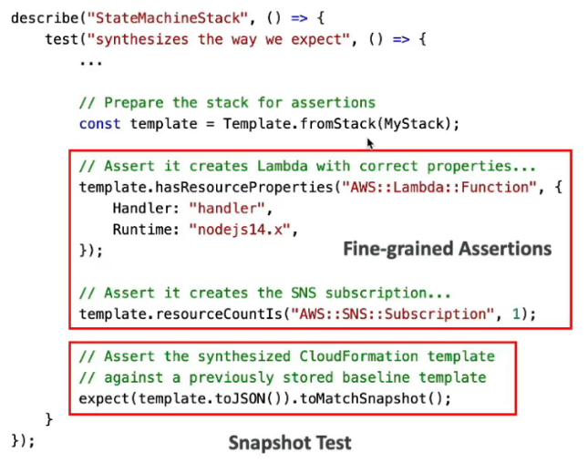

**Amplify**

**Intro**

* Used to build mobile and web applications
* amplify init - initialize an amplify project
* Provides features such as data storage, authentication, ML, etc. (all powered by AWS services)
* Provides front-end libraries with ready to use components for popular frameworks like React, Vue, Flutter, etc.

**Offerings**

* **Amplify Studio**: Visually build a full-stack app (front-end Ul and backend)
* **Amplify CLI**: Configure an Amplify backend with a guided CLI workflow
* **Amplify Libraries**: Connect your app to existing AWS services
* **Amplify Hosting**: Host web apps via the AWS **CDN**

**Auth**

* Provides authentication out of the box (amplify add auth)
* Leverages [Cognito](https://www.notion.so/Cognito-1fc7771b245647b691302be769d1c370?pvs=21)
* Supports MFA, Social Sign-in (federated identities), Account Recovery, etc.
* Provides pre-built UI components to integrate in the front-end
* Provides fine-grained authorization

**GraphQL API & Data Store**

* Provides **GraphQL API using AppSync** and DynamoDB as the data store (amplify add api)
* Work with data locally with automatic synchronization to the cloud (offline and real-time capabilities)
* Visual data modeling using Amplify Studio

**Hosting**

* Host web applications (amplify add hosting)
* Support for CICD, PR Reviews, Custom Domains, Monitoring, etc.
* Competing with services like **Netlify** and **Vercel**.

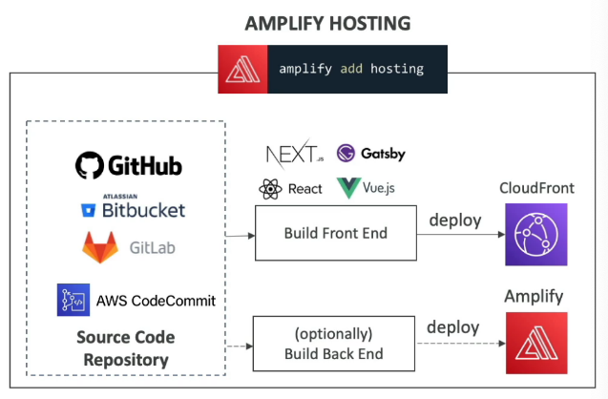

**Testing**

* **Run unit tests during the build phase** (defined as test step in amplify.yml)
* Run **end-to-end tests during the test phase** before deploying the app in production environment (app is deployed in the testing environment)
  + Integrated with **Cypress** E2E testing framework (allows to generate UI report for the tests)

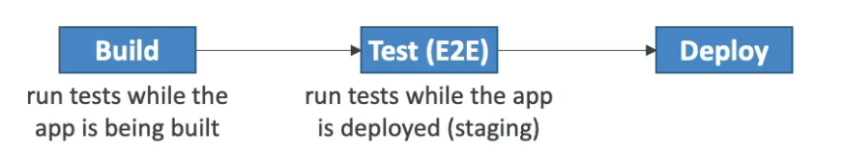

**AppConfig**

* Used to **separate configuration from the application**
* Deploy dynamic configuration changes without redeploying application
* Used for apps running on EC2, Lambda, ECS, EKS, etc.
* Use cases: **feature flags** to enable or disable a feature, **dynamic IP blocklist**, etc.
* Gradually deploy the configuration changes and rollback if issues occur
* **Validate configuration** changes before deployment using:
  + **JSON Schema** (syntactic check)
  + **Lambda Function** - run code to perform validation (semantic check)

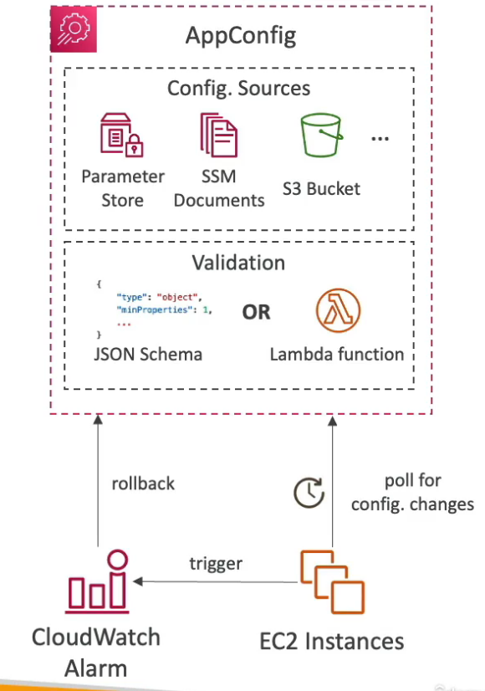

**Cloud9**

* **Cloud-based IDE that runs in the browser**
* Features debugger, terminal and **live pair programming**
* Pre-packaged with essential tools for popular programming languages
* **Fully integrated with SAM** and Lambda to easily build serverless applications
* Runs on EC2 instance under the hood (hibernates after some period of idleness to reduce unnecessary charges)